Activity 2: We’re Closed!

CATEGORY: NUMBER & QUANTITY

DOMAIN: THE REAL NUMBER SYSTEM
Use properties of rational and irrational numbers.
Explain why the sum or product of two rational numbers is rational; that the sum
of a rational number and an irrational number is irrational; and that the product of a
nonzero rational number and an irrational number is irrational.

LEARNING OBJECTIVES
Students will be able to reason with properties of rational and irrational numbers.
Students will also become more familiar with creating proofs.

BACKGROUND KNOWLEDGE
Students are expected to have fluent definitions of rational and irrational numbers:

- A rational number is any number that can be expressed as the quotient or fraction of two integers, with the denominator not equal to zero.

- Irrational numbers cannot be written as the ratio of two integers.

- Rational numbers have decimal expansions that either terminate or repeat

- Irrational numbers have decimal expansions that never terminate and never repeat.

- Rational numbers are countable and irrational numbers are uncountable, therefore almost all real numbers are irrational.

Know that there are numbers that are not rational, and approximate them by rational numbers.

1. Know that numbers that are not rational are called irrational. Understand informally that every number has a decimal expansion; for rational numbers show that the decimal expansion repeats eventually, and convert a decimal expansion which repeats eventually into a rational number.

Activity 2: Getting Started



GETTING STARTED
The ancient Greeks believed that every number was rational. They eventually discovered
that some quantities could not be expressed using rational numbers. One example is the length
of the diagonal of a square having sides equal to 1 unit.

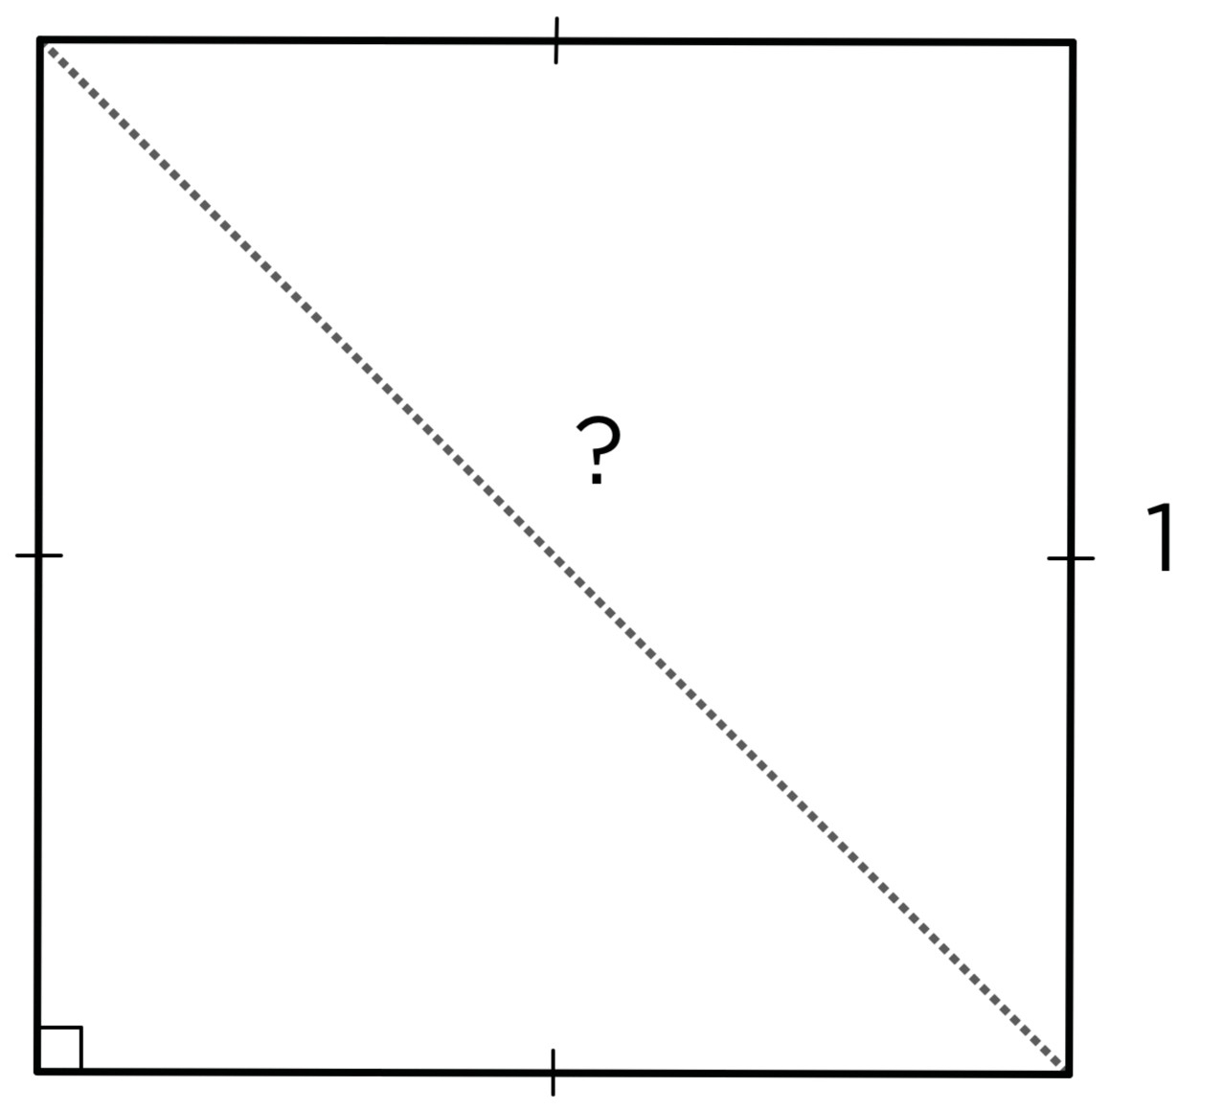

- Given that the sides of the square above are equal to 1 unit, what is the length
of the diagonal of this square?

- Use your calculator to expand $\sqrt{2}$. Is $\sqrt{2}$ a rational number?

- Follow these steps:

  - Choose an integer [a].

  - Square the integer [$a^{2}$].

  - Prime factor the squared integer. How many twos [2s] are in the prime factorization?

  - Repeat this process with at least five integers. Use even and odd integers

  - Is it possible to find an integer [a] such that the prime factorization of [$a^{2}$] contains an odd number of twos? If so, find the integer. If not, explain why.

  - Now, choose an integer [b].

  - Square the integer [$b^{2}$].

  - Multiply the squared integer by two [2$b^{2}$].

  - Prime factor the result. How many twos [2s] are in the prime factorization?

  - Repeat this process with at least five integers. Use even and odd integers

  - In general, does the prime factorization of [2$b^{2}$] contain an even or odd number of twos, or does it depend on our choice of integer [b]?

Activity 2: Getting Started


UNDERSTAND
- Complete the addition table:
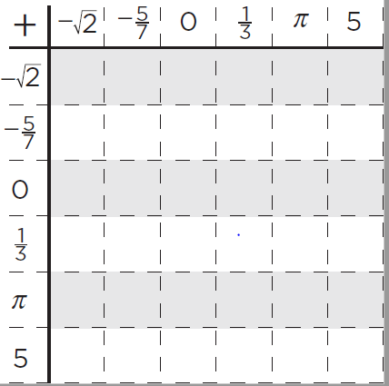
+ | $$-\sqrt{2}$$ | $-\frac{5}{7}$ | 0 | $$\frac{1}{3}$$ | $$π$$ | 5
$$-\sqrt{2}$$
$-\frac{5}{7}$
0
$$\frac{1}{3}$$
$$π$$
5

- Complete the multiplication table.

× | $$-\sqrt{2}$$ | $$-\frac{5}{7}$$ | 0 | $$\frac{1}{\sqrt{2}}$$ | $$π$$ | 5
$-\sqrt{2}$
$$-\frac{5}{7}$$
0
$$\frac{1}{\sqrt{2}}$$
$$π$$ |  |  |  | 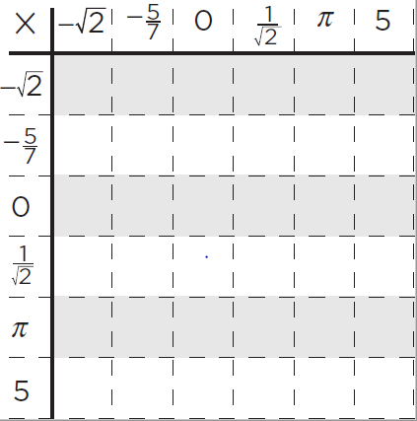
5

Activity 2: Getting Started


- Based on the above information, conjecture which of the statements is ALWAYS true,
which is SOMETIMES true, and which is NEVER true?

- The sum of a rational number and a rational number is rational

- The sum of a rational number and an irrational number is irrational

- The sum of a rational number and an irrational number is rational

- The product of a rational number and a rational number is rational

- The product of a rational number and an irrational number is irrational

- The product of an irrational number and an irrational number is irrational

PRACTICE
- The rectangle below has side lengths a & b. Decide if it is possible to find a & b to
make the statements below true. If you think it is possible, give values for a & b. If you
think it is impossible, explain why no values of a & b will work.

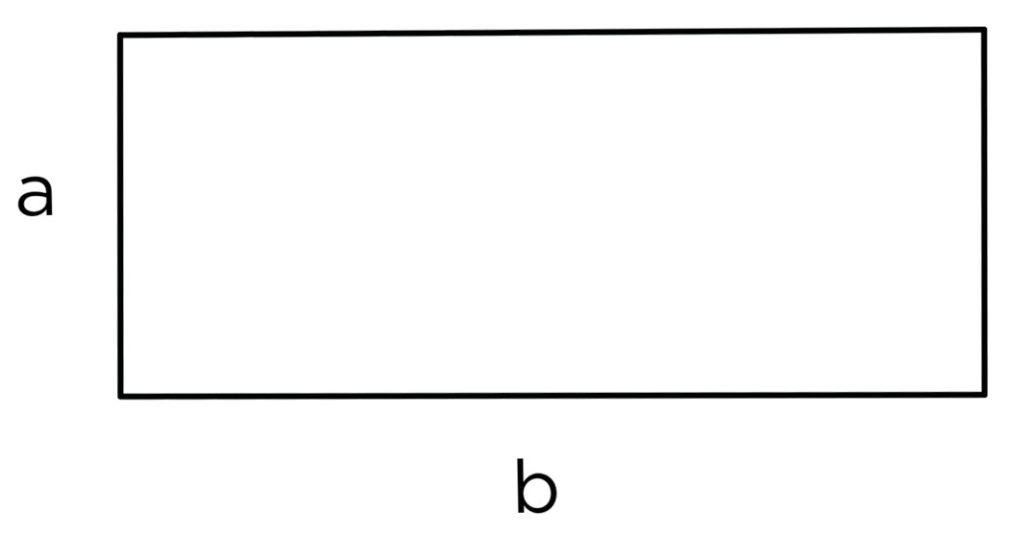
- The perimeter and area are both rational numbers

- The perimeter is a rational number, and the area is an irrational number

- The perimeter and area are both irrational numbers

- The perimeter is an irrational number, and the area is a rational number.

- Simplify each expression leaving no perfect square inside the radical or without leaving radicals in the denominator.

a. $4\sqrt{28}-\sqrt{7}$

b. $3\sqrt{4}×4\sqrt{3}$
c. $\frac{3\sqrt{14}}{15\sqrt{7}}$

Activity 2: Getting Started


EXTEND
- Prove that the sum of two rational numbers is rational.

- Prove that the product of two rational numbers is rational.

- Prove that the sum of a rational number and an irrational number is irrational.

- Prove that the product of a nonzero rational number and an irrational number is irrational.

