Unit
9
STATISTICS

KEY CONCEPTS
TEACHER’S GUIDE

Pictogram
A symbol is used to represent a standard quantity of items.
A key will be given to show the quantity represented by the symbol.

Bar graphs
Rectangular bars of equal width are used in bar graphs. Horizontal or vertical representations are possible.
The spaces between the bars are uniform.

Pie chart
A pie chart shows the quantity of items by using the sectors of a circle.
The angle in each sector is proportional to the quantity of items represented.

Line graph
Data points are plotted on the graph and joined up with line segments.

Frequency table
A frequency table records and shows how many times a value occurs.

Histogram
Vertical bar graph without spaces between bars.
The area of the bar is proportional to the frequency it represents. The width of the bars may not be equal.
Displays information from a frequency table.

Grouped frequency table
Usually for large amounts of data.
Data are grouped into class intervals of equal sizes. Accuracy of individual data will be lost.

Dot diagram
A horizontal line is first drawn to represent the numbers or the items of the data.
Dots are drawn above the horizontal line’s number or item to represent the frequency.

Stem and leaf diagram
Each data value is split into two parts, one for the stem and one for the leaf. The stem and the leaf are separated by a vertical line.

Casio ClassWiz Mathematics Workbook
TEACHER’S GUIDE

Mean
Sum of data Number of data
Mean =
For a set of data,
x1 + x2 + x3 + … + xn
n
$\overline{x}$ =

For a set of data in a frequency table below,
x1 f1 + x2 f2 + x3 f 3 + … + xn fn
f1 + f2 + f 3 + … + fn
$\overline{x}$ =

x | x1 | x2 | x3 | … | xn
f | f1 | f2 | f3 | … | fn

For a set of grouped data with equal class intervals in a frequency table,
x1 f1 + x2 f2 + x3 f 3 + … + xn fn
f1 + f2 + f 3 + … + fn
$\overline{x}$ =

where x1, x2, x3, ... ,xn are the mid values of the class intervals.

Median
For a set of data that has odd number of data ranked from the smallest to the largest, the median is the middle position’s value.
For a set of data that has even number of data ranked from the smallest to the largest, the median is the mean of the middle 2 position’s value.
S = $\sqrt{\frac{\sum{x^{2}}}{n} - {(\frac{\sum{x}}{n})}^{2}}$ = $\sqrt{\frac{\sum{{(x-x)}^{2}}}{n}}$

S = $\sqrt{\frac{\sum{{fx}^{2}}}{n} - {(\frac{\sum{fx}}{n})}^{2}}$ = $\sqrt{\frac{\sum{{(x-x)}^{2}}}{n}}$

S = $\sqrt{\frac{\sum{x^{2}}}{n} - {(\frac{\sum{x}}{n})}^{2}}$ = $\sqrt{\frac{\sum{{(x-x)}^{2}}}{n}}$

S = $\sqrt{\frac{\sum{{fx}^{2}}}{n} - {(\frac{\sum{fx}}{n})}^{2}}$ = $\sqrt{\frac{\sum{{(x-x)}^{2}}}{n}}$

Mode
Mode is the value that occurs the most frequently.
S = $\sqrt{\frac{\sum{x^{2}}}{n} - {(\frac{\sum{x}}{n})}^{2}}$ = $\sqrt{\frac{\sum{{(x-x)}^{2}}}{n}}$

Standard Deviation
Measures the spread of a set of data from the mean. For ungrouped data:
S = $\sqrt{\frac{\sum{x^{2}}}{n} - {(\frac{\sum{x}}{n})}^{2}}$ = $\sqrt{\frac{\sum{{(x-\overline{x})}^{2}}}{n}}$

For grouped data:
S = $\sqrt{\frac{\sum{{fx}^{2}}}{\sum{f}} - {(\frac{\sum{fx}}{\sum{f}})}^{2}}$ = $\sqrt{\frac{\sum{{(x-\overline{x})}^{2}}}{\sum{f}}}$

Range
Measures the spread of data.
Range = Largest value of the data – smallest value of the data.

Unit 9 Statistics

Quartile
TEACHER’S GUIDE
A set of ascending data can be divided in 4 equal parts.
Between the first and second quarter, we call it the Lower Quartile (Q1)
Between the second and third quarter, which is also the middle value of the whole set of data, we call it the Median. (Q2)
Between the third and fourth quarter, we call it the Upper Quartile. (Q3)

Interquartile range (IQR)
IQR = Q3 – Q1

Box-and-Whisker Diagram (Box Plot)
Displays 5 main information in numerical order: Smallest value, Lower quartile, Median, Upper quartile, Largest value.

WORKED EXAMPLES

Level 1

Worked Example 1
The pictogram shows the number of burgers sold in a day by a store for the given flavours.

Chicken Burger | 
Fish Burger | 
Veggie Burger | 
Beef Burger | 

Each  represents 10 burgers.

- Calculate the total burgers sold.
- State the flavour that is the most popular and express it as a percentage of all burgers sold.
- Find the ratio of Chicken burger to Fish burger sold.

Solution
- (5 + 4.5 + 3 + 5.5) × 10 = 180 burgers sold in total.
- The most popular flavour is beef burger.
$\frac{ No. of beef burgers }{Total no. of burgers}$ = $\frac{55}{180}$ = $\frac{11}{36}$
- Chicken burger : Fish burger = 5 : 4.5 = 10 : 9

Casio ClassWiz Mathematics Workbook

Worked Example 2
The bar graph shows the survey results for the favourite cartoon of each student in a club.
No. of students 20
18
16
14
12
10
8
6
4
2

The Simpsons
Tom and Jerry
Looney Tunes
Scooby Doo
Spongebob Squarepants
Family Guy

Types of cartoons
TEACHER’S GUIDE

- Find the total number of students in the club.
- State the top 3 most popular cartoons. Express the votes for all 3 cartoons as a percentage of the votes for all the cartoons.
- Find the fraction of students who chose ‘The Simpsons’ cartoon.

Solution
- 10 + 16 + 12 + 8 + 19 + 20 = 85 students in the club
- Top 3 most popular cartoons are
The order does not matter as
question did not ask for it.
Family Guy, Spongebob Squarepants, and Tom and Jerry.
$\frac{16 + 19 + 20}{85}$ × 100% = 64$\frac{ 12 }{17}$ %
- Fraction of students who chose The Simpsons = $\frac{10}{85}$ = $\frac{2}{17}$

Worked Example 3
The pie chart shows the allocation of Isaac’s monthly salary.
Food
Bills
Parents
30°
Shopping
Retirement planning
Leisure
50°
Transport
Savings
- Given that he spent $360 on food every month, calculate his total income.
- Given that he saves as much as he gives his parents, calculate the amount he gives his parents.
- Given that the ratio of leisure to savings is 3:2, find the amount of money that Isaac spends on leisure
every month.
- Given that the ratio of bills : shopping : retirement planning : transport is 2 : 1 : 2 : 1, calculate the
amount of money spent on shopping. 4

Unit 9 Statistics

Solution
TEACHER’S GUIDE
- $\frac{\$360}{30°}$ × 360° = $4320
Isaac’s total monthly salary is $4320 (b) $\frac{50°}{360°}$ × $4320 = $600
Isaac gives his parents $600 every month.
- Amount spent on leisure = $\frac{\$600}{2}$ × 3 = $900
- Amount spent on bills, shopping, retirement planning and transport
= 4320 – 360 – 600 – 600 – 900 = 1860
1860 ÷ 6 units = $310
Isaac spends $310 on shopping.

Worked Example 4
The line graphs show the number of egg tarts baked every two hours for sale on a particular working day from 8 am to 8 pm.
No. of egg tarts
80
60
40
20
8 am
10 am 12 pm
2 pm
Time
4 pm
6 pm
8 pm

- State the time when sales of egg tarts are the most popular.
- State the time when sales of egg tarts are the least popular.
- Find the number of egg tarts baked at
  - 10 am.
  - 8 pm.
- Calculate how many egg tarts were baked on this particular working day.

Casio ClassWiz Mathematics Workbook

Solution
- 8 a.m.
- 2 p.m. and 6 p.m.
- (i) 60 egg tarts
(ii) 70 egg tarts
- 90 + 60 + 70 + 40 + 50 + 40 + 70 = 420

Worked Example 5
The dot diagram shows the daily allowances of a group of children

3 4 5 6 7 8 9 10 11 12 13 14 15
Daily allowance ($)
TEACHER’S GUIDE

- Calculate the total number of children in the group.
- State the highest daily allowance.
- State the modal daily allowance.
- State the median daily allowance.
- Calculate the mean daily allowance.

Solution
(a) 44 children
The number of dots are the number of children.
(b) $15
(c) $5
(d) $\frac{\$6+\$7}{2}$ = $6.50
(e) Mean = $\frac{ 3\left(2\right) + 4\left(4\right) + 5\left(10\right) + 6\left(6\right) + 7\left(7\right) + 8\left(5\right) + 9\left(3\right) + 10\left(1\right) + 11\left(0\right) + 12\left(2\right) + 13\left(0\right) + 14\left(1\right) +15\left(3\right) }{44}$
= $\frac{ 317 }{44}$
= 7.20 (3 s.f.)

Unit 9 Statistics

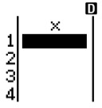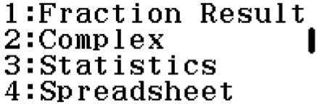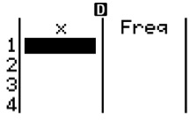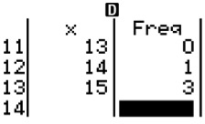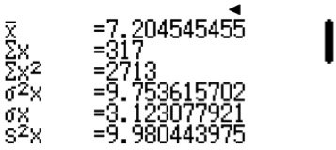 ClassWiz steps
TEACHER’S GUIDE
Finding the mean using ClassWiz:
Press w6 for Statistics function and 1 for 1-Variable.
If you see this, then we need to switch on the frequency function.

Press L and press R. You will see this.

Press 3 for Statistics. Next, press 1 to switch on the frequency. You should see this.

For the column in x, key in the daily allowances. Press 3 = 4 = 5 = until you key in the final value of 15.
Next, move on to the top of the frequency column by pressing $R and fill in the number of dots present for the
corresponding daily allowance. In this case, press 2 = 4
= 10 = 6 = 7 = 5 = 3 = 1 =
0 = 2 = 0 = 1 = 3 =.
You should see this at the end of the page when you are done keying in everything.

Note that for daily allowance of 11 and 14, there are no dots. Hence you key in 0 for the value.

Press T3 to select “1-Variable Calc” and you will see this page.

The mean is given by x = 7.20 (3 s.f.)

The standard deviation is not required in this
question, but it is given by
σx = 3.12 (3 s.f.)

Casio ClassWiz Mathematics Workbook
TEACHER’S GUIDE

Worked Example 6
The stem and leaf show the age of some auditionees auditioning for a singing competition.

Stem | Leaf
1 | 3 | 6 | 6 | 8 | 9 | 9 | 9
2 | 0 | 1 | 3 | 4 | 4 | 7 | 8
3 | 0 | 3 | 5 | 7
4 | 3 | 6 | 8
5 | 2 | 3
6 | 0

Key: 2|5 represents 25 years old.
- Find the total number of people who auditioned for the singing competition.
- Calculate the mean age of the auditionees.
- State the median age of the auditionees.

Solution
- 24 auditionees.
Count the number of leaves. They represent each auditionee.

- Mean age = $\frac{ 13+ 16+ 16+ 18+ 19+ 19+ 19+ 20+ 21+ 23+ 24+ 24+ 27+ 28+ 30+ 33+ 35 + 37+ 43 + 46+ 48 + 52+ 53 + 60 }{24}$
= $\frac{724}{24}$
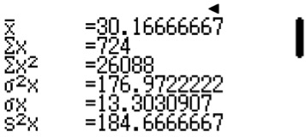= $30\frac{1}{6}$
The mean is given as 30.2 (to 3 s.f.)
ClassWiz steps
Finding the mean using ClassWiz:
Press w6 for Statistics function and 1 for 1-Variable.
Press L and press R. Press 3 for Statistics. Next, press 2
to switch off the frequency. You should see only 1 column. In the column, key in all 24 values.
Press T3 to select “1-Variable Calc” and you will see this page.

- Median age = $\frac{24+27}{2}$ = 25.5
Since we have even number of data points, we take the mean of the middle 2 values. They are position 12 and 13.

Unit 9 Statistics

Level 2
TEACHER’S GUIDE

Worked Example 7
The histogram shows the number of air conditioners owned by 27 households.
No. of households 10

8

6

4

2

0 1 2 3 4 5
No. of air conditioners

- State the most common number of air conditioners owned by each household.
- Calculate the mean number of air conditioners owned by each household.
- Find the number of households who owned at least 4 air conditioners.

Solution
The question is looking for modal number of air conditioners.
- Most common number of air conditioners owned is 2.
- Mean = $\frac{ 0(3) + 1(4) + 2(8) + 3(7) + 4(4) + 5(1) }{27}$
= $\frac{62}{27}$
= $2\frac{8}{27}$
- Number of households with at least 4 conditioners = 4 + 1 = 5
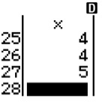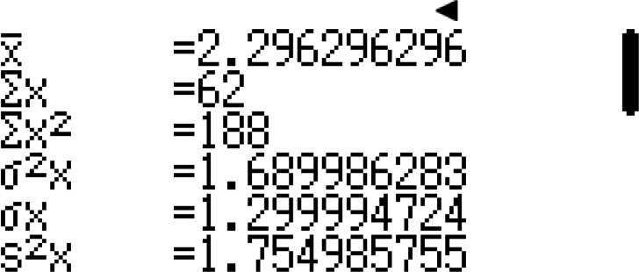
In the column, key in all 27 values.
The mean is given as 2.30 (to 3 s.f.)
Press T3 to select “1-Variable Calc” and you will see this page.
You should NOT leave out the 3
zeros at the top for the ClassWiz
step. It will affect the denominator
of the mean.
ClassWiz steps
Finding the mean using ClassWiz:
Press w6 for Statistics function and 1 for 1-Variable.
Press L and press R. Press 3 for Statistics. Next, press 2
to switch off the frequency. You should see only 1 column.

Casio ClassWiz Mathematics Workbook

Worked Example 8
TEACHER’SGUIDE
The table shows the number of overseas trips made by a group of adults in a year.

No. of overseas trips | 0 | 1 | 2 | 3 | 4
No. of adults | 9x | 34 | 57 | 11x – 1 | 10

- Given that there are 140 adults in the group, calculate the value of x.
- State the median number of overseas trips.
- Calculate the mean number of overseas trips and the standard deviation.

Solution
- 9x + 34 + 57 + 11x – 1 + 10 = 140
20x = 40
x = 2
- As there are 140 adults, the median is the mean value of position 70 and 71. Both position 70 and 71 have the value of 2.
Median = 2
- Mean = $\frac{ 0(18) + 1(34) + 2(57) + 3(21) + 4(10) }{140}$
= $\frac{251}{140}$
= $1\frac{111}{140}$
= 1.79

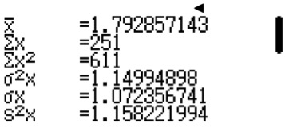
ClassWiz steps
Finding the mean and standard deviation using ClassWiz: Press w6 for Statistics function and 1 for 1-Variable.
Press L and press R. Press 3 for Statistics. Next, press 1
to switch on the frequency.
For the column in x, key in the number of overseas trips.
Next, move on to the top of the frequency column by pressing
$R and fill in the frequency (No. of adults).
Press T3 to select “1-Variable Calc” and you will see this page.

The mean is given by $\overline{x}$ = 1.79 (3 s.f.) and standard deviation is given by σx = 1.07 (3 s.f.)

Unit 9 Statistics

Worked Example 9
TEACHER’S GUIDE
The table shows the weight, in kg, of a group of students.

Weight (x) | 30 < x ≤ 40 | 40 < x ≤ 50 | 50 < x ≤ 60 | 60 < x ≤ 70 | 70 < x ≤ 80
No. of students | 3 | 15 | 27 | y | 11

- Given that the modal weight is 50 < x ≤ 60, find the largest possible value of y.
- Given that the median weight is 50 < x ≤ 60, find the largest possible value of y.
- Given that there are 80 students altogether, find the value of y. Hence, find the mean weight and the
standard deviation.

Solution
- y = 26
- To have the largest possible value of y, let the median value be the last of the 27 students.
26 because the last of the 27
values is taken to be the median.
Hence, 3 + 15 + 26 = y + 11.
y = 33

- y = 80 – 3 – 15 – 27 – 11 = 24
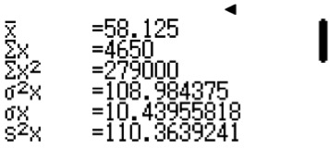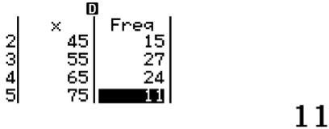
ClassWiz steps
Finding the mean and standard deviation using ClassWiz steps: Press w6 for Statistics function and 1 for 1-Variable.
Press L and press R. Press 3 for Statistics. Next, press 1 to switch on the frequency. You should see 2 columns.
In the first column, key in weight of the students. As this is grouped data, take the mean of the range. i.e. For 30 < x ≤ 40, we take x to be 35.
In the second column, key in the frequency. You should see this.

Press T3 to select “1-Variable Calc” and you will see this page.

The mean is given as 58.1kg (to 3 s.f.) and standard deviation is 10.4 kg.

Casio ClassWiz Mathematics Workbook
TEACHER’S GUIDE

Worked Example 10
The set of data shows the Spanish test score of 12 students.
43, 45, 45, 48, 54, 57, 58, 62, 63, 67, 67, 70
Find the
- Range.
- Median.
- Upper quartile.
- Lower quartile.
- Interquartile range.
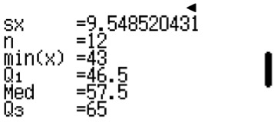
ClassWiz steps
Finding the median and interquartile range using ClassWiz steps:
Press w6 for Statistics function and 1 for 1-Variable. Press L and press R. Press 3 for Statistics. Next, press
2 to switch off the frequency. You should see 1 column.
Key in all the 12 values.
Press T3 to select “1-Variable Calc” and press R and you will see this page.

Press R and you will see this page.

Solution
- Range = max(x) – min(x) = 70 – 43 = 27
- Median = 57.5
- Upper quartile = Q3 = 65
- Lower quartile = Q1 = 46.5
- Interquartile range = Q3 – Q1 = 65 – 46.5 = 18.5

Unit 9 Statistics

Worked Example 11
TEACHER’S GUIDE
The box plot shows the score of a Chemistry test by a class of students.
20
30
40
50
60
70
80

- Find the
  - Range.
  - Median.
  - Interquartile range.
- Given that Jim scored 56 marks, state which quartile he is in.

Solution
- (i) Range = 82 – 22 = 60
- Median = 53
- Interquartile range = 62 – 48 = 14
- Jim is in the third quartile.

Casio ClassWiz Mathematics Workbook
CLASSWIZ WORKSHEETS

CLASSWIZ WORKSHEET
Level 1 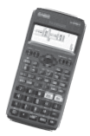
- The pictogram shows the total pizzas sold in a day by a store for the given flavours.

Hawaiian | 
Four Cheese | 
BBQ Chicken
Seafood | 
Each represents 8 pizzas.
  - Calculate the total pizzas sold.

  - State the flavour that is the most popular and express it as a percentage of all pizzas sold.

  - Find the ratio of Hawaiian pizza to Four Cheese pizza sold.

- The pictogram shows the total donuts sold by a store for the given flavours.

Oreo | 
Strawberry | 
Glazed
Chocolate
Pistachio
Each represents 40 donuts.
  - Calculate the total donuts sold by the store.

  - State the flavour that is the most popular and express it as a percentage of all pizzas sold.

  - Find the ratio of Pistachio donuts to Glazed donuts sold.

  - Calculate how many more chocolate donuts than strawberry donuts were sold.

Unit 9 Statistics

- The pictogram shows the total cars sold in a month for their given colours.
CLASSWIZ WORKSHEETS
Black
Blue | 
Red | 
Silver | 
Each represents x cars.
  - State the most popular colour.

  - Given that 125 blue cars are sold in the month, find the value of x.

  - Find the ratio of black cars to blue cars sold.

  - Calculate how many more red cars were sold than blue cars.

- The pictogram shows the number of ebi burger sold by a restaurant from Monday to Friday.

Mon
Tue
Wed
Thu
Fri

Each represents 4 burgers.
  - Find the number of burgers sold on Wednesday and on Friday.

  - Find the difference in the number of burgers sold on Tuesday and Friday.

  - Express the number of burgers sold on Wednesday as a percentage of the total burgers sold.

  - Express the number of burgers sold on Thursday as a fraction of the total burgers sold.

Casio ClassWiz Mathematics Workbook
CLASSWIZ WORKSHEETS

- The pictogram shows the number of cans of soft drinks sold in a coffeeshop.

Coca-Cola
Pepsi
Root Beer
Green Tea
7-Up
Each represents k drinks.
  - Given that there are 36 more cans of Pepsi sold than Root Beer, find the value of k.

  - State the drink that is the most popular and express it as a percentage of all soft drinks sold.

  - Given that each can of soft drinks costs $1.70, calculate the total revenue received from the sales of
the soft drinks.

- The table shows the number of bread loaves sold by a bread factory over a week.

Day | Mon | Tue | Wed | Thu | Fri | Sat | Sun
No. of bread loaves sold | 180 | 220 | 200 | 240 | 260 | 280 | 300
  - Calculate the total number of bread loaves sold in the week.

  - State the day that sold the least number of bread loaves and express it as a percentage of the total number of bread loaves sold.

  - Complete the pictogram using the values given in the table.

Mon | 
Tue
Wed
Thu
Fri
Sat
Sun
Each represents 40 bread loaves.

Unit 9 Statistics

- The pictogram shows the number of eggs laid by the hens on a farm in 4 weeks.
CLASSWIZ WORKSHEETS

Week | 1 | 2 | 3 | 4
No. of eggs laid | 34 | 30 | 40 | 32
  - Calculate the total number of eggs laid by the hens in 4 weeks.

  - State the week that has the most eggs laid and express it as a percentage of the total number of
eggs.

  - Complete the pictogram using the values given in the table.

Week 1
Week 2
Week 3
Week 4
Each represents 4 eggs.

ClassWiz steps
Finding the mean and median and standard deviation using ClassWiz: For frequency tables
Press w6 for Statistics function and 1 for 1-Variable.
Press L and press R. Press 3 for Statistics. Next, press 1 to switch on the frequency.
For the column in x, key in the number of items pertaining to the question.
Next, move on to the top of the frequency column by pressing $R and fill in the frequency.
Press T3 to select “1-Variable Calc” and the calculator will display the useful information
such as mean, standard deviation, median, range (Max – min) and interquartile range (Q3 – Q1)

- The bar graph shows the number of books read by each student in a class in a particular month.
No. of students
3
4
6
8 8
7
6
5
4
3
2 2
1 1

0 0 1

2 3 4 5

Number of books

Casio ClassWiz Mathematics Workbook

  - Find the total number of students in the class.

  - Calculate the total number of books read.

  - Calculate the mean number of books read by each student in the class.

  - Find the median number of books read.

  - Calculate the percentage of students who read more than 3 books.

- The bar graph shows the survey results for the favourite sport of each student in a class.
No. of students 12
11
10
9
8
7
6
5
4
3
2
1

Soccer Basketball Netball Tennis Volleyball
CLASSWIZ WORKSHEETS
  - Find the total number of students in the class.

  - Calculate the percentage of students who did not choose volleyball and soccer.

  - Find the fraction of students who chose basketball.

Unit 9 Statistics

- The bar graph shows the ages of the students in a sports club.
CLASSWIZ WORKSHEETS
No. of students 9
8
7
6
5
4
3
2
1

0 10

11 12 13

14 15

Age (years)
  - Find the total number of students in the sports club.

  - Given that students who are older than 13 years old are seniors. Calculate the percentage of students who are seniors in the sports club.

  - Find the modal age of the students.

  - Find the mean age of the students.

  - Find the median age of the students.

- The bar graph shows the number of children in each family living in a particular district.
No. of families

6
5
4
3
2
1

0 0 1 2 3 4
No. of children
  - Find the total number of families living in the district.

Casio ClassWiz Mathematics Workbook

  - Calculate the total number of children living in the district.

  - Find the modal number of children in each family.

  - Find the mean number of children in each family.

  - Find the median number of children in each family.

ClassWiz steps
Finding the mean and median and standard deviation using ClassWiz steps: (For individual data points)
Press w6 for Statistics function and 1 for 1-Variable.
Press L and press R. Press 3 for Statistics. Next, press 2 to switch off the frequency. You should see only 1 column. In the column, key in all given values.
Press T3 to select “1-Variable Calc” and the calculator will display the useful information such as mean, standard deviation, median, range (Max – min) and interquartile range (Q3 – Q1)

- A class of 15 students sat for a short quiz. Their marks are as shown.
5
6
7
6
4
4
6
7
5
8
7
6
7
5
6

  - On the axes given, draw a bar graph to represent the information above.
No. of students

5
4
3
2
1

0 4
CLASSWIZ WORKSHEETS

  - State the modal score.

  - State the median score.
5 6 7 8
Score

Unit 9 Statistics

  - Calculate the mean score.
CLASSWIZ WORKSHEETS

  - Given that everyone passed the short quiz and the passing score is 50%, find the maximum score possible for the quiz.

  - Calculate the percentage of students who scored full marks for the test.

  - Calculate the percentage of students who scored below 75%.

- The set of data shows the number of plastic bags used per day by each individual.

0 | 7 | 3 | 5 | 6 | 3 | 5
2 | 3 | 5 | 0 | 0 | 4 | 1
7 | 3 | 6 | 8 | 5 | 3 | 6
1 | 5 | 2 | 1 | 0 | 4 | 2
  - On the axes given, draw a bar graph to represent the information above.

Frequency 5
4
3
2
1

0 0 1 2 3 4 5 6 7 8
No. of plastic bags

  - State the modal number of plastic bags used per day.

  - State the median number of plastic bags used per day.

  - Calculate the mean number of plastic bags used per day.

  - Calculate the percentage of people who used more than 5 plastic bags per day.

Casio ClassWiz Mathematics Workbook

- The speeds of the vehicles on a particular highway are recorded by the speed camera. The speeds in km/h of 30 vehicles rounded off to the nearest tens are given in the set of data.

90 | 110 | 100 | 90 | 90 | 90 | 100 | 120 | 100 | 80
90 | 100 | 110 | 120 | 120 | 100 | 100 | 90 | 90 | 80
100 | 110 | 100 | 90 | 80 | 120 | 110 | 100 | 90 | 80
  - On the axes given, draw a bar graph to represent the information above.
No. of cars

9
8
7
6
5
4
3
2
1

80 90

100

110

120

  - State the modal speed.

  - State the median speed.

  - Calculate the mean speed.
Speed (km/h)

CLASSWIZ WORKSHEETS

  - Given that people driving over 100km/h are speeding, calculate the percentage of drivers who sped along that particular highway.

- The pie chart shows the monthly expenditure of Eric.

Bills
Food
120°
Insurance
Entertainment

Unit 9 Statistics

  - Given that his total monthly expenditure is $1800, calculate the amount of money he spends on food.
CLASSWIZ WORKSHEETS

  - Given that he spends the same amount on entertainment as food, calculate how much money he spends on insurance monthly.

  - Given that his total income is $4000, calculate the amount of money Eric saves monthly.

- A survey was conducted on the students’ favourite colour and the results are shown in the pie chart.
Black
15°
Green
Pink
35°
White x
100°
Red
x
Orange
55°
Blue

  - Given that there are 120 students whose favourite colour is black, find the number of students whose favourite colour is red.

  - Given that the number of students who chose green is the same as pink, find the value of x.

  - Find the total number of students who took this survey.

  - Calculate the percentage of students whose favourite colour is green or blue.

  - Find the ratio of students whose favourite colour is pink to orange.

Casio ClassWiz Mathematics Workbook
CLASSWIZ WORKSHEETS

- The pie chart shows the sports played by students during their physical education lessons.


Hockey
Football
80°
6x
5x
60°
Volleyball
Badminton

  - State the sport that has the largest percentage.

  - Find the value of x.

  - Given that there are 10 students playing volleyball, find the number of students playing badminton.

- The pie chart shows the transport taken by students to school.
Train
Walk Cycle
Bus
130°
Car

  - State the transport most commonly taken by students.

  - Calculate the number of students coming to school by bus, given that the total number of students surveyed is 1440.

It is given that the number of students taking train, walking and cycling is equal to the number of students taking bus. The ratio of students coming to school by train, walking and cycling are 14 : 7 : 5.
  - Calculate the number of students taking train.

  - Calculate the maximum number of cars that the school should expect to receive in the morning.

Unit 9 Statistics

- A fair 6-sided die was thrown 90 times and the outcome was recorded in a frequency table.
CLASSWIZ WORKSHEETS

Outcome | 1 | 2 | 3 | 4 | 5 | 6
Frequency | 13 | 16 | 15 | 18 | 12 | 16
  - Find the modal score.

  - Find the mean score.

  - Find the angle of the sector in the pie chart for the score of 6.

  - Hence, complete the pie chart to illustrate the data in the table.

- During an archery competition, the score of all the competitors are recorded in the frequency table. There are 4 rings on the archery board. The scores for landing the bow on the rings are as written on the archery board.
0
1
4
6
8
10

Outcome | Out of target | First ring (outermost) | Second Ring | Third Ring | Fourth Ring (innermost) | Bullseye
Score | 0 | 1 | 4 | 6 | 8 | 10
Frequency | 10 | 25 | 32 | 36 | 12 | 5

  - Find the modal score.

  - Find the mean score.

Casio ClassWiz Mathematics Workbook
CLASSWIZ WORKSHEETS

  - Find the median score.

  - Find the total number of arrows shot for the whole competition.

  - Calculate the angle of the sector in the pie chart for the score of 8.

  - Hence, complete the pie chart to illustrate the data in the table.

- The number of hours spent on the internet in a day by each student was recorded in a frequency table.

Number of hours | 0 | 1 | 2 | 3 | 4 | 5 | 6
Frequency | 20 | 88 | 158 | 202 | 140 | 72 | 40

  - Find the modal number of hours.

  - Find the mean number of hours.

  - Find the angle of the sector in the pie chart for students who spent 2 hours on the internet in a day.

Unit 9 Statistics

- The line graph shows the temperature recorded at 1 p.m. every day for 7 days.
CLASSWIZ WORKSHEETS
Temperature (°C)
30
20
10
0
1 2
3 4
Day
5 6 7

  - State the day that is the
    - Coolest.
    - Hottest.

  - Given that a temperature of 28°C is considered warm for the current season, find the percentage of the days that are warm.

Casio ClassWiz Mathematics Workbook
CLASSWIZ WORKSHEETS

- The line graph shows the number of cheese tarts sold every day for a week.
No of cheese tarts sold
100
80
60
40
20
Mon Tue Wed Thu Fri Sat Sun Day

  - State the number of cheese tarts sold
    - On Thursday.
    - In the whole week.

  - Calculate how many more cheese tarts were sold on Sunday than on Tuesday.

Unit 9 Statistics

- The line graph shows the temperature recorded at 3 p.m. every day for a period of 20 days.
CLASSWIZ WORKSHEETS
No. of days
6
4
2
0
18 19 20 21 22 23 24 25
Temperature (°C)

  - State the temperature that is the
    - Coolest.
    - Hottest.

  - State the
    - Modal temperature.
    - Median temperature.
    - Mean temperature.

  - Calculate the percentage of the days that are warmer than 22°C.

Casio ClassWiz Mathematics Workbook
CLASSWIZ WORKSHEETS

- The line graph shows the number of movie tickets sold at the cinema every day for a week.
No of tickets sold
1000
900
800
700
600
500
Mon Tue Wed Thu Fri Sat Sun Day

  - State the day(s) that has the
    - Most number of tickets sold.
    - Least number of tickets sold.

  - State the
    - Modal number of tickets sold.
    - Mean number of tickets sold.

Unit 9 Statistics

- The line graph shows the average pricing of petrol per litre in the first 6 months of 2017.
CLASSWIZ WORKSHEETS
Price of Petrol per litre ($)

3.00
2.50
2.00
1.50
1.00
Jan
Feb
Mar
Month
Apr
May
June

  - State the month that has
    - The highest price of petrol.
    - The lowest price of petrol.

  - Calculate the percentage decrease of the price of petrol from March to April.

  - On one of these months, Jonathan spent $50 on 20 litres of petrol. Find the month that Jonathan made this transaction.

  - Sandy took a road trip in May and drove 180 km. Given that her car can travel 9 km with a litre of petrol, calculate the total amount she needs to spend on petrol.

Casio ClassWiz Mathematics Workbook
CLASSWIZ WORKSHEETS

- The daily allowance, in dollars, of x students are given in the set of data.
3
10
5
6
8
9
6
7
10 3
5 3
8
8
4
6
5
4
7
8
  - On the axes given, draw a line graph to represent the information above.
No. of students

5
4
3
2
1
0
3
4
5
6
7
8
9
10
Daily Allowance ($)

  - Find the value of x.

  - State the modal daily allowance.

  - State the median daily allowance.

  - Calculate the mean daily allowance.

Unit 9 Statistics

- The scores of a math quiz by x students are recorded in the set of data. The passing rate is 50%.
CLASSWIZ WORKSHEETS
9 8 11 12 10 11 13 15 8 8
10 13 12 14 15 9 10 12 12 13

  - On the axes given, draw a line graph to represent the information above.
No. of students

5
4
3
2
1
0
8
9
10
11
Score
12
13
14
15

  - Find the value of x.

  - State the modal score.

  - State the median score.

  - Calculate the mean score.

  - Find the score of the quiz, given that
    - Nobody scored full marks and everybody passed the quiz.
    - There are 5 failures.

Casio ClassWiz Mathematics Workbook
CLASSWIZ WORKSHEETS

- The dot diagram shows the hourly wages of all the part timers in a company.

4 5 6 7 8 9 10 11
Hourly wages ($)
  - Calculate the total number of part timers in the company.

  - State the highest hourly wage.

  - State the modal hourly wage.

  - State the median hourly wage.

  - Calculate the mean hourly wage.

- The dot diagram shows the number of cars owned by each household living along a particular road.

0 1 2 3 4 5
No. of cars
  - Calculate the total number of households living along the particular road.

  - State the highest number of cars owned by a household.

  - State the modal number of cars.

Unit 9 Statistics

- The dot diagram shows the number of goals scored by a football team in all their matches in August.
CLASSWIZ WORKSHEETS

0 1 2 3 4 5 6
No. of goods

  - Calculate the total number of matches the football team had in August.

  - State the highest number of goals scored by the team.

  - State the modal number of goals.

- The dot diagram shows the number of latecomers on a particular school day, and their total number of times late in the school year, inclusive of the particular school day, were noted in the dot diagram.

1 2 3 4 5 6 7
No. of times late
  - Calculate the total number of latecomers on that particular school day.

  - Calculate the mean number of times each student was late for in the school year.

- The dot diagram shows the age of all the children in a childcare centre.

0 1 2 3 4
Age of children

  - Calculate the total number of children in the childcare centre.

  - State the modal age of the children.

  - State the age of the oldest child.

Casio ClassWiz Mathematics Workbook

- The data shows the number of pens found in each student’s pencil case in a class.
6
7
9
6
4
3
6
4
8
8
7 7
15 6
5
6
6
8
4
6
  - On the axes given, draw a dot diagram to represent the information above.

3 4 5 6 7 8 9 10 11 12 13 14 15
No. of pens

  - State the total number of students in the class.

  - State the modal number of pens.

  - Calculate the mean number of pens.

- The number of mistakes made by each student in a Science test are recorded in the set of data.
4
1
5
5
3
6
5
3
8
4
6
2
3
4
5
0
8
1
6
2

On the axes given, draw a dot diagram to represent the information above.

3 4 5 6 7 8 9 10 11 12 13 14 15
No. of mistakes
CLASSWIZ WORKSHEETS

  - State the total number of students.

  - State the modal number of mistakes.

  - State the median number of mistakes.

  - Calculate the mean number of mistakes.

Unit 9 Statistics

- The stem and leaf show the age of teachers in a school.
CLASSWIZ WORKSHEETS

Stem | Leaf
2 | 5 | 5 | 6 | 8 | 9
3 | 0 | 3 | 5
4 | 4 | 6 | 7 | 9
5 | 5 | 8
6 | 7

Key: 2|5 represents 25 years old.
  - Find the total number of teachers in the school.

  - Calculate the mean age of the teachers.

- The stem and leaf show the time taken for a team of athletes to complete a 2.4 km run.

Stem | Leaf
7 | 10 | 28 | 46
8 | 24 | 39
9 | 12 | 28 | 31 | 43 | 58
10 | 23 | 37 | 44 | 50
11 | 20 | 55

Key: 8|50 represents 8 minutes and 50 seconds.
  - Find the total number of athletes in the team.

  - Calculate the mean time taken to complete a 2.4 km run.

  - State the median time taken to complete a 2.4 km run.

  - Given athletes who took a time longer than 10 minutes and 30 seconds are considered as underperforming, find the percentage of underperformers.

Casio ClassWiz Mathematics Workbook
CLASSWIZ WORKSHEETS

- The stem and leaf diagram shows the height, in cm, of the students in the class.

Stem | Leaf
15 | 2 | 4 | 5 | 5 | 7 | 9
16 | 0 | 1 | 1 | 2 | 4 | 5 | 5 | 6 | 7 | 9 | 9
17 | 0 | 2 | 2 | 4 | 5 | 6 | 7 | 8 | 8 | 8
18 | 0 | 0 | 1
Key: 17|5 represents 175 cm.

  - Find the total number of students in the class.

  - State the modal height.

  - State the median height.

  - Calculate the mean height.

  - Given that the boys are taller than 166 cm, find the maximum number of boys.

  - Find the percentage of students shorter than 170 cm.

Unit 9 Statistics

- The stem and leaf diagram shows the mass, in kg, of the students in the class.
CLASSWIZ WORKSHEETS

Stem | Leaf
4 | 5 | 6 | 7 | 9 | 9 | 9
5 | 0 | 0 | 1 | 1 | 2 | 5 | 6 | 6 | 8 | 9 | 9
6 | 0 | 1 | 1 | 2 | 3 | 3 | 5 | 7 | 7 | 8 | 9
7 | 0 | 1 | 2 | 2 | 4 | 4 | 5 | 6 | 6 | 8 | 8
8 | 2
Key: 6|5 represents 65 kg.

  - Find the total number of students in the class.

  - State the modal weight.

  - State the median weight.

  - Calculate the mean weight.

  - Given that students heavier than 70kg need to go for weight management programme, find the percentage of the students who are required to go for this programme.

- The stem and leaf diagram shows the test scores of the students in the class.

Stem | Leaf
3 | 5 | 8
4 | 0 | 1 | 3 | 5 | 5 | 7 | 8 | 9 | 9
5 | 0 | 2 | 2 | 3 | 4 | 5 | 5 | 7 | 8 | 8 | 8
6 | 0 | 3 | 4 | 7 | 8
7 | 0 | 0 | 2 | 7
8 | 2
Key: 5|8 represents 58 marks.
  - Find the total number of students in the class.

  - State the modal score.

  - State the median score.

  - Given that students who scored less than 50 need to go for a remedial programme, find the percentage of the students who are required to go for this programme.

Casio ClassWiz Mathematics Workbook
CLASSWIZ WORKSHEETS

- The set of data shows the scores of a class of students for their English test.

33 | 47 | 39 | 58 | 36
54 | 48 | 38 | 49 | 45
59 | 37 | 41 | 50 | 42

  - Using the data given, complete the ordered stem and leaf diagram below.
Stem Leaf

  - State the median score.

  - The rate for an A1 score is 75%. Given that the total score for this English test is 60 marks, calculate the percentage of students who obtained A1.

- The set of data shows the waiting time, in minutes, in a clinic for 12 patients.

15 | 22 | 18 | 32
25 | 28 | 30 | 21
17 | 27 | 31 | 35

  - Using the data given, complete the ordered stem and leaf diagram below.
Stem Leaf

  - State the median score.

  - Given that waiting times over 25 minutes are considered as slow service, find the percentage of slow service.

Level 2
Unit 9 Statistics

- Two classes of 15 students, Class A and Class B, took a History test and their results are shown in the back to back stem and leaf diagram.
CLASSWIZ WORKSHEETS
Leaf (A) Stem Leaf (B)
9
9
7
7
8
5
6
6
4
4
6
3
1
1
3
2
3
4
5
8
4
3
4
9
6
5
6
8
6
8
7
9
7
8

Key for Leaf (A): 9 | 2 represents 29 marks. Key for Leaf (B): 3 | 5 represents 35 marks.
  - Calculate the mean score and standard deviation for
    - Class A
    - Class B

  - State which class performed better and support your answer with reasons.

- The amount of money spent by two groups of tourists, Group 1 and Group 2, was recorded in the back to back stem and leaf diagram.
Leaf (1) Stem Leaf (2)
98af (Girls) Stem Leaf (Boys)
9
8
5
9
6
5
3
7
3
4
5
6
0
3
7
1
6
9
4
8
9
8
3
2

Key for Leaf (1): 9 | 2 represents $29.
Key for Leaf (2): 3 | 5 represents $35.
  - Calculate the mean amount of money spent and standard deviation for
    - Group 1
    - Group 2

  - State the tourist group that spent more money and support your answer with reasons.

Casio ClassWiz Mathematics Workbook
CLASSWIZ WORKSHEETS

- In a class of 15 girls and 15 boys, their heights are measured and recorded in the back-to-back stem and leaf diagram.
Leaf (Girls) Stem Leaf (Boys)
9
8
8
7
8
5
7
5
7
5
7
5
6
3
2
15
16
17
18
6
4
0
8
4
1
8
5
2
9
6
7
8
8
9

Key for Leaf (Girls): 9 | 15 represents 159 cm. Key for Leaf (Boys): 17 | 3 represents 173 cm.
  - Calculate the mean height and standard deviation for
    - Girls
    - Boys

  - State which group is taller and support your answer with reasons.

- Two classes of 15 students, Class A and Class B, took a Geography test.
Class A’s results are shown in the set of data and Class B’s results are shown in the back to back stem and leaf diagram.
Class A
77 86 58 61
70 65 82 74
69 73 78 62
Leaf (A) Stem Leaf (B)
5
6
7
8
3
1
0
2
5
3
8
7
4
8
9
9

Key for Leaf (A): 9 | 2 represents 29 marks. Key for Leaf (B): 3 | 5 represents 35 marks.
  - Complete the stem and leaf diagram.

  - Calculate the mean score and standard deviation for
    - Class A
    - Class B

  - State which class performed better and support with reasons.

Unit 9 Statistics

- Two schools participated in the zonal debate competition. Schools A and B sent 15 students each from their school for the competition.
CLASSWIZ WORKSHEETS
The score obtained by each student is recorded in the stem and leaf diagram. Class A
8 15 9 10 7
9 13 17 22 16
14 13 25 24 18

Leaf (A) Stem Leaf (B)
9 8 8 7 6 0
9 7 5 4 3 1 1 1
2 0 0 2

Key for Leaf (A): 9 | 2 represents 29 marks. Key for Leaf (B): 3 | 5 represents 35 marks.
  - Complete the stem and leaf diagram.

  - Calculate the mean score and standard deviation for
    - School A
    - School B

  - Comment on the performance of the two schools.

- The histogram shows the number of handphones owned by 40 families.
No. of families 20
18
16
14
12
10
8
6
4
2
0 1 2 3 4 5 6
No. of handphones

  - State the most common number of handphones owned by a family.

  - Calculate the mean number of handphones owned by each family.

  - Find the number of families who owned more than 4 handphones.

Casio ClassWiz Mathematics Workbook

- The histogram shows the number of books read in a month by x children.
No. of children 20
18
16
14
12
10
8
6
4
2
0 1 2 3 4 5 6 7

  - State the value of x.
No. of books

  - Calculate the mean number of books read by each child.

  - Calculate the percentage of children who read at least 4 books.

- The histogram shows the time, in minutes, spent by customers on queuing up for the noodle stall on a particular day.
No. of customers 20
18
16
14
12
10
8
6
4
2

- 1 2 3 4 5 6 7 8 9 10
Time (minutes)
CLASSWIZ WORKSHEETS

  - State the number of customers who bought from the noodle stall on that particular day.

  - Calculate the mean waiting time by each customer.

  - Calculate the percentage of customers who had to wait over 6 minutes.

Unit 9 Statistics

- The histogram shows grouped data of the amount spent on food in a month by 32 working adults.
CLASSWIZ WORKSHEETS

No. of adults 10
9
8
7
6
5
4
3
2
1

50 100 150 200 250 300 350
Amount spent on food monthly

  - State the most common amount of money spent on food.

  - Calculate the mean amount of money spent on food.

  - Find the percentage of working adults who spend between $250 to $350 on food monthly.

- The histogram shows grouped data of the number of times late by employees of a company in a particular month.

No. of employees 20
18
16
14
12
10
8
6
4
2

0 2 4 6 8 10 12 14
  - State the number of employees in this company.

  - State the most common number of times late.

  - Find the percentage of employees who are late more than 10 times in a month.

Casio ClassWiz Mathematics Workbook
CLASSWIZ WORKSHEETS

- The table shows the number of goals scored during matches by the Netball team.

No. of goals | 0 | 1 | 2 | 3 | 4
Frequency | 5 | 15 | 22 | 8 | 1
  - Draw a histogram in the given axes to represent the set of data given in the table.
Frequency
25
20
15
10
5
0
1

3
4
No. of goals
2

  - State the total number of matches played.

  - Calculate the mean number of goals scored in each match.

  - Calculate the percentage of matches which scored at least 3 goals.

Unit 9 Statistics

- The table shows the grouped data of the score of a Biology exam for the whole cohort.
CLASSWIZ WORKSHEETS

Score (x) | Number of students (frequency)
40 < x ≤ 50 | 26
50 < x ≤ 60 | 48
60 < x ≤ 70 | 27
70 < x ≤ 80 | 8
80 < x ≤ 90 | 1
  - Draw a histogram in the given axes to represent the set of data given in the table.
No. of students
50
40
30
20
10
0
40
50 60 70
Score
80 90

  - State the number of students in the cohort taking the Biology exam.

  - Given that the passing rate is a score of more than 50, calculate the percentage of passes.

  - Given that the distinction rate is a score of more than 70, calculate the percentage of distinctions.

Casio ClassWiz Mathematics Workbook
CLASSWIZ WORKSHEETS

- The table shows the number of siblings that a group of students have.

No. of siblings | 0 | 1 | 2 | 3 | 4
No. of students | 6 | 5 | 4 | 2 | 1
  - State the modal number of siblings.

  - State the median.

  - Calculate the mean and the standard deviation.

- The table shows the number of visits to the doctor made by a group of working adults in a month.

No. of visits to the doctor | 0 | 1 | 2 | 3 | 4
No. of working adults | x + 5 | 2x – 1 | 8 | 2 | 1
  - Given that there are 60 working adults in the group, calculate the value of x.

  - State the median number of visits to the doctor.

  - Calculate the mean number of visits to the doctor and the standard deviation.

- The table shows the total number of handphones that a household has.

No. of handphones | 0 | 1 | 2 | 3 | 4 | 5
No. of households | 2 | 4 | 6 | k | 13 | 7
  - Given that the mean is 3.2, find the value of k.

  - State the modal number of handphones in a household.

  - State the median number of handphones in a household.

Unit 9 Statistics

- The table shows the number of books borrowed by some students from the school library.
CLASSWIZ WORKSHEETS

No. of books borrowed | 0 | 1 | 2 | 3 | 4
No. of students | 29 | 27 | p | 18 | 15
  - Given that the mode is 2, find the largest possible value of p.

  - Given that the median is 2, find the smallest possible value of p.

  - Given that there are 100 students altogether, find the value of p. Hence, find the mean number of books borrowed per student and the standard deviation.

- The table shows the number of dresses bought by ladies browsing a store. There were at least 50 ladies who entered the store.

No. of dresses bought | 0 | 1 | 2 | 3 | 4
No. of ladies | 18 | 16 | a | 5 | 2
  - Given that the mode is 0, find the largest possible value of a.

  - Given that the median is 1, find the smallest possible value of a.

  - Given that there were at least 60 ladies who entered the store, find the modal number of dresses and the smallest possible value of a.

- The table shows the range of monthly salary for a group of bankers.

Monthly salary (x) | 2000 < x ≤  3000 | 3000 < x ≤  4000 | 4000 < x ≤  5000 | 5000 < x ≤  6000 | 6000 < x ≤  7000
No. of bankers | 11 | 35 | 45 | 34 | 27
  - State the modal monthly salary.

  - State the median monthly salary.

  - Calculate the mean monthly salary and the standard deviation.

Casio ClassWiz Mathematics Workbook
CLASSWIZ WORKSHEETS

- The table shows the number of hours spent on gaming in a day for a group of teenagers.

No. of hours (x) | 0 < x ≤ 2 | 2 < x ≤ 4 | 4 < x ≤ 6 | 6 < x ≤ 8
No. of teenagers | 5 | 26 | 21 | 10
  - State the modal number of hours.

  - State the median number of hours.

  - Calculate the mean number of hours and the standard deviation.

  - Given that teenagers who spend more than 6 hours on gaming in a day are considered addicted to gaming, find the percentage of teenagers who are addicted to gaming.

- The table shows the speed in km/h of 120 vehicles driving along a road on an evening.

Speed (x) | 50 < x ≤ 60 | 60 < x ≤ 70 | 70 < x ≤ 80 | 90 < x ≤ 100 | 100 < x ≤ 110
No. of vehicles | 16 | 25 | b | 28 | 11
  - Find the value of b.

  - State the modal speed.

  - State the median speed.

  - Calculate the mean speed and the standard deviation.

  - Given that vehicles travelling over 90 km/h are speeding, find the fraction of the vehicles who are speeding.

Unit 9 Statistics

- The table shows the score of some students taking an appeal entry test.
CLASSWIZ WORKSHEETS

Score (x) | 30 < x ≤ 40 | 40 < x ≤ 50 | 50 < x ≤ 60 | 60 < x ≤ 70 | 70 < x ≤ 80
No. of students | 7 | 18 | 28 | p | 13
  - Given that the modal score is 60 <x ≤ 70, find the smallest possible value of p.

  - Given that the median score is 50 <x ≤ 60, find the largest possible value of p.

  - Given that there are 100 students altogether, find the value of p. Hence, find the mean score and the standard deviation.

- The table shows the number of hours spent at work by a group of teachers.

No. of hours (x) | 7 < x ≤ 8 | 8 < x ≤ 9 | 9 < x ≤ 10 | 10 < x ≤ 11 | 11 < x ≤ 12
No. of teachers | 11 | 23 | y | 29 | 15
  - Given that the modal number of hours is 10 < x ≤ 11, find the largest possible value of y.

  - Given that the median number of hours is 9 < x ≤ 10, find the smallest possible value of y.

  - Given that there are 113 teachers altogether, find the value of y. Hence, find the mean number of hours and the standard deviation.

- The set of data shows the Mathematics test score of 9 students.
54, 58, 60, 60, 62, 68, 70, 71, 79
Find the
  - Range

  - Median

  - Upper quartile

  - Lower quartile

  - Interquartile range

Casio ClassWiz Mathematics Workbook
CLASSWIZ WORKSHEETS

- The set of data shows the Science test score of 10 students.
34, 47, 47, 53, 55, 59, 64, 65, 74, 81
Find the
  - Range

  - Median

  - Upper quartile

  - Lower quartile

  - Interquartile range

- The box plot shows the score of a mathematics test by a class of students.
0
20
40
60
80
100
Score of Mathematics test

  - Find the
    - Range
    - Median
    - Interquartile range

  - Given that Jennifer is the only student who scored 56 marks, state her percentile in the class.

  - Given that Jennifer is ranked number 18th, find the total number of students in the class.

Unit 9 Statistics

- The set of data shows the number of hours spent on their handphone by a group of teenagers.
CLASSWIZ WORKSHEETS
2, 2, 2, 3, 3, 3, 4, 4, 4, 4, 4, 5, 5, 6, 8
The box plot is drawn and shown as below
2
q
r
8
No. of hours spent on handphone

p

  - Find the value of
    - p
    - q
    - r

  - Find the interquartile range.

- The set of data shows the number of hours spent on watching drama by a group of people in a day.
0, 0, 1, 1, 2, 2, 3, 3, 3, 3, 4, 4, 4, 4, 4, 4, 5, 5, 5, 6, 6, 7

  - Find the
    - Number of people in this group
    - Median
    - Interquartile range

  - Draw a box-and-whisker plot in the axes given.

0 1 2 3 4 5 6 7
No. of hours spent on watching drama

Casio ClassWiz Mathematics Workbook
CLASSWIZ WORKSHEETS

- The stem and leaf diagram show the number of sit ups completed in 1 minute by a group of athletes.

Stem | Leaf
2 | 6 | 8
3 | 7 | 9 | 9
4 | 0 | 2 | 2 | 3 | 4 | 5 | 5 | 7 | 8 | 8 | 8
5 | 1 | 3 | 5 | 5 | 7 | 8 | 9 | 9
6 | 0 | 3 | 4 | 7 | 8
7 | 0 | 0 | 2 | 7

Key: 4|8 represents 48 sit ups.

  - Find the
    - Number of people in this group
    - Median
    - Interquartile range

  - Draw a box-and-whisker plot in the axes given.
20
30
40
50
60
70
80
No. of sit-ups

  - Given that athletes who complete less than 45 sit ups are unfit, find the percentage of unfit athletes.

Level 3
Unit 9 Statistics

- The box plot given shows the score of a Physics test for a class of students.
CLASSWIZ WORKSHEETS
20
40
60
80
100
120
Score of Physics test

Amelia stated that half the cohort failed the test. Given that the passing mark is 50 marks, explain, with reasons, if Amelia’s statement is correct.

- The box plot given shows the monthly salary of a group of executives.
0
2000
4000
6000
8000
Monthly Salary
10000
12000
14000

  - Find the
    - Range
    - Interquartile range

  - State and explain one disadvantage of using only the range, without the interquartile range, for analysis of data.

Casio ClassWiz Mathematics Workbook
CLASSWIZ WORKSHEETS

- The box plot given shows the Economics exam scores of 2 classes of students.
Class A:

Class B:
20
30
40
50
60
70
80
90
Economics exam scores

  - Find, for both classes, the
    - Range
    - Interquartile range

  - State the class that has a greater spread and explain your answer.

  - Kylie stated that if both classes are merged and a student is randomly selected, the probability of selecting a student who scored at most 60 marks is at least $\frac{1}{4}$. Explain, with reasons, whether you agree with Kylie.

- The table shows the number of hours of sleep on a weekday by a group of students in a school.

No. of hours (x) | 1 < x ≤ 3 | 3 < x ≤ 5 | 5 < x ≤ 7 | 7 < x ≤ 9 | 9 < x ≤ 12
No. of students | 25 | 78 | 45 | 21 | 5
  - Find the
    - Mean
    - Standard deviation

  - Explain
    - One advantage of using grouped data
    - One disadvantage of using grouped data

Unit 9 Statistics

- The pictogram shows some ice cream flavours that are sold in the store.
CLASSWIZ WORKSHEETS

Chocolate | 
Cookies & Cream | 
Strawberry
Vanilla
Hazelnut

Each represents 6 ice creams.
  - Suggest another type of diagram that will be useful to represent the data in the pictogram. Give reasons for your suggestion.

  - Suggest a type of diagram that will not be useful to represent the data in the pictogram. Give reasons for your suggestion.

- Two classes of 15 students, Class A and Class B, took an Accounting test and their results are shown in the back to back stem and leaf diagram.
Leaf (A) Stem Leaf (B)
8 5 4 4 3 2 9
9 9 6 5 4 1 3 1 5 7 7 8 9
7 5 4 4 1 3 3 5 7 7
1 5 3 3

Key for Leaf (A): 9 | 2 represents 29 marks. Key for Leaf (B): 3 | 5 represents 35 marks.
  - Calculate the median score and interquartile range for
    - Class A
    - Class B

Casio ClassWiz Mathematics Workbook
CLASSWIZ WORKSHEETS

  - Draw box-and-whisker plot for both Class A and B. By comparing the box-and-whisker plot, state which class performed better and support with reasons.
Class A:

Class B:
20
30
40
50
Score for Accounting test

  - State an advantage of using box plot over stem and leaf diagram.

  - State a disadvantage of using box plot over stem and leaf diagram.

- The stem and leaf diagram shows the number of push ups completed in 1 minute by a group of athletes.

Stem | Leaf
1 | 0 | 4 | 5 | 6 | 9 | 9
2 | 1 | 2 | 2 | 4 | 4 | 7 | 7 | 7 | 8 | 9
3 | 0 | 2 | 3 | 6 | 7 | 9
4 | 0 | 2 | 5
Key: 4|1 represents 41 push ups.
  - Find the
    - Mean
    - Standard deviation

It is given that the number of push ups completed in 1 minute by another group of athletes has the following mean score and standard deviation.
Mean = 32.1
Standard Deviation = 5.9
  - Compare the data and explain, with reasons, which group of athletes are fitter.

Unit 9 Statistics

- The table shows the score of a National Mathematics examination by a level cohort of students in School A.
CLASSWIZ WORKSHEETS

Score (x) | 30 < x ≤ 40 | 40 < x ≤ 50 | 50 < x ≤ 60 | 60 < x ≤ 70 | 70 < x ≤ 80 | 80 < x ≤ 90 | 90 < x ≤ 100
No. of students | 2 | 4 | 35 | 87 | 65 | 23 | 10
  - Find the
    - Mean
    - Standard deviation

It is given the score of the same National Mathematics examination by a level cohort of students in School B has the following mean score and standard deviation.
Mean = 64.8
Standard Deviation = 12.5
  - Compare the data and explain, with reasons, which school performed better at the National Mathematics examination.

- The table shows the number of hours in a week spent on training for a swimming competition by Swimming club A.

No. of hours (x) | 0 < x ≤ 3 | 3 < x ≤ 6 | 6 < x ≤ 9 | 9 < x ≤ 12 | 12 < x ≤ 15
No. of swimmers | 10 | 8 | 20 | 13 | 5
  - Find the
    - Mean
    - Standard deviation

Another set of data is gathered on the number of hours in a week spent on training for a swimming competition by Swimming club B. The mean and standard deviation are as follows:
Mean = 7.0
Standard Deviation = 2.8
During a competition, Swimming club A produced 2 winners and Swimming club B produced 6 winners.
  - Compare the data and comment on the effectiveness of the training in both swimming clubs.

Level 4
Casio ClassWiz Mathematics Workbook

CLASSWIZ WORKSHEETS
- The sum of the ages of 5 friends is 144 and the sum of the squares of their ages is 4244.
  - Find the mean age of the friends.

  - Calculate the standard deviation of the friends.

- Two sets of data information for 10 numbers and 20 numbers are given in the boxes.
A set of 10 numbers has Mean = 7.2
Standard deviation of 3.09
A set of 20 numbers has Mean = 12.4
Standard deviation of 10.16

Find,
  - The mean of all 30 numbers.
  - The standard deviation of all 30 numbers.

Unit 9 Statistics

SOLUTIONS
TEACHER’S GUIDE

Level 1

- (a) Total pizzas sold = (5.5 + 3 + 6.25 + 3.75) × 8 = 148
- BBQ chicken is the most popular.
$\frac{(6.25 × 8)}{148}$ × 100% = 33.8% (1 dp) or $33\frac{29}{37}$
- Hawaiian pizza : Four Cheese pizza = 5.5 : 3 = 11 : 6
Just counting the number of symbols would do as ratio is a proportion.

- (a) Total donuts sold by the store = (7 + 3.75 + 5.5 + 6 + 3.25) × 40 = 1020
- Oreo is the most popular flavor.
$\frac{7(40)}{1020}$ × 100% = 27.5% (1 dp) or $27\frac{23}{51}$
- Pistachio donuts : Glazed donuts = 3.25 : 5.5 = 13 : 22
- (6 – 3.75)(40) = 90 more chocolate donuts than strawberry donuts were sold.

- (a) The most popular colour is red.
(b) $\frac{125}{2.5}$ = x
x = 50
- Black cars : Blue cars = 4 : 2.5 = 8 : 5
- (4.5 – 2.5)(50) = 100 more red cars were sold than blue cars.

- (a) 4.25(4) = 17 burgers were sold on Wednesday.
6.5(4) = 26 burgers were sold on Friday.
(b) (6.5 – 3.5)(4) = 12
The difference in the number of burgers sold on Tuesday and Friday is 12. (c) Total burgers sold = (4.75 + 3.5 + 4.25 + 4 + 6.5)(4) = 92
Percentage of burgers sold on Wednesday = $\frac{17}{92}$ × 100% = 18.5% (1 dp) or $18\frac{11}{23}$
(d) Number of burgers sold on Thursday as a fraction of the total burgers sold = $\frac{4(4)}{92}$ = $\frac{4}{23}$

5. (a) (9 – 6)(k) = 36
k = 12
(b) Coca Cola is the most popular.
Total number of drinks = (11.5 + 9 + 6 + 8 + 6.5)(12) = 492
Percentage of Coca Cola = $\frac{11.5(12)}{492}$ × 100% = 28.0% (1 dp) or 28$\frac{2}{41}$
(c) 492 × $1.70 = $836.40.
The total revenue received from the sales of the soft drinks is $836.40.

Casio ClassWiz Mathematics Workbook

- (a) Total number of bread loaves sold in the week = 1680
(b) Monday has the least number of bread loaves sold.
$\frac{180}{1680}$ × 100% = 10.7% or $10\frac{5}{7}$
(c)
Mon | 
Tue | 
Wed | 
Thu
Fri
Sat | 
Sun | 

- (a) Total number of eggs laid = 34 + 30 + 40 + 32 = 136
- Week 3 that has the most eggs laid.
Percentage = $\frac{40}{136}$ × 100% = 29.4% (1 dp) or $29\frac{7}{17}$
(c)
Week 1
Week 2
Week 3
Week 4

- (a) Total number of students in the class = 4 + 3 + 6 + 8 + 2 + 1 = 24
(b) Total number of books read = 0(4) + 1(3) + 2(6) + 3(8) + 4(2) + 5(1) = 52
- Mean number of books read by each student in the class = $\frac{52}{24}$ = $2\frac{1}{6}$
The 12th and 13th position both have a value of 2

- Median number of books read = 2
TEACHER’S GUIDE

- Percentage of students who read more than 3 books = $\frac{3}{52}$ × 100% = 5.8% (1 dp) or $5\frac{10}{13}$

- (a) Total number of students in the class = 7 + 12 + 4 + 8 + 7 = 38
- Percentage of students who did not choose volleyball and soccer = $\frac{24}{38}$ × 100% = 63.2% or $63\frac{3}{19}$
- Fraction of students who chose basketball = $\frac{12}{38}$ = $\frac{6}{19}$

Unit 9 Statistics

- (a) Total number of students in the sports club = 4 + 7 + 6 + 9 + 8 + 5 = 39
TEACHER’S GUIDE
- Percentage of students who are seniors in the sports club = $\frac{13}{39}$ × 100% = 33.3% or $33\frac{1}{2}$

- Modal age of the students = 13
(d) Mean age of the students = $\frac{[10(4) + 11(7) + 12(6) + 13(9) + 14(8) + 15(5)]}{39}$
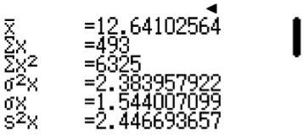= $\frac{493}{39}$

Finding the mean and median using ClassWiz:
Press w6 for Statistics function and 1 for 1-Variable.
Press L and press R. Press 3 for Statistics. Next, press 1 to switch on the frequency.
For the column in x, key in the age.
Next, move on to the top of the frequency column by pressing $R and fill in the frequency of students.
Press T3 to select “1-Variable Calc” and you will see this page.

The mean is given by 12.6 (3 s.f.)
ClassWiz steps
= $12\frac{25}{39}$

(e) 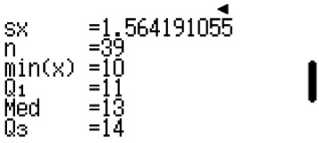Median age of the students = 13
ClassWiz steps
Press R and you will see this page.

- (a) Total number of families living in the district = 5 + 6 + 6 + 4 + 3 = 24
- Total number of children living in the district = 0(5) + 1(6) + 2(6) + 3(4) + 4(3) = 42
- Modal number of children in each family = 1 and 2
- Mean number of children in each family = $\frac{42}{24}$ = 1.75
- Median number of children in each family = 2 [[both 12th and 13th positions have the value of 2]]
- (a)
5
4
3
2
1

0 4 5 6 7 8
Score

Casio ClassWiz Mathematics Workbook

- Modal score = 6
Finding the mean and median using ClassWiz:
- Median score = 6
- 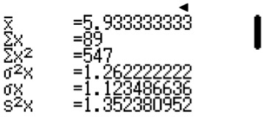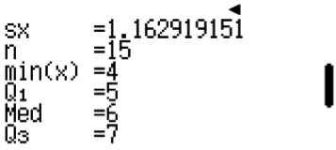Mean score = $\frac{[4(2) + 5(3) + 6(5) + 7(4) + 8(1)]}{15}$ = $\frac{89}{15}$ = $5\frac{14}{15}$
ClassWiz steps
Finding the mean and median using ClassWiz:
Press w6 for Statistics function and 1 for 1-Variable.
Press L and press R. Press 3 for Statistics. Next, press 1 to switch on the frequency.
For the column in x, key in the score.
Next, move on to the top of the frequency column by pressing $R and fill in the frequency of students.
Press T3 to select “1-Variable Calc” and you will see this page.

Mean = 5.93 (3s.f.)
Press and you will see this page.
- Maximum score possible for the quiz = 8
- Percentage of students who scored full marks for the
test = $\frac{1}{15}$ × 100% = $6\frac{2}{3}$ %
- Percentage of students who scored below 75% =
percentage of students who scored less than 6 marks
= $\frac{5}{15}$ × 100% = 33.3% or $33\frac{1}{2}$

- (a)
Frequency
No. of plastic bags
5 5 5
4 4
3 3 3 3
2 2 2
1 1

0 0 1 2 3 4 5 6 7 8
TEACHER’S GUIDE

Unit 9 Statistics

- 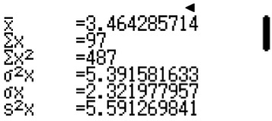Modal number of plastic bags used per day = 3 and 5
ClassWiz steps
Finding the mean and median using ClassWiz:
Press w6 for Statistics function and 1 for 1-Variable.
Press L and press R. Press 3 for Statistics. Next, press 1 to switch on the frequency.
For the column in x, key in the number of plastic bags.
Next, move on to the top of the frequency column by pressing $R and fill in the frequency of individuals.
Press T3 to select “1-Variable Calc” and you will see this page.

Mean = 3.46 (3s.f.)
Press R and you will see this page.
TEACHER’S GUIDE
- Median number of plastic bags used per day= 3[[both position 14 and 15 have the value of 3.]]
- Mean number of plastic bags used per day
= $\frac{[0(4) + 1(3) + 2(3) + 3(5) + 4(2) + 5(5) + 6(3) + 7(2) + 8(1)]}{28}$
= $3\frac{13}{28}$
- Percentage of people who used more than 5 plastic bags per day
= $\frac{6}{28}$ × 100%
= 21.4%

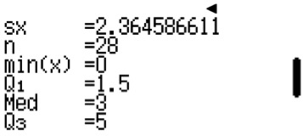

- (a)
No. of cars

9
8
7
6
5
4
3
2
1

80 90 100 110 120
Speed (km/h)

- Modal speed = 90 km/h and 100 km/h
- Median speed = 100 km/h
- Mean speed = $\frac{[80(4) + 90(9) + 100(9) + 110(4) + 120(4)]}{30}$ = 98$\frac{1}{3}$ km/h
- Percentage of drivers who sped along that particular highway = $\frac{8}{30}$ × 100% = $26\frac{2}{3}$%

- (a) Amount of money spent on food = $\frac{120°}{360°}$ × $1800 = $600
(b) Amount of money spent on insurance monthly = $\frac{(360° – 120° – 120° – 90°)}{360° × \$1800}$ × $1800 = $\frac{30°}{360°}$ × $1800 = $150
(c) Amount of money Eric saves monthly = $4000 – $1800 = $2200

Casio ClassWiz Mathematics Workbook
TEACHER’S GUIDE

- (a) 15° represents 120 students.
100° represents $\frac{100}{15}$ × 120 = 800 students whose favourite colour is red.
(b) x = $\frac{(360° – 15° – 35° – 35° – 100° – 55°)}{2}$ = 60°
- 15° represents 120 students.
360° represents $\frac{360}{15}$ × 120 = 2880 students who took this survey.
- Percentage of students whose favourite colour is green or blue = $\frac{(35° + 55°)}{360° × 100\%}$ = 25%
- Ratio of students whose favourite colour is pink to orange = 35 : 60 = 7 : 12

- (a) The sport that has the largest percentage is Hockey.
(b) 11x = 360° – 80° – 60°
x = 20°
(c) 100° represents 10 students.
60° represents $\frac{60°}{100°}$ × 10 = 6 students
Teachers may explain to students that pie charts have the advantage of seeing who has the largest sector at a glance, but only if the sector
is significantly larger. If there are 2 sectors that are comparable, then bar graphs will be much better.
- (a) The transport most commonly taken by students is bus.

(b) $\frac{130°}{360°}$ × 1440 = 520
(c) $\frac{14}{26}$ × 130° = 70°
$\frac{70°}{360°}$ 70° × 1440 = 280
The number of students taking the train is 280.
(d) $\frac{(360° – 130° – 130°)}{360°}$ × 1440 = 400 cars.
Teacher may explain to students that it’s the maximum number of cars because there might be absentees, or some students may car pool.

- (a) Modal score = 4
(b) Mean score = $\frac{[1(13) + 2(16) + 3(15) + 4(18) + 5(12) + 6(16)]}{90}$ = $3\frac{8}{15}$
(c) Angle of the sector in the pie chart for the score of 6 = $\frac{16}{90}$ × 360° = 64°
(d)
1

52°
6
2
64°
64°

48°
60°
5
3 72°
4
Teacher may explain to students the disadvantage of the pie chart when all the outcomes have fairly similar frequency. i.e. Even the largest sector is not significantly larger than the other sectors. Hence, information will be difficult to analyse at a glance.

Unit 9 Statistics

- 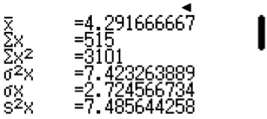(a) Modal score = 6
ClassWiz steps
Finding the mean and median using ClassWiz:
Press w6 for Statistics function and 1 for 1-Variable.
Press L and press R. Press 3 for Statistics. Next, press 1 to switch on the frequency.
For the column in x, key in the score.
Next, move on to the top of the frequency column by pressing $R and fill in the frequency.
Press T3 to select “1-Variable Calc” and you will see this page.

Mean = 4.29 (3s.f.)
Press R and you will see this page.
TEACHER’S GUIDE

- Mean score
= $\frac{[0(10) + 1(25) + 4(32) + 6(36) + 8(12) + 10(5)]}{[10 + 25 + 32 + 36 + 12 + 5]}$
= $4\frac{7}{24}$

- Median score = 4
Both positions 60 and 61 have a
score of 4.

- Total number of arrows shot for the whole competition = 120.
- Angle of the sector in the pie chart for the score of 8.
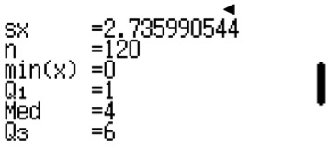

(f) 0, 10°
1
52°
2
6
20°
36°
5
79°
70°
101°
4
3

- (a) Modal number of hours = 3
- Mean number of hours = $\frac{[0(20) + 1(88) + 2(158) + 3(202) + 4(140) + 5(72) + 6(40)]}{[20 + 89 + 157 + 202 + 140 + 73 + 39]}$
= $3\frac{1}{72}$
- Angle of the sector in the pie chart for 2 hours = $\frac{158}{720}$ × 360° = 79°

Casio ClassWiz Mathematics Workbook
TEACHER’S GUIDE

For the following line graph questions, teacher can explain to students about the axes not starting from 0, and that we did not make any references to the 0 axes. Data points are kept to internal comparison, so that it is easy for us to see noticeable changes as opposed to starting the axes from 0. Line graphs are for seeing trends within the stipulated frame.

  - (i) Day 4 is the coolest.
(ii) Day 7 is the hottest.
  - Percentage of the days that are warm $\frac{3}{7}$ × 100% = $42\frac{6}{7}$%

- (a) (i) Number of cheese tarts sold on Thursday = 65
(ii) Number of cheese tarts sold in the whole week = 60 + 70 + 55 + 65 + 80 + 70 + 90 = 490
(b) 90 – 70 = 20 more cheese tarts were sold on Sunday than on Tuesday.

- (a) (i) The temperature that is the coolest = 18°C
(ii) The temperature that is the hottest = 25°C
- 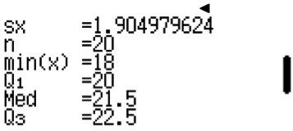(iii) Modal temperature = 22°C
ClassWiz steps
Finding the mean and median using ClassWiz:
Press w6 for Statistics function and 1
for 1-Variable.
Press L and press R. Press 3 for Statistics. Next, press 1 to switch on the frequency.
For the column in x, key in the temperature.
Next, move on to the top of the frequency column by pressing $R and fill in the frequency of days.
Press T3 to select “1-Variable Calc” and you will see this page.

Mean = 21.45
Press R and you will see this page.
- Median temperature
= $\frac{(21+22)}{2}$
= 21.5°C
Position 10 and 11 have a temperature of 21°C and 22°C respectively.

- Mean temperature
= $\frac{[18(1) + 19(2) + 20(4) + 21(3) + 22(5) + 23(1) + 24(3) + 25(1)]}{20}$
= 21.45°C
- Percentage of the days that are warmer than 22°C
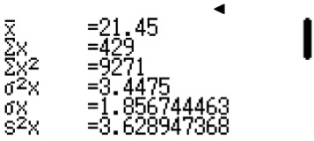= $\frac{5}{20}$ × 100%
= 25%

- (a) (i) The day(s) that has the most number of tickets sold = Friday and Saturday
(ii) The day(s) that has the least number of tickets sold = Monday and Wednesday
(b) (i) Modal number of tickets sold = 100
(ii) Mean number of tickets sold = $\frac{(550 + 600 + 550 + 700 + 1000 + 1000 + 900)}{7}$ = $757\frac{1}{7}$

Unit 9 Statistics

- (a) (i) March has the highest price of petrol.
TEACHER’S GUIDE
(ii) June has the lowest price of petrol.
- Percentage decrease of the price of petrol from March to April = $\frac{(2.70 - 2.00)}{2.70}$ × 100% = 25.9% or $25\frac{25}{27}$
- $\frac{50}{20}$ = $2.50 per litre
Jonathan made this transaction in February.
(d) $\frac{180 km}{9 km}$ × $1.80 = $36

- (a)
No. of students

5
4
3
2
1
0
3
4
5
6
7
8
9
10
Daily Allowance ($)

- 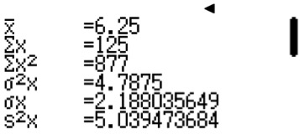x = 20
ClassWiz steps
Finding the mean and median using ClassWiz:
Press w6 for Statistics function and 1 for 1-Variable.
Press L and press R. Press 3 for Statistics. Next, press 1 to switch on the frequency.
For the column in x, key in the daily allowance.
Next, move on to the top of the frequency column by pressing $R and fill in the frequency of students.
Press T3 to select“1-Variable Calc”and you will see this page.

Mean = 6.25
Press R and you will see this page.
- Modal daily allowance = $8

- Median daily allowance
= $6
Both positions 10 and 11 have a value of $6

- Mean daily allowance
= $\frac{[3(3) + 4(2) + 5(3) + 6(3) + 7(2) + 8(4) + 9(1) + 10(2)]}{20}$
= $6.25

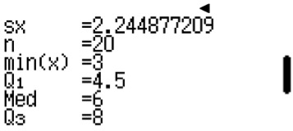

Casio ClassWiz Mathematics Workbook
TEACHER’S GUIDE

- (a)
No. of students

5
4
3
2
1
0
8
9
10
11
Score
12
13
14
15

- x = 20
- 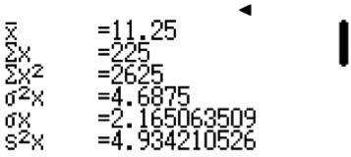Modal score = 12
ClassWiz steps
Finding the mean and median using ClassWiz:
Press w6 for Statistics function and 1 for 1-Variable.
Press L and press R. Press 3 for Statistics. Next, press 1 to switch on the frequency.
For the column in x, key in the scores.
Next, move on to the top of the frequency column by pressing $R and fill in the frequency of students.
Press T3 to select “1-Variable Calc” and you will see this page.

Mean = 11.25
Press R and you will see this page.
- Median score = $\frac{(11 + 12)}{2}$
= 11.5
Positions 10 and 11 have
a value of 11 and 12 respectively.

- Mean score
= $\frac{[8(3) + 9(2) + 10(3) + 11(2) + 12(4) + 13(3) + 14(1) + 15(2)]}{20}$
= 11.25
- (i) Score of the quiz = 16
(ii) Score of the quiz = 20

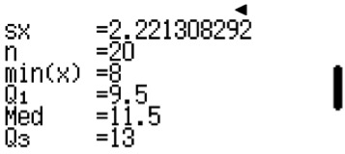

Unit 9 Statistics

- 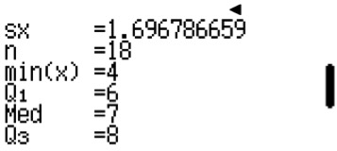(a) Total number of part timers in the company = 18
The total number of dots are the total number of part timers
TEACHER’S GUIDE

- Highest hourly wage = $11
- 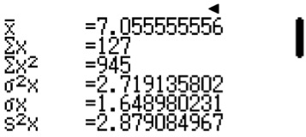Modal hourly wage = $7
ClassWiz steps
Finding the mean and median using ClassWiz:
Press w6 for Statistics function and 1 for 1-Variable.
Press L and press R. Press 3 for Statistics. Next, press 1 to switch on the frequency.
For the column in x, key in the hourly wages.
Next, move on to the top of the frequency column by pressing $R and fill in the frequency of part timers.
Press T3 to select “1-Variable Calc” and you will see this page.

Mean = $7.06 (3s.f.)
Press R and you will see this page.
- Median hourly wage
= $7
Both positions 9 and 10 have a value of $7

- Mean hourly wage
= $\frac{[4(1) + 5(2) + 6(3) + 7(6) + 8(4) + 9(0) + 10(1) + 11(1)]}{18}$
= $7.06
- (a) Total number of households living along
the particular road
= 14
Total number of dots

- Highest number of cars owned by a household
= 4
- Modal number of cars = 1

- (a) Total number of matches the football team had in August = 18 [[Total number of dots]]
- Highest number of goals scored by the team = 1
- Modal number of goals = 1

- (a) Total number of latecomers on that particular school day = 18
- Mean number of times each student was late for in the school year
= $\frac{\left[1\left(6\right)+ 2\left(3\right)+ 3\left(2\right)+ 4\left(4\right)+ 5\left(2\right)+ 6\left(0\right)+ 7\left(1\right)\right]}{18}$
= $2\frac{5}{6}$

- (a) Total number of children in the childcare centre = 18 [[Total number of dots]]
- Modal age of the children = 1
- Age of the oldest child = 4

Casio ClassWiz Mathematics Workbook

- (a)

3 4 5 6 7 8 9 10 11 12 13 14 15

No. of pens

- Total number of students in the class = 20
- Modal number of pens = 6
- 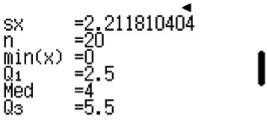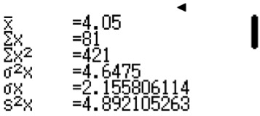Mean number of pens
ClassWiz steps
Finding the mean and median using ClassWiz:
Press w6 for Statistics function and 1 for 1-Variable.
Press L and press R. Press 3 for Statistics. Next, press 1 to switch on the frequency.
For the column in x, key in the number of mistakes.
Next, move on to the top of the frequency column by pressing $R and fill in the frequency of students.
Press T3 to select “1-Variable Calc” and you will see this page.

Mean = 4.05 (3s.f.)
Press R and you will see this page.
The mean number is affected by an extreme value which is 15. The cluster of data
points are from 4 pens to 8 pens. Hence, a disadvantage of using mean is that they include the value of extreme values.
= $\frac{[3(1) + 4(3) + 5(1) + 6(7) + 7(3) + 8(3) + 9(1) + 15(1)]}{20}$
= $6\frac{11}{20}$

- (a)

0 1 2 3 4 5 6 7 8
No. of mistakes
TEACHER’S GUIDE

- Total number of students = 20
- Modal number of mistakes = 5
- Median number of mistakes
= 4
Both positions 10 and 11 have a value of 4.

- Mean number of mistakes
= $\frac{\left[0\left(1\right)+ 1\left(2\right)+ 2\left(2\right)+ 3\left(3\right)+ 4\left(3\right)+ 5\left(4\right)+ 6\left(3\right)+ 7 + 8\left(2\right)\right]}{20}$
= $4\frac{1}{20}$

Unit 9 Statistics

- (a) Total number of teachers in the school = 15
Total number of leaves
TEACHER’S GUIDE

(b) Mean age of the teachers = $\frac{(25 + 25 + 26 + 28 + 29 + 30 + 33 + 35 + 44 + 46 + 47 + 49 + 55 + 58 + 67)}{15}$

- (a) Total number of athletes in the team = 16
- Mean time taken to complete a 2.4km run:
Total time taken
= [7(3) + 8(2) + 9(5) + 10(4) + 11(2)] minutes + [10 + 28 + 46 + 24 + 39 + 12 + 28 + 31 + 43 + 58 + 23 + 37 +
44 + 50 + 20 + 55] seconds
= 144 minutes 548 seconds
= 153 minutes and 8 seconds
- Median time taken to complete a 2.4km run
Positions 8 and 9 have values of 9 min
31 sec and 9 min 43 sec respectively.
= $\frac{(9 min 31 sec + 9 min 43 sec)}{2}$
= 9 min 37 sec
- Percentage of underperformers = $\frac{5}{16}$ × 100% = 31.25%

- (a) Total number of students in the class = 30
Total number of leaves

- Modal height = 178 cm
Note that modal values are sometimes inaccurate if data points are very distributed. In this case, it might be more accurate to look at clusters. The cluster of heights 160 cm to 178 cm is more reflective of an average.

- Median height
= $\frac{(167 + 169)}{2}$
= 168 cm
Positions 15 and 16 have values
of 167 and 169 respectively.

- Mean height

= $\frac{\begin{aligned}(152 + 154 + 155 + 155 + 157 + 159 + 160 + 161 + 161 + 162 + 164 + 165 + 165 + 166 + 167 + \\ 169 + 169 + 170 + 172 + 172 + 174 + 175 + 176 + 177 + 178 + 178 + 178 + 180 + 180 + 181)\end{aligned}}{30}$
= $167\frac{11}{15}$
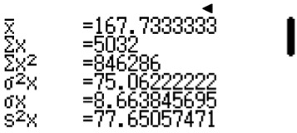
ClassWiz steps
Finding the mean and median using ClassWiz:
Press w6 for Statistics function and 1 for 1-Variable.
Press L and press R. Press 3 for Statistics. Next, press 2 to switch off the frequency. You should see only 1 column.
In the column, key in all 40 values.
Press T3 to select “1-Variable Calc” and you will see this page.

The mean is given as 167.7kg (to 4 s.f.)
- Maximum number of boys = 16
- Percentage of students shorter than 170 cm
= $\frac{17}{30}$ × 100%
= $56\frac{2}{3}$ %

Casio ClassWiz Mathematics Workbook
TEACHER’S GUIDE

- (a) Total number of students in the class = 40
- Modal weight
= 49 kg
Note that modal values are sometimes inaccurate if data points are very distributed.

- Median weight
= $\frac{(61 + 62)}{2}$
= 61.5kg
Positions 20 and 21 have values
of 61 and 62 respectively.

- Mean weight
= $\frac{\begin{aligned}[45 + 46 + 47 + 3(49) + 2(50) + 2(51) + 52 + 55 + 2(56) + 58 + 2(59) + 60 + 2(61) + 62 \\ + 2(63) + 65 + 2(67) + 68 + 69 + 70 + 71 + 2(72) + 2(74) + 75 + 2(76) + 2(78) + 82]\end{aligned}}{40}$
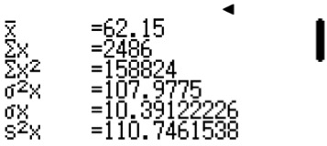= 62.15 kg
ClassWiz steps
Finding the mean and median using ClassWiz:
Press w6 for Statistics function and 1 for 1-Variable.
Press L and press R. Press 3 for Statistics. Next, press 2 to switch off the frequency. You should see only 1 column.
In the column, key in all 40 values.
Press T3 to select “1-Variable Calc” and you will see this page.

The mean is given as 62.15kg (to 3 s.f.)

- Percentage of the students who are required to
go for this programme
= $\frac{11}{40}$ × 100%
= 27.5%

- (a) Total number of students in the class = 32
- Modal score = 58
- Median score = $\frac{(54 + 55)}{2}$ = 54.5
- Percentage of the students who are required to go for this programme = $\frac{11}{32}$ × 100% = 34.375%

- (a)
Stem Leaf
3 3 6 7 8 9
4 1 2 5 7 8 9
5 0 4 8 9

- Median score = 42
Position 7
- 75% × 60 = 45 marks.
Percentage of students who obtained A1 = $\frac{8}{15}$ × 100% = $53\frac{1}{3}$%

Unit 9 Statistics

- (a)
Stem Leaf
1 5 7 8
2 1 2 5 7 8
3 0 1 2 5
TEACHER’S GUIDE

- Median score = $\frac{(25 + 27)}{2}$ = 26
Positions 6 and 7 have values of 25 and 27
- Percentage of slow service = $\frac{6}{12}$ × 100% = 50%

Level 2
- (a) (i) For class A, mean = 37.9 (to 3 s.f.); standard deviation = 9.54 (3 s.f.)
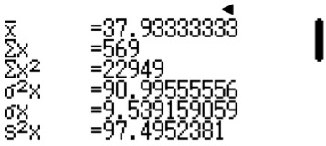
ClassWiz steps
Finding the mean and median using ClassWiz:
Press w6 for Statistics function and 1 for 1-Variable.
Press L and press R. Press 3 for Statistics. Next, press 2 to switch off the frequency. You should see only 1 column.
In the column, key in all 15 values from Leaf (A). (i.e. 23, 26, 28, 29,
31, 34, 35, 37…) The order does not matter.
Press T3 to select “1-Variable Calc” and you will see this page.

For class A, the mean is given as 37.9 (to 3 s.f.) and the standard deviation is given as 9.54 (3 s.f.)
(ii) For class B, mean = 41.9 (to 3 s..f ); standard deviation = 9.54 (3 s.f.)
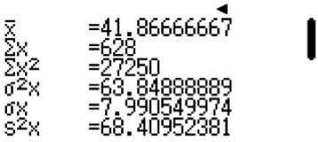
ClassWiz steps
Finding the mean and standard deviation using ClassWiz steps: Press w6 for Statistics function and 1 for 1-Variable.
Press L and press R. Press 3 for Statistics. Next, press 2 to switch off the frequency. You should see only 1 column.
In the column, key in all 15 values from Leaf (B). (i.e. 28, 29, 24, 26, 28, 28…) The order does not matter.
Press T3 to select “1-Variable Calc” and you will see this page.

For class B, the mean is given as 41.9 (to 3 s.f.) and the standard deviation is given as 9.54 (3 s.f.)

- Class B has a higher mean score than Class A. Since both classes have the same standard deviation,
therefore both classes are equally consistent. Hence, Class B performed better.

Casio ClassWiz Mathematics Workbook
TEACHER’S GUIDE

- (a) (i) For tourist group 1, mean = $51.9 (to 3 s.f.); standard deviation = 10.3 (3 s..f )
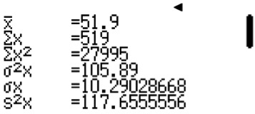
ClassWiz steps
Finding the mean and standard deviation using ClassWiz steps: Press w6 for Statistics function and 1 for 1-Variable.
Press L and press R. Press 3 for Statistics. Next, press 2 to switch off the frequency. You should see only 1 column.
In the column, key in all 10 values from Leaf (1). (i.e. 36, 39, 45, 48,…) The order does not matter. Press T3 to select “1-Variable Calc” and you will see this page.

For tourist group 1, the mean is given as $51.9 (to 3 s.f.) and the standard deviation is given as 10.3 (3 s.f.)

(ii) For tourist group 2, mean = $45.5 (to 3 s.f.); standard deviation = 10.5 (3 s.f.)
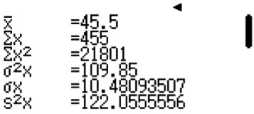
ClassWiz steps
Finding the mean and standard deviation using ClassWiz steps: Press w6 for Statistics function and 1 for 1-Variable.
Press L and press R. Press 3 for Statistics. Next, press 2 to switch off the frequency. You should see only 1 column.
In the column, key in all 10 values from Leaf (2). (i.e. 30, 31, 34, 40,…) The order does not matter. Press T3 to select “1-Variable Calc” and you will see this page.

For tourist group 2, the mean is given as $45.5 (to 3 s.f.) and the standard deviation is given as 10.5 (3 s.f.)

(b) Tourist group 1 has a higher mean than tourist group 2. This meant that tourist group 1 spent more money. Tourist group 1 has a lower standard deviation than tourist group 2. This meant that they were more consistent in their spending.

Unit 9 Statistics

- (a) (i) For the girls, mean = 162.1 cm (to 3 s.f.); standard deviation = 4.83 (3 s.f.)
TEACHER’S GUIDE
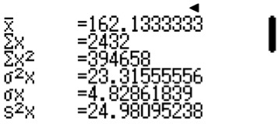
ClassWiz steps
Finding the mean and standard deviation using ClassWiz steps: Press w6 for Statistics function and 1 for 1-Variable.
Press L and press R. Press 3 for Statistics. Next, press 2 to switch off the frequency. You should see only 1 column.
In the column, key in all 10 values from Leaf (Girls). (i.e. 156, 157, 157, 157,…) The order does not matter.
Press T3 to select “1-Variable Calc” and you will see this page.

For the girls, the mean is given as 162.1cm (to 3 s.f.) and the standard deviation is given as 4.83 (3 s.f.)

(ii) For the boys, mean = 175 cm (to 3 s.f.); standard deviation = 4.94 (3 s.f.)
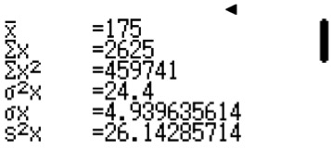
ClassWiz steps
Finding the mean and standard deviation using ClassWiz steps: Press w6 for Statistics function and 1 for 1-Variable.
Press L and press R. Press 3 for Statistics. Next, press 2 to switch off the frequency. You should see only 1 column.
In the column, key in all 10 values from Leaf (Boys). (i.e. 166, 168, 168, 169,…) The order does not matter.
Press T3 to select “1-Variable Calc” and you will see this page.

For the boys, the mean is given as 175 cm (to 3 s.f.) and the standard deviation is given as 4.94 (3 s.f.)

(b) The boys have a higher mean of 175 cm than the girls, whose mean height is 162.1 cm. However, the boys have a bigger standard deviation than the girls, given as 4.94 and 4.83 respectively. Since the difference in standard deviation is small but the difference in mean height is large, hence the boys are taller.

Casio ClassWiz Mathematics Workbook
TEACHER’S GUIDE

- (a)
Leaf (A) |  |  |  |  | Stem
 |  |  |  | 8 | 5
 | 9 | 5 | 2 | 1 | 6
8 | 7 | 4 | 3 | 0 | 7
 |  |  | 6 | 2 | 8

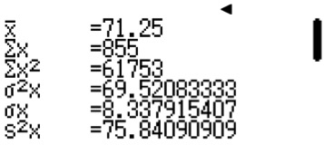(b) (i) For Class A, mean = 71.25; standard deviation = 8.34 (3 s.f.)
ClassWiz steps
Finding the mean and standard deviation using ClassWiz steps: Press w6 for Statistics function and 1 for 1-Variable.
Press L and press R. Press 3 for Statistics. Next, press 2 to switch off the frequency. You should see only 1 column.
In the column, key in all 12 values from Leaf (A). The order does not matter. Press T3 to select “1-Variable Calc” and you will see this page.

For Class A, the mean is given as 71.25 and the standard deviation is given as 8.34 (3 s.f.)

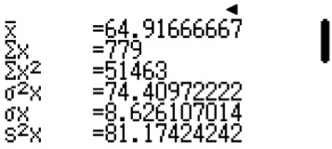(ii) For Class B, mean = 64.9 (to 3 s.f.); standard deviation = 8.63 (3 s.f.)
ClassWiz steps
Finding the mean and standard deviation using ClassWiz steps: Press w6 for Statistics function and 1 for 1-Variable.
Press L and press R. Press 3 for Statistics. Next, press 2 to switch off the frequency. You should see only 1 column.
In the column, key in all 12 values from Leaf (B). The order does not matter. Press T3 to select “1-Variable Calc” and you will see this page,

For Class B, the mean is given as 64.9 (to 3 s.f.) and the standard deviation is given as 8.63 (3 s.f.)

(b) Class A has a higher mean score than Class B. Class A also has a smaller standard deviation than Class B which means that the students’ scores were more consistent. Hence, Class A performed better than Class B.

Unit 9 Statistics

- (a)

Stem | Leaf (B)
0 | 7 | 8 | 9 | 9
1 | 0 | 3 | 3 | 4 | 5 | 6 | 7 | 8
2 | 2 | 4 | 5

- For School A, mean = 13.3; standard deviation = 5.12 (3 s.f.)
TEACHER’S GUIDE

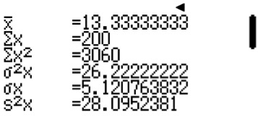
ClassWiz steps
Finding the mean and standard deviation using ClassWiz steps: Press w6 for Statistics function and 1 for 1-Variable.
Press L and press R. Press 3 for Statistics. Next, press 2 to switch off the frequency. You should see only 1 column.
In the column, key in all 15 values from Leaf (A). The order does not matter. Press T3 to select “1-Variable Calc” and you will see this page.

For School A, the mean is given as 13.3 and the standard deviation is given as 5.12 (3 s.f.)

- For School B, mean = 14.7 (to 3 s.f.); standard deviation = 5.55 (3 s.f.)

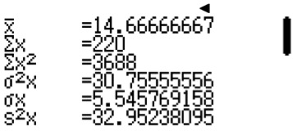
ClassWiz steps
Finding the mean and standard deviation using ClassWiz steps: Press w6 for Statistics function and 1 for 1-Variable.
Press L and press R. Press 3 for Statistics. Next, press 2 to switch off the frequency. You should see only 1 column.
In the column, key in all 15 values from Leaf (B). The order does not matter. Press T3 to select “1-Variable Calc” and you will see this page.

For School B, the mean is given as 14.7 (to 3 s.f.) and the standard deviation is given as 5.55 (3 s.f.)

(b) School B has a higher mean score than School A. This means that School B has a higher score in total. However, School A has a smaller standard deviation than School B which means that the scores of the students in School A were more consistent.

Casio ClassWiz Mathematics Workbook
TEACHER’S GUIDE

- (a) Most common number of handphones owned by a family = 4
- 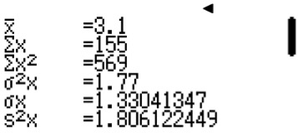Mean = 3.1
ClassWiz steps
Finding the mean using ClassWiz:
Press w6 for Statistics function and 1 for 1-Variable.
Press L and press R. Press 3 for Statistics. Next, press 1 to switch on the frequency. For the column in x, key in the number of handphones.
Next, move on to the top of the frequency column by pressing $R and fill in the frequency of families.
Press T3 to select “1-Variable Calc” and you will see this page.

The mean is given by 3.1.

- Number of families who owned more than 4 handphones = 5
- (a) Value of x = 6 + 12 + 10 + 16 + 10 + 8 + 6 + 4 = 72
- 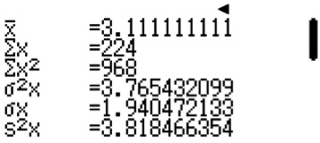Mean = 3.11
ClassWiz steps
Finding the mean using ClassWiz:
Press w6 for Statistics function and 1 for 1-Variable.
Press L and press R. Press 3 for Statistics. Next, press 1 to switch on the frequency. For the column in x, key in the number of books.
Next, move on to the top of the frequency column by pressing $R and fill in the frequency of children.
Press T3 to select “1-Variable Calc” and you will see this page.

The mean is given by 3.11.
- Percentage of children who read at least 4 books = $\frac{28}{72}$ × 100% = 38.9%

Unit 9 Statistics

- (a) Number of customers who bought from the noodle stall on that particular day
TEACHER’S GUIDE
= 2 + 6 + 6 + 8 + 4 + 8 + 7 + 12 + 17 + 12 + 14
= 96
- 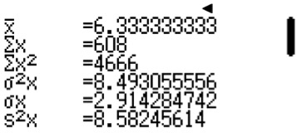Mean = 6.33
ClassWiz steps
Finding the mean using ClassWiz:
Press w6 for Statistics function and 1 for 1-Variable.
Press L and press R. Press 3 for Statistics. Next, press 1 to switch on the frequency. For the column in x, key in the number of minutes.
Next, move on to the top of the frequency column by pressing $R and fill in the frequency of customers.
Press T3 to select “1-Variable Calc” and you will see this page.

The mean is given by 6.33.

- Calculate the percentage of customers who had to wait over 6 minutes = $\frac{55}{96}$ × 100% = 57.3%

- (a) Most common amount of money spent on food = $100 to $150
(b) Mean = $168.75
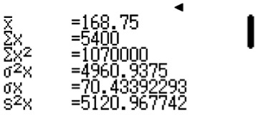(c) Percentage of working adults who spend between $250 to $350 on food monthly = $\frac{5}{32}$ × 100% = 15.625%
ClassWiz steps
Finding the mean using ClassWiz:
Press w6 for Statistics function and 1 for 1-Variable.
Press L and press R. Press 3 for Statistics. Next, press 1 to switch on the frequency.
For the column in x, key in the amount spent on food monthly. As this is grouped data, take the mean of the range. i.e. For 50 < x ≤ 100, we take x to be 75.
Next, move on to the top of the frequency column by pressing $R and fill in the frequency of customers.
Press T3 to select “1-Variable Calc” and you will see this page.

The mean is given by $168.75.

- (a) Number of employees in this company = 20 + 14 + 10 + 5 + 2 + 1 = 52
- Most common number of times late = 0 to 2 times.
- Percentage of employees who are late more than 10 times in a month = $\frac{3}{52}$ × 100% = $5\frac{10}{13}$%

Casio ClassWiz Mathematics Workbook
TEACHER’S GUIDE

- (a)
Frequency
25
20
15
10
5
0
1
2
No. of goals
3
4

- Total number of matches played = 5 + 15 + 22 + 8 + 1 = 51
- Mean = 1.71
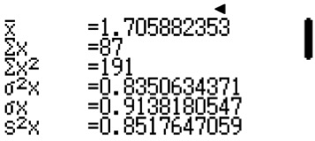
ClassWiz steps
Finding the mean using ClassWiz:
Press w6 for Statistics function and 1 for 1-Variable.
Press L and press R. Press 3 for Statistics. Next, press 1 to switch on the frequency. For the column in x, key in the number of goals.
Next, move on to the top of the frequency column by pressing $R and fill in the frequency of matches.
Press T3 to select “1-Variable Calc” and you will see this page.

The mean is given by 1.71.

- Percentage of matches which scored at least 3 goals = $\frac{9}{51}$ × 100% = $17\frac{11}{17}$%

Unit 9 Statistics

- (a)
No. of students
50
40
30
20
10
0
40 50 60 70 80 90
Score
TEACHER’S GUIDE

- Number of students in the cohort taking the Biology exam = 26 + 48 + 27 + 8 + 1 = 110
- Percentage passes = $\frac{84}{110}$ × 100% = $76\frac{4}{11}$%
- Percentage of distinctions = $\frac{36}{100}$ × 100% = $32\frac{8}{11}$%

- 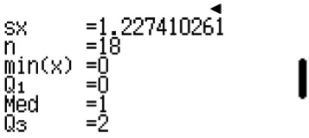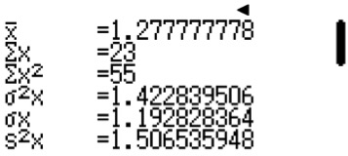(a) Modal number of siblings = 0
ClassWiz steps
Finding the mean, standard deviation and median using ClassWiz: Press w6 for Statistics function and 1 for 1-Variable.
Press L and press R. Press 3 for Statistics. Next, press 1 to switch on the frequency. For the column in x, key in the number of siblings.
Next, move on to the top of the frequency column by pressing $R and fill in the frequency of students. Press T3 to select “1-Variable Calc” and you will see this page.

Press R and you will see this page.

- Median number of siblings = 1
- Mean number of siblings = 1.28 (3 s.f.)
Standard deviation = 1.19 (3 s.f.)

Casio ClassWiz Mathematics Workbook
TEACHER’S GUIDE

- (a) x + 5 + 2x – 1 + 8 + 2 + 1 = 60
3x = 45
x = 15
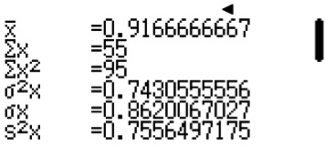
ClassWiz steps
Finding the mean, standard deviation and median using ClassWiz: Press w6 for Statistics function and 1 for 1-Variable.
Press L and press R. Press 3 for Statistics. Next, press 1 to switch on the frequency. For the column in x, key in the number of visits to the doctor.
Next, move on to the top of the frequency column by pressing $R and fill in the frequency of working adults.
Press T3 to select “1-Variable Calc” and you will see this page.

Press R and you will see this page.

- 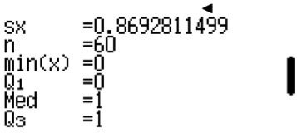Median number of visits to the doctor = 1
- Mean number of visits to the doctor = 0.917
Standard deviation = 0.862

- (a) Mean = $\frac{\left[0\left(2\right)+ 1\left(4\right)+ 2\left(6\right)+ 3\left(k\right)+ 4\left(13\right)+ 5\left(7\right)\right]}{\left[2 + 4 + 6 + k + 13 + 7\right]}$
3.2 = (103 + 3k)/(32 + k)
3.2(32 + k) = 103 + 3k
102.4 + 3.2k = 103 + 3k
0.2k = 0.6
k = 3
- Modal number of handphones in a household = 4
- Median number of handphones in a household = 3

- (a) Largest possible value of p = 26
- Smallest possible value of p = (29 + 27 – 18 – 15) + 1 = 24

Unit 9 Statistics

- 29 + 27 + p + 18 + 15 = 100
TEACHER’S GUIDE
p = 11
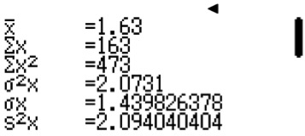
ClassWiz steps
Finding the mean and standard deviation using ClassWiz: Press w6 for Statistics function and 1 for 1-Variable.
Press L and press R. Press 3 for Statistics. Next, press 1 to switch on the frequency. For the column in x, key in the number of books borrowed.
Next, move on to the top of the frequency column by pressing $R and fill in the frequency of students. Press T3 to select “1-Variable Calc” and you will see this page.

Mean number of books borrowed per student = 1.63 Standard deviation = 1.44
- (a) Largest possible value of a = 17
- Smallest possible value of a = 9
The most instinctive answer is to put a = 0. However, question stated that there were at least 50 ladies who entered the store. Hence, the total number of ladies need to make up 50 and a = 9.

- a = 19
As there were at least 60 ladies who entered the store.
Modal number of dresses = 2

- 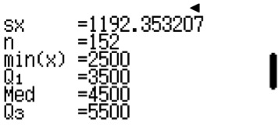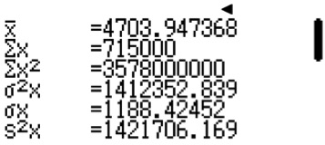(a) Modal monthly salary is between $4000 to $5000.
ClassWiz steps
Finding the mean, standard deviation and median using ClassWiz: Press w6 for Statistics function and 1 for 1-Variable.
Press L and press R. Press 3 for Statistics. Next, press 1 to switch on the frequency.
For the column in x, key in the monthly salary. As this is grouped data, take the mean of the range. i.e. For 3000 < x ≤ 4000, we take x to be 3500.
Next, move on to the top of the frequency column by pressing $R and fill in the frequency of bankers. Press T3 to select “1-Variable Calc” and you will see this page.

Press R and you will see this page.
- Median monthly salary is 4500
- Mean monthly salary = $4703.95 (2 d.p.)
Standard deviation = $1188.42 (2 d.p.)

Casio ClassWiz Mathematics Workbook
TEACHER’S GUIDE

- 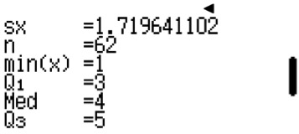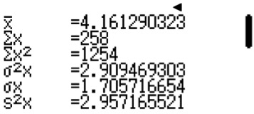(a) Modal number of hours is between 2 to 4 hours.
ClassWiz steps
Finding the mean, standard deviation and median using ClassWiz: Press w6 for Statistics function and 1 for 1-Variable.
Press L and press R. Press 3 for Statistics. Next, press 1 to switch on the frequency.
For the column in x, key in the number of hours. As this is grouped data, take the mean of the range, i.e. For 2 < x ≤ 4, we take x to be 3.
Next, move on to the top of the frequency column by pressing $R and fill in the frequency of teenagers. Press T3 to select “1-Variable Calc” and you will see this page.

Press R and you will see this page.
- Median number of hours = 4 hours
- Mean number of hours = 4.16 hours (3 s.f.)
Standard deviation = 1.71 hours (3 s.f.)
- Percentage of teenagers who are addicted to gaming = $\frac{10}{62}$ × 100% = 16.1% or $16\frac{4}{31}$

- (a) b = 120 – 16 – 25 – 28 – 11 = 40
- 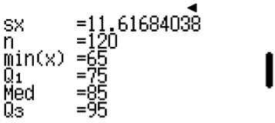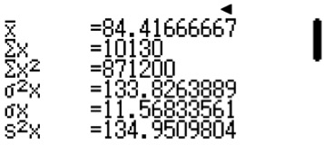Modal speed is between 70 km/h and 80km/h
ClassWiz steps
Finding the mean, standard deviation and median using ClassWiz: Press w6 for Statistics function and 1 for 1-Variable.
Press L and press R. Press 3 for Statistics. Next, press 1 to switch on the frequency.
For the column in x, key in the speed. As this is grouped data, take the mean of the range. i.e. For 60 < x ≤ 70, we take x to be 65.
Next, move on to the top of the frequency column by pressing $R and fill in the frequency of vehicles. Press T3 to select “1-Variable Calc” and you will see this page.

Press R and you will see this page.

- Median speed = 85 km/h
- Mean speed = 84.4 km/h
Standard deviation = 11.6 km/h
- Fraction of the vehicles who are speeding = $\frac{39}{120}$ = $\frac{13}{40}$

Unit 9 Statistics

- (a) Smallest possible value of p = 29
TEACHER’S GUIDE
- 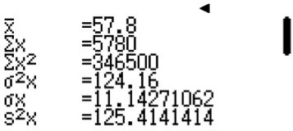Largest possible value of p = 28 – 1 + 18 + 7 – 13 = 39
ClassWiz steps
Finding the mean and standard deviation using ClassWiz: Press w6 for Statistics function and 1 for 1-Variable.
Press L and press R. Press 3 for Statistics. Next, press 1 to switch on the frequency.
For the column in x, key in the score. As this is grouped data, take the mean of the range. i.e. For 60 < x ≤ 70, we take x to be 65.
Next, move on to the top of the frequency column by pressing $R and fill in the frequency of students. Press T3 to select “1-Variable Calc” and you will see this page.
- p = 100 – 7 – 18 – 28 – 13 = 34
Mean score = 57.8
Standard deviation = 11.1 (3s.f.)

- (a) Largest possible value of y = 28
- Smallest possible value of y = 11
- 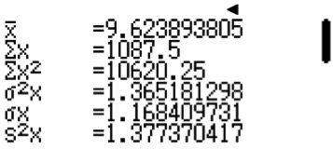y = 113 – 11 – 23 – 29 – 15 = 35
ClassWiz steps
Finding the mean and standard deviation using ClassWiz: Press w6 for Statistics function and 1 for 1-Variable.
Press L and press R. Press 3 for Statistics. Next, press 1 to switch on the frequency.
For the column in x, key in the hours. As this is grouped data, take the mean of the range. i.e. For 7 < x ≤ 8, we take x to be 7.5.
Next, move on to the top of the frequency column by pressing $R and fill in the frequency of teachers. Press T3 to select “1-Variable Calc” and you will see this page.
Mean number of hours = 9.62 hours (3s.f.)
Standard deviation = 1.17 hours (3s.f.)

Casio ClassWiz Mathematics Workbook
TEACHER’S GUIDE

- 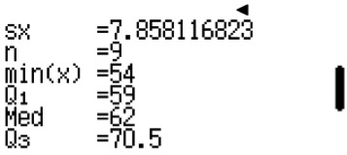
ClassWiz steps
Finding the median and interquartile range using ClassWiz steps: Press w6 for Statistics function and 1 for 1-Variable.
Press L and press R. Press 3 for Statistics. Next, press 2 to switch off the frequency. You should see 1 column.
Key in all the 9 values.
Press T3 to select “1-Variable Calc” and press R and you will see this page.

Press R and you will see this page.

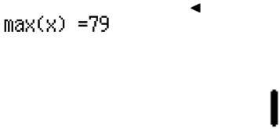

- Range = 79 – 54 = 25(b)
- Median = 62
- Upper quartile = 70.5
- Lower quartile = 59
- Interquartile range = 70.5 – 59 = 11.5

- 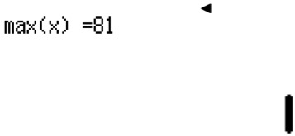
ClassWiz steps
Finding the median and interquartile range using ClassWiz steps: Press w6 for Statistics function and 1 for 1-Variable.
Press L and press R. Press 3 for Statistics. Next, press 2 to switch off the frequency. You should see 1 column.
Key in all the 10 values.
Press T3 to select “1-Variable Calc” and press R and you will see this page.

Press R and you will see this page.

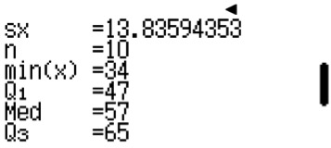

- Range = 81 – 34 = 47
- Median = 57
- Upper quartile = 65
- Lower quartile = 47
- Interquartile range = 65 – 47 = 18

Unit 9 Statistics

- (a) (i) Range = 88 – 36 = 52
TEACHER’S GUIDE
  - Median = 56
  - Interquartile range = 64 – 46 = 18
- Jennifer’s percentile in the class = 50th percentile
If Jennifer is the 50th percentile, then she is the median. Since she is the only one to score 56 marks, then the median is made up of only 1 student.
Hence, there will be 35 students in the class.
- Total number of students in the class = 35

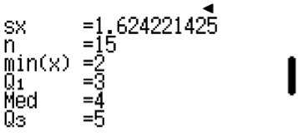26.
ClassWiz steps
Finding the median and interquartile range using ClassWiz steps: Press w6 for Statistics function and 1 for 1-Variable.
Press L and press R. Press 3 for Statistics. Next, press 2 to switch off the frequency. You should see 1 column.
Key in all the 15 values.
Press T3 to select “1-Variable Calc” and press R and you will see this page.

  - (i) p = 3
- q = 4
- r = 5
  - Interquartile range = 5 – 3 = 2

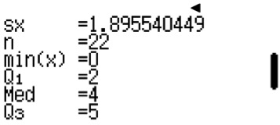27.
ClassWiz steps
Finding the median and interquartile range using ClassWiz steps: Press w6 for Statistics function and 1 for 1-Variable.
Press L and press R. Press 3 for Statistics. Next, press 2 to switch off the frequency. You should see 1 column.
Key in all the 22 values.
Press T3 to select “1-Variable Calc” and press R and you will see this page.

  - (i) Number of people in this group = 22
- Median = 4 hours
- Interquartile range = 5 – 2 = 3 hours
(b)

0 1 2 3 4 5 6 7
No. of hours spent on watching drama

Casio ClassWiz Mathematics Workbook

- (a) (i) Number of people in this group = 33
Total number of leaves

- Median = 51 sit ups
Position 17
- Interquartile range = $\left[\frac{(60 + 63)}{2}\right]$ – $\left[\frac{(42 + 43)}{2}\right]$ = 61.5 – 42.5 = 19
(b)
20
30
40
50
60
70
80
No. of sit-ups

  - Percentage of unfit athletes = $\frac{10}{33}$ × 100% = $30\frac{10}{33}$%

Level 3
TEACHER’S GUIDE
- Amelia’s statement is incorrect. To say that half the cohort failed means to say that the median is the passing mark. However, the median is 52 marks and the passing mark is 50 marks. This goes to mean that less than half the cohort failed the test.

- (a) (i) Range = $15000 – $3000 = $12000
(ii) Interquartile range = $6600 – $4600 = $2000
  - The range consists of extreme values which are not reflective of the general population. Interquartile range gives us information of the middle 50% of the population, exclusive of extreme values. Hence, it will be more useful to use both the range and the interquartile range to help us analyse data.

- (a) (i) Range of Class A = 81 – 35 = 46
Range of Class B = 87 – 42 = 45
  - Interquartile range of Class A = 69 – 54 = 15
Interquartile range of Class B = 73 – 60 = 13
- Class A has a greater spread. Its range is 46, which is higher than the range of Class B. The interquartile range is 15, which is higher than the interquartile range of Class B. Hence Class A is less consistent and has a
greater spread.
- In Class A, there are 50% of the population scoring less than 60 marks. In Class B, there are 25% of the population scoring less than 60 marks. Hence, if both classes are merged, the percentage of total population scoring at most 60 marks will be more than 25%. Hence, I agree with Kylie that the minimum probability is at least $\frac{1}{4}$.

- 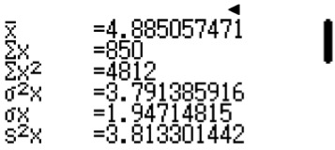(a)
ClassWiz steps
Finding the mean and standard deviation using ClassWiz steps:
Press w6 for Statistics function and 1 for 1-Variable.
Press L and press R. Press 3 for Statistics. Next, press 1 to switch on the frequency. You should see 2 columns.
In the first column, key in number of hours. As this is grouped data, take the mean of the range, i.e. For 3 < x ≤ 5, we take x to be 4.
In the second column, key in the frequency of students.
Press T3 to select “1-Variable Calc” and you will see this page.

Unit 9 Statistics

- Mean = 4.89 hours (3 s.f.)
TEACHER’S GUIDE
- Standard deviation = 1.95 (3s.f.)
(b) (i) One advantage of using grouped data is that it can handle large amounts of data, as individual data in
huge amounts can be very overwhelming and difficult to analyse. Grouped data helps us see the bigger
picture and makes the data easier to analyse.
- One disadvantage of using grouped data is that individual data are lost. We cannot refer to individual
data anymore.

- (a) Another diagram that is useful will be the bar graph. Bar graphs can show the individual data and still can show the proportion of the data clearly.
- Line graphs will not be so useful. Line graphs show a trend, but in this context, we are concerned with the flavours and trends are not necessary. Hence a bar graph would be better.

- Two classes of 15 students, Class A and Class B, took an Accounting test and their results are shown in the back to back stem and leaf diagram.

Leaf (A) |  |  |  |  |  | Stem | Leaf (B)
 | 8 | 5 | 4 | 4 | 3 | 2 | 9
9 | 9 | 6 | 5 | 4 | 1 | 3 | 1 | 5 | 7 | 7 | 8 | 9
 |  |  | 7 | 5 | 4 | 4 | 1 | 3 | 3 | 5 | 7 | 7
 |  |  |  |  | 1 | 5 | 3 | 3

(a)
ClassWiz steps
Finding the median and interquartile range using ClassWiz steps: Press w6 for Statistics function and 1 for 1-Variable.
Press L and press R. Press 3 for Statistics. Next, press 2 to switch off the frequency. You should see 1 column.
Key in all the 15 values separately for Class A and Class B.
Press T3 to select “1-Variable Calc” and press R and you will see this page.

  - 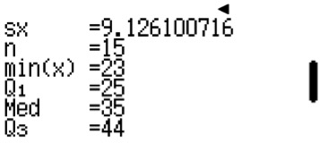For Class A:

Median score = 35
Interquartile range = 44 – 25 = 19
  - 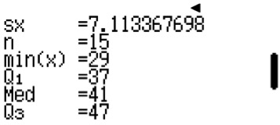For Class B,

Median score = 41
Interquartile range = 47 – 37 = 10

Casio ClassWiz Mathematics Workbook
TEACHER’S GUIDE

(b)
Class A:

Class B:
20
30
40
50
Score for Accounting test

Class B performed better. Class B has a higher median score than Class A. This means that Class B scored better and higher. Class B also has a smaller interquartile range than Class A. This means that the students are more consistent in scoring. Hence, Class B performed better.
- Box plot helps to organise the data into quarters and we can analyse them easily in quartiles. Stem and leaf diagram can only show the visual representation similar to a bar graph, and also where the data points are clustering at.
- A box plot loses the individual data points but stem and leaf retains the individual data points.

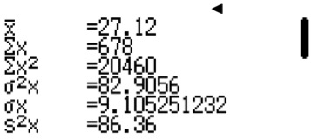7.
ClassWiz steps
Finding the mean and standard deviation using ClassWiz steps: Press w6 for Statistics function and 1 for 1-Variable.
Press L and press R. Press 3 for Statistics. Next, press 2 to switch off the frequency. You should see 1 column.
Key in all the 25 values.
Press T3 to select “1-Variable Calc” and you will see this page.

- (i) Mean = 27.12
  - Standard deviation = 9.11 (3s.f.)
- The first group has a mean of 27.12 and the second group has a higher mean of 32.1. This means that the second group can do more push ups.
The first group has a standard deviation of 9.11 and the second group has a lower standard deviation of 5.9. This means that the second group is more consistent in doing their push ups. Hence, the second group performed better and is fitter.

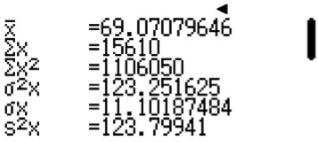8. (a)
ClassWiz steps
Finding the mean and standard deviation using ClassWiz steps: Press w6 for Statistics function and 1 for 1-Variable.
Press L and press R. Press 3 for Statistics. Next, press 1 to switch on the frequency. You should see 2 columns.
In the first column, key in the scores of the students. As this is grouped data, take the mean of the range, i.e. for 30 < x ≤ 40, we take x to be 35.
In the second column, key in the frequency of students.
Press T3 to select “1-Variable Calc” and you will see this page.

Unit 9 Statistics

(i) Mean = 69.1 (3s.f.)
TEACHER’S GUIDE
(ii) Standard deviation = 11.1 (3s.f.)
- School A has a higher mean than School B. This means that students from School A scored higher.
School A has a lower standard deviation from School B. This means that students in School A scored more consistently. Hence, School A performed better.

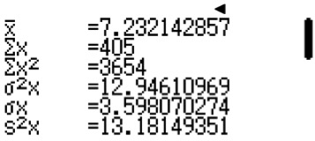9. (a)
ClassWiz steps
Finding the mean and standard deviation using ClassWiz steps: Press w6 for Statistics function and 1 for 1-Variable.
Press L and press R. Press 3 for Statistics. Next, press 1 to switch on the frequency. You should see 2 columns.
In the first column, key in the number of hours. As this is grouped data, take the mean of the range, i.e. for 30 < x ≤ 40, we take x to be 35.
In the second column, key in the frequency of swimmers.
Press T3 to select “1-Variable Calc” and you will see this page.

(i) Mean = 7. 23 (3s.f.)
(ii) Standard deviation = 3.60 (3s.f.)
(b) Swimming club A has a higher mean than Swimming club B. This means that Swimming club B spends less time training as compared to Swimming club A.
Swimming club B has a smaller standard deviation as compared to Swimming club A. This means that their training hours are more consistent. Swimming club B spends less time training and has more consistent trainings and also produced 6 winners. Hence Swimming club B has a more effective training schedule or method than Swimming club A.

Level 4
- (a) Mean age of the friends = $\frac{144}{5}$ = 28.8

  - Standard deviation of the friends = $\sqrt{\frac{4244}{5} -{28.8}^{2}}$ = 4.4

2. (a) Mean of all 30 numbers = $\frac{[7.2(10) + 12.4(20)]}{30}$ = $10\frac{2}{3}$
(b) The standard deviation of all 30 numbers:
For set of 10 numbers: Standard deviation = $\sqrt{\frac{{\sum{x_{1}}}^{2}}{10}- {7.2}^{2}}$ = 3.09
$\frac{{\sum{x_{1}}}^{2}}{10}$ – ${7.2}^{2}$ = 9.5481
$\frac{{\sum{x_{1}}}^{2}}{10}$ = 61.3881
${\sum{x_{1}}}^{2}$ = 613.881
For set of 20 numbers: Standard deviation = $\sqrt{\frac{{\sum{x_{2}}}^{2}}{20}- {12.4}^{2}}$ = 10.16
$\frac{{\sum{x_{2}}}^{2}}{20}$ – ${12.4}^{2}$ = 103.2256
$\frac{{\sum{x_{2}}}^{2}}{20}$ = 256.9856
${\sum{x_{2}}}^{2}$ = 5139.712
For set of all 30 numbers: Standard deviation = $\sqrt{\frac{\left(613.881 + 5139.712\right)}{30} - {\left(10\frac{2}{3}\right)}^{2}}$
= 8.83 (3s.f.)

