Unit
12
RECURSION, SEQUENCES AND SERIES

KEY CONCEPTS
TEACHER’S GUIDE

Arithmetic Series
A series is called an arithmetic series if:
d = ${\text{T}}_{\text{n}}$– ${\text{T}}_{\text{n}\text{-1}}$
where d is the constant, called the common difference.

The general term of an arithmetic series with a first term a and a common difference d is given as:
${\text{T}}_{\text{n}}$ = a + (n – 1)d
The sum of the first n terms of an arithmetic series with a first term a is given as:
when the last term I = Tn is known.
${\text{S}}_{\text{n}}$ = $\frac{ \text{n}}{ \text{2} }$ (a + /)

when the common difference d is known.
${\text{S}}_{\text{n}}$ = $\frac{\text{n}}{ \text{2} }$ $\left[\text{2}\text{a}\text{+ }\left(\text{n} \text{– }\text{1}\right)\text{d}\right]$

Geometric Series
A series is called a geometric series if
r = $\frac{{\text{T}}_{\text{n}}}{{\text{T}}_{\text{n} \text{–} \text{1}}}$

where r is a constant, called the common ratio.

The general term of a geometric series with a first term a and a constant ratio r is given as:
${\text{T}}_{\text{n}}$= ${\text{a}\text{r}}^{\text{n} \text{–} \text{1}}$
The sum of the first n terms of a geometric series is given as:
for r > 1
${\text{S}}_{\text{n}}$ = $\frac{\text{a}\left({\text{r}}^{\text{n}} \text{–} \text{1}\right)}{\text{r} \text{– }\text{1}}$

for r < 1
${\text{S}}_{\text{n}}$ = $\frac{\text{a}\left(\text{1} \text{–} {\text{r}}^{\text{n}}\right)}{\text{1} \text{– }\text{r}}$

Casio ClassWiz Mathematics Workbook

WORKED EXAMPLES
TEACHER’S GUIDE

Level 1

Worked Example 1
Given the arithmetic sequence 5, 9, 13, 17, …,
- find the next 2 terms.
- write down the nth term.
- find the sum of the first 10 terms of the series.

Solution (a) 21, 25
(b) Tn = 5 + (n – 1)(4) = 4n + 1

(c) S10
= $\frac{\text{10}}{\text{2}}$ [2(5) + (10 – 1)(4)] = 230

Worked Example 2
Given the geometric sequence 5, 15, 45, …,
(a) find the next 2 terms.
(b) write down the nth term.
(c) find the sum of the first 10 terms of the series.

Solution
(a) 135, 405

(b) Tn
(c) S10
= 5(3)n –1 or $\frac{\text{5}{\left(\text{3}\right)}^{\text{n}}}{\text{3}}$
= $\frac{\text{5}\left({\text{3}}^{\text{10}}– \text{1}\right)}{\text{3} \text{– 1}} \text{=} \text{147 620}$

Worked Example 3
Given the following general formula, write out the first 7 terms for n = 1, 2, 3, 4, 5, 6, 7.
(a) 5n – 3,
(b) n2 – 2

Solution
(a) 2, 7, 12, 17, 22, 27, 32
(b) –1, 2, 7, 14, 23, 34, 47

Level 2

Worked Example 4
An arithmetic sequence has first term 7 and common difference 6. Find the twelfth term.

Solution
T12 = 7 + (12 – 1)(6) = 73

Unit 12 Recursion, Sequences and Series

Worked Example 5
TEACHER’S GUIDE
Find the sum of the first 10 terms of 5 + 11 + 17 + 23 + …

Solution
Since the series is increasing by an addition of 6, it is an arithmetic progression.

S10
= $\frac{\text{10}}{\text{2}}$ [2(5) + (10 – 1)(6)] = 320

Worked Example 6
Find the sum of the first 10 terms of a geometric progression 2187, –729, 243, …

Solution
$${\text{S}}_{\text{10}} \text{= }\frac{2187\left(1-{\left(-\frac{1}{3}\right)}^{10}\right)}{\text{1} \text{– }\text{(} \text{– }\frac{\text{1}}{ \text{3} }\text{)}}\text{= }\frac{\text{14762}}{\text{9}}$$

Worked Example 7
Find the two possible values of x if for the geometric progression 9, x, 81

Solution
$$\frac{\text{x}}{ \text{9} } \text{= }\frac{\text{81}}{\text{x}}$$
x2 = 729
x = ±27

Casio ClassWiz Mathematics Workbook

CLASSWIZ WORKSHEETS
CLASSWIZ WORKSHEETS
Level 1 
- Given the arithmetic sequence 2, 5, 8, 11, find the next 2 terms. Next, write down the nth term.

- Given the arithmetic sequence 7, 12, 17, 22, find the next 2 terms. Next, write down the nth term.

- Given the arithmetic sequence 11, 19, 27, 35, find the next 2 terms. Next, write down the nth term.

- Given the arithmetic sequence 45, 31, 17, 3, find the next 2 terms. Next, write down the nth term.

- Given the arithmetic sequence 51, 74, 97, 120, find the next 2 terms. Next, find the sum of the first 10 terms of the series.

- Given the arithmetic sequence 12, 54, 96, 138, find the next 2 terms. Next, find the sum of the first 10 terms of the series.

- Given the arithmetic sequence 60, 77, 94, 111, find the next 2 terms. Next, find the sum of the first 10 terms of the series.

Unit 12 Recursion, Sequences and Series

- Given the arithmetic sequence 2, 5, 8, 11, 14, find the next 2 terms. Next, find the sum of the first 10 terms of the series.
CLASSWIZ WORKSHEETS

- Given the geometric sequence 2, 4, 8, 16, find the next 2 terms. Next, write down the nth term.

- Given the geometric sequence 6, 18, 54, 162, find the next 2 terms. Next, write down the nth term.

- Given the geometric sequence, 7, 28, 112, 448, find the next 2 terms. Next, write down the nth term.

- Given the geometric sequence 9, –18, 36, –72, find the next 2 terms. Next, write down the nth term.

- Given the geometric sequence 188, 94, 47, 23.5, find the next 2 terms. Next, find the sum of the first 10 terms of the series.

- Given the geometric sequence 2, 14, 98, 686, find the next 2 terms. Next, find the sum of the first 10 terms of the series.

Casio ClassWiz Mathematics Workbook

- Given the geometric sequence 3, 12, 48, 192, find the next 2 terms. Next, find the sum of the first 10 terms of the series.
TEACHER’S GUIDE

- Given the geometric sequence 2, 5, 12.5, 31.25, find the next 2 terms. Next, find the sum of the first 10 terms of the series.

- Given the following general formula, write out the first 7 terms for n = 1, 2, 3, 4, 5, 6, 7
Teacher to note that these are odd number series.
(b) 2n – 1
(a) 2n + 1

(c) 3n – 1 (d) 4n + 5

(e) 8 – 3n

- Given a general formula, write out the first 7 terms for n = 1, 2, 3, 4, 5, 6, 7
(a) 2n (b) 2n + 1

(c) 3n2 (d) n3

(e) n3 + 2

Unit 12 Recursion, Sequences and Series

Level 2
CLASSWIZ WORKSHEETS

- An arithmetic sequence has first term 8 and common difference 12. Find the fifteenth term.

- An arithmetic sequence has first term 18 and common difference 5. Find the sum of the twenty terms.

- Find the sum of the first 10 terms of the series 2, 8, 14, 20, …

- Find the sum of the first 10 terms of 14, 23, 32, 41, …

- The third term of an arithmetic series is 12 and the fifth term is 24. Find the value of the common difference and the first term, hence, evaluate the sum of the first 10 terms.

- Given that the third term and the twelfth term of an arithmetic progression is 20 and 56 respectively, find the sum of the first 20 terms.

Casio ClassWiz Mathematics Workbook

- Find the sum of the first 10 terms of a geometric progression 18, 6, 2, …
CLASSWIZ WORKSHEETS

- Find the sum of the first n terms, in terms of n, of a geometric progression 10, –5, 1, …

- Find the two possible values of x if for the geometric progression 5, x, 245

- Find the two possible values of x if for the geometric progression 7, x, 35

- The sum of a geometric progression is Sn = $\frac{\text{3}}{ \text{2} }$ (3n – 1). Find the first term and the common ratio.

- The sum of a geometric progression is ${\text{S}}_{\text{n}}$= 4(1 – ${\text{(}\frac{\text{1}}{ \text{2} }\text{)}}^{\text{n}}$). Find the first term and the common ratio.

Unit 12 Recursion, Sequences and Series

Level 3
CLASSWIZ WORKSHEETS

- Given that the sum of the first 4 terms of an arithmetic progression is 100 and the sum of the first 7 terms is 238, find the sum of the n terms, in terms of n.

- Find the sum of all positive integers less than 40 which are not multiples of 3.

- Find the sum of all positive integers less than 80 and which are not multiples of 5 or of 7.

Casio ClassWiz Mathematics Workbook

- Find three numbers in geometric progression such that their sum is 26 and their product 216.
CLASSWIZ WORKSHEETS

- Find three numbers in geometric progression such that their sum is 13 and their product 27.

Unit 12 Recursion, Sequences and Series
CLASSWIZ WORKSHEETS

- Find the sum of n terms of the geometric series 1, $\frac{\text{3}}{ \text{4} }$ , ${\text{(}\frac{\text{3}}{ \text{4} }\text{)}}^{\text{2}}$, … Find the least number of terms needed
for the sum of these terms to exceed 3.

Casio ClassWiz Mathematics Workbook

SOLUTIONS
TEACHER’S GUIDE
Level 1
TEACHER’S GUIDE

1. 14, 17
Tn = 2 + 3(n – 1) = 3n – 1

2. 27, 32
Tn = 7 + 5(n – 1) = 5n + 2

3. 43, 51
Tn = 11 + 8(n – 1) = 8n + 3

4. –11, –25
Tn = 45 + (–14)(n – 1) = 59 – 14n

5. 143, 166
S10 = $\frac{\text{10}}{\text{2}}$ [2(51) + (10 – 1)(23)] = 1545

6. 180, 222
S10 = $\frac{\text{10}}{\text{2}}$ [2(12) + (10 – 1)(42)] = 2010

7. 128, 145
S10 = $\frac{\text{10}}{\text{2}}$ [2(60) + (10 – 1)(17)] = 1365

8. 17, 20
S10 = $\frac{\text{10}}{\text{2}}$ [2(2) + (10 – 1)(3)] = 155

9. 32, 64
Tn = 2(2)n – 1 = 2n

10. 486, 1458
Tn = 6(3)n – 1 = 2(3) n

11. 1792, 7168
Tn = 7(4)n – 1 or $\frac{\text{7}{\left(\text{4}\right)}^{\text{n} }}{\text{4}}$

12. 144, –288
Tn = 9(–2)n – 1

13. 11.75, 5.875
S10 = $\frac{\text{188} \text{[}{\text{(} \frac{\text{1}}{ \text{2} } \text{)}}^{\text{10}} – \text{1]}}{\frac{\text{1}}{ \text{2} } – \text{1}}$ = 375 $\frac{\text{81}}{\text{128}}$

14. 4802, 33614
S10 = $\frac{\text{2(}{\text{7}}^{\text{10}} \text{–} \text{1)}}{\text{7 }\text{– }\text{1}}$ = 94 158 416

Unit 12 Recursion, Sequences and Series

TEACHER’S GUIDE
15. 768, 3072

S10
= 3(410 – 1) = 1 048 575
4 – 1

16. 78.125, 195.3125

17.
S10
= 2(2.510 – 1) = 12 714.32 (7 s.f.)
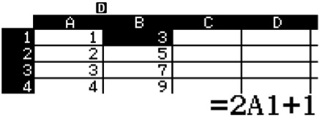
2.5 – 1
ClassWiz steps
Solution using ClassWiz Press w8

First, fill in cells A1 to A7 with 1, 2, 3, 4, 5, 6, 7.

Next, in cell B1, press T1 to fill formula.

For the Form, press 2Qz1+1=. For the range, press $ to edit “B1:B1” to “B1:B7”. You should see this:

Press = and you should see the list of values for question (a) listed out in column B.

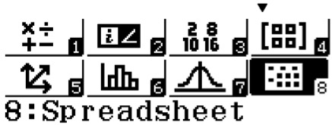
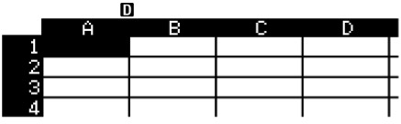

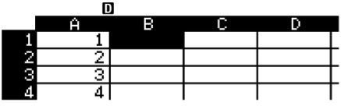





Casio ClassWiz Mathematics Workbook

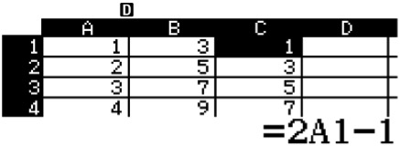
(a) 3, 5, 7, 9, 11, 13, 15
ClassWiz steps
Next, in cell C1, press T1 to fill formula.
For the Form, press 2Qz1p1=. For the range, press $ to edit “C1:C1” to “C1:C7”.
Press = and you should see the list of values for question (b) listed out in column C.
TEACHER’S GUIDE

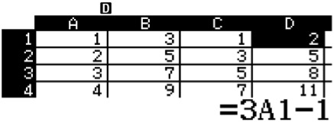
(b) 1, 3, 5, 7, 9, 11, 13
ClassWiz steps
Next, in cell D1, press T1 to fill formula.
For the Form, press 3Qz1p1=. For the range, press $ to edit “D1:D1” to “D1:D7”.
Press = and you should see the list of values for question (c) listed out in column D.

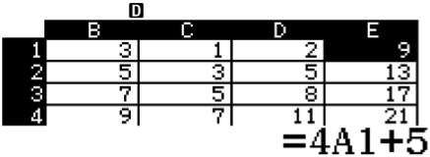
(c) 2, 5, 8, 11, 14, 17, 20
ClassWiz steps
Next, in cell E1, press T1 to fill formula.
For the Form, press 4Qz1+5=. For the range, press $ to edit “E1:E1” to “E1:E7”.
Press = and you should see the list of values for question (d) listed out in column E.

Unit 12 Recursion, Sequences and Series

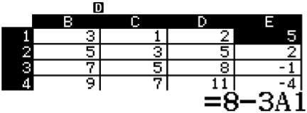
(d) 9, 13, 17, 21, 25, 29, 33
ClassWiz steps
As we exhaust the excel spreadsheet space, we can reuse column B,C,D or E. I am going to reuse E.
Next, in cell E1, press T1 to fill formula.
For the Form, press 8p3Qz1=. For the range, press $ to edit “E1:E1” to “E1:E7”.
Press = and you should see the list of values for question (e) listed out in column E.
TEACHER’S GUIDE

(e) 5, 2, –1, –4, –7, –10, –13

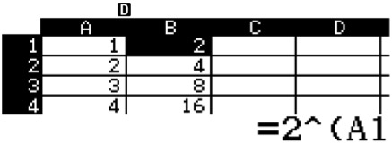
18.
ClassWiz steps
Solution using ClassWiz Press w8
First, fill in cells A1 to A7 with 1, 2, 3, 4, 5, 6, 7. Next, in cell B1, press T1 to fill formula.
For the Form, press 2^Qz1=. For the range, press $ to edit “B1:B1” to“B1:B7”.
Press = and you should see the list of values for question (a) listed out in column B.

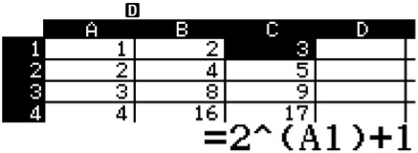
(a) 2, 4, 8, 16, 32, 64, 128
ClassWiz steps
Next, in cell C1, press T1 to fill formula. For the Form, press
2^Qz1)+1=. For the
range, press $ to edit “C1:C1” to“C1:C7”.
Press = and you should see the list of values for question (b) listed out in column C.

Casio ClassWiz Mathematics Workbook

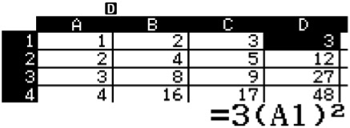
(b) 3, 5, 9, 17, 33, 65, 129
ClassWiz steps
Next, in cell D1, press T1 to fill formula.
For the Form, press 3(Qz1) d=. For the range, press $ to edit “D1:D1” to“D1:D7”.
Press = and you should see the list of values for question (c) listed out in column D.
TEACHER’S GUIDE

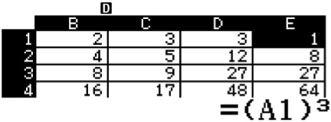
(c) 3, 12, 27, 48, 75, 108, 147
ClassWiz steps
Next, in cell E1, press T1 to fill formula.
For the Form, press (Qz1)D=. For the range, press $ to edit “E1:E1” to “E1:E7”.
Press = and you should see the list of values for question (d) listed out in column E.

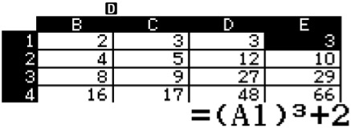
(d) 1, 8, 27, 64, 125, 216, 343
ClassWiz steps
As we exhaust the excel spreadsheet space,
we can reuse column B, C, D or E. I am going to reuse E.
Next, in cell E1, press T1 to fill formula.
For the Form, press (Qz1) D+2=. For the range, press $ to edit “E1:E1” to “E1:E7”.
Press = and you should see the list of values for question (e) listed out in column E.

(e) 3, 10, 29, 66, 127, 218, 345

Unit 12 Recursion, Sequences and Series

Level 2
TEACHER’S GUIDE

1. T15 = 8 + (15 – 1)(12) = 176

2. S20 =$\frac{\text{20}}{\text{2}}$ [2(18) + (20 – 1)(5)] = 1310
3. S10 =$\frac{\text{10}}{\text{2}}$ [2(2) + (10 – 1)(6)] = 290
4. S10 =$\frac{\text{10}}{\text{2}}$[2(14) + (10 – 1)(9)] = 545

5. T3 = a + (3 – 1)d = 12 a + 2d = 12 …(1) T5 = a + (5 – 1)d = 24 a + 4d = 24 …(2)
Take (1) – (2) –2d = –12
d = 6
Hence a + 2(6) = 12
a = 0

S10 = $\frac{10}{\text{2}}$[2(0) + (10 – 1)(6)] = 270
6. T3 = a + (3 – 1)d = 20
a + 2d = 20 …(1)
T12 = a + (12 – 1)d = 56 a + 11d = 56 …(2)
Take (2) – (1) 9d = 36
d = 4
Hence, a + 2(4) = 20
a = 12
S20 =$\frac{\text{20}}{\text{2}}$[2(12) + (20 – 1)(4)] = 1000
7. S10= $\frac{\text{18[}{\text{(} \frac{\text{1}}{ \text{3} } \text{)}}^{\text{10}} \text{– }\text{1]}}{\frac{\text{1}}{ \text{3} } \text{– }\text{1}}$ = 26.999 54…

8. Sn= $\frac{\text{10[1 }\text{– }{\text{(}\text{– } \frac{\text{1}}{ \text{2} }\text{)}}^{\text{n}}\text{]}}{\text{1 }\text{– }\text{ (}\text{– } \frac{\text{1}}{ \text{2} }\text{)}}$ = $\frac{\text{10[1 }\text{– }{\text{(}\text{– } \frac{\text{1}}{ \text{2} }\text{)}}^{\text{n}}\text{]}}{\frac{\text{3}}{ \text{2} }}$ = $\frac{\text{20}}{\text{3}}\text{[1 }\text{– }{\text{(}\text{– }\frac{\text{1}}{ \text{2} }\text{)}}^{\text{n}}\text{]}$
9. $\frac{\text{x}}{ \text{5} }$ = $\frac{\text{245}}{\text{x}}$
x2 = 1225
x = ± 35

10. $\frac{\text{x}}{ \text{7} }$ = $\frac{\text{35}}{\text{x}}$
x2 = 245
x = ± 7$\sqrt{\text{5}}$

11. Sn = $\frac{\text{3}}{\text{2}}$ (${\text{3}}^{\text{n}}$– 1) = $\frac{\text{3(}{\text{3}}^{\text{n}} \text{– }\text{1)}}{\text{3 }\text{– }\text{1}}$
Hence, first term = 3, common ratio = 3.

12. Sn = 4[1 – ${\text{(}\frac{\text{1}}{ \text{2} }\text{)}}^{\text{n}}$] = $\frac{a\text{[1 }\text{– }{\text{(}\text{– }\frac{\text{1}}{ \text{2} }\text{)}}^{\text{n}}\text{]}}{\text{1 }\text{– }\frac{\text{1}}{ \text{2} }}$
4 = $\frac{\text{a}}{ \text{1 }\text{– }\frac{\text{1}}{ \text{2} } }$
4 = 2a
a = 2
Hence, first term = 2 and common ratio = $\frac{\text{1}}{ \text{2} }$.

Casio ClassWiz Mathematics Workbook

Level 3
TEACHER’S GUIDE

1. S4 = $\frac{\text{4}}{ \text{2} }$ [2a + (4 – 1)d] = 100
2a + 3d = 50 …(1)
S7 = $\frac{\text{7}}{ \text{2} }$ [2a + (7 – 1)d] = 238
2a + 6d = 68 …(2)
Take (1) – (2) – 3d = – 18
d = 6
2a + 3(6) = 50
a = 16
Sn= $\frac{\text{n}}{ \text{2} }$ [2(16) + (n – 1)(6)]
= $\frac{\text{n}}{ \text{2} }$ (6n + 26)
= 3n2+13n

2. ${\text{Σ}}_{\text{i} \text{=} \text{1}}^{\text{39}}$n – ${\text{Σ}}_{\text{i} \text{=} \text{1}}^{\text{13}}$3n
ClassWiz steps
Solution using ClassWiz:
Press w1 and press q[ for the summation
function.
Press [$1$39 and you will see this:
Press $pq[ for a new summation function.
Press 3[$1$13= and the
calculator should display 507.

= $\frac{\text{39}}{\text{2}}$ [2(1) + (39 – 1)(1)] – $\frac{\text{13}}{\text{2}}$ [2(3) + (13 – 1)(3)]
= 780 – 273
= 507
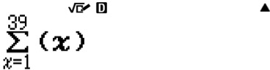

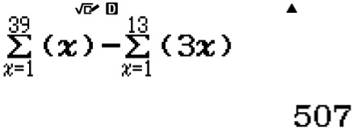

3.${\text{Σ}}_{\text{i} \text{=} \text{1}}^{\text{79}}$n – ${\text{Σ}}_{\text{i} \text{=} \text{1}}^{\text{15}}$5n – ${\text{Σ}}_{\text{i} \text{=} \text{1}}^{\text{11}}$7n
= $\frac{79}{2}$ [2(1) + (79 – 1)(1)] – $\frac{15}{2}$ [2(5) + (15 – 1)$(5)$] – $\frac{11}{2}$[2(7) + (11 – 1)$(7)$]
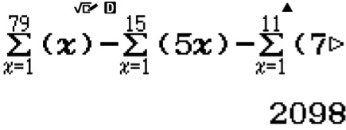
= 3160 – 600 – 462
ClassWiz steps
Solution using ClassWiz:
Press w1 and press q[ for the summation function.
Press [$1$79.
Press $pq[ for a new summation function.
Press 5[$1$15.
Press $pq[ for a new summation function.
Press 7[$1$11=. Your calculator should display 2098.

= 2098

Unit 12 Recursion, Sequences and Series

- Let the three numbers be a, ar, ar2. a + ar + ar2 = 26
TEACHER’S GUIDE
a(1 + r + r2) = 26 …(1)
a(ar)(ar2) = 216
a3r3 = 216
ar = 6

a = $\frac{\text{6}}{ \text{r} }$ …(2)

Sub (2) into (1) ( $\frac{\text{6}}{ \text{r} }$ )(1 + r + ${\text{r}}^{\text{2}}$ ) = 26
6 + 6r + 6r2 = 26r
6 – 20r + 6r2 = 0
3 – 10r + 3r2 = 0 (3r – 1)(r – 3) = 0
r = $\frac{\text{1}}{ \text{3} }$ or 3
When r =$\frac{\text{1}}{ \text{3} }$ , a = 18
Hence the three numbers are 18, 6, 2 When r = 3, a = 2
Hence the three numbers are 2, 6, 18.

- Let the three numbers be a, ar, ar2. a + ar + ar2 = 13
a(1 + r + r2) = 13 …(1)
a(ar)(ar2) = 217
a3r3 = 27
ar = 3

a = $\frac{\text{3}}{ \text{r} }$ …(2)
Sub (2) into (1) ( $\frac{\text{3}}{ \text{r} }$ )(1 + r + ${\text{r}}^{\text{2}}$ ) = 13
3 + 3r + 3r2 = 13r
3 – 10r + 3r2 = 0 (3r – 1)(r – 3) = 0
r = $\frac{\text{1}}{ \text{3} }$ or 3
When r = $\frac{\text{1}}{ \text{3} }$ , a = 9
Hence the three numbers are 9, 3, 1 When r = 3, a = 1
Hence the three numbers are 1, 3, 9.

- ${\text{S}}_{\text{n}}$ = $\frac{\text{1[1 }\text{– }{\text{(}\text{– }\frac{\text{3}}{ \text{4} }\text{)}}^{\text{n}}\text{]}}{\text{1 }\text{– }\frac{\text{3}}{ \text{4} }}$ = $\frac{\text{1[1 }\text{– }{\text{(}\text{– }\frac{\text{3}}{ \text{4} }\text{)}}^{\text{n}}\text{]}}{\frac{\text{1}}{ \text{4} }}$ = 4[1 – ${\text{( }\frac{\text{3}}{ \text{4} }\text{ )}}^{\text{n}}\text{]}$

For 4[1 – ${\text{( }\frac{\text{3}}{ \text{4} }\text{ )}}^{\text{n}}$] > 3, 1 – ${\text{( }\frac{\text{3}}{ \text{4} }\text{ )}}^{\text{n}}$ > $\frac{3}{ 4 }$
${\text{( }\frac{\text{3}}{ \text{4} }\text{ )}}^{\text{n}}$< $\frac{\text{1}}{ \text{4} }$
n ln ( $\frac{3}{ 4 }$ ) > ln ( $\frac{1}{ 4 }$ )

a negative value.
taking ln on $\frac{\text{3}}{ \text{4} }$ and $\frac{\text{1}}{ \text{4} }$ gives
There is a sign change as
n > $\frac{ \text{In }\frac{\text{1}}{ \text{4} } }{ \text{ In }\frac{\text{3}}{ \text{4} } }$
n > 4.8188
n = 5
At least 5 terms are needed for the sum of these terms to exceed the value of 3.

