Unit
8
VECTORS

KEY CONCEPTS
TEACHER’S GUIDE

Vector notation
Vectors are quantities that possess both magnitude and direction.
A vector is represented by a directed line segment, with the direction indicated by the arrow drawn on the line. The magnitude of the vector is represented by the length of the line segment.
Magnitude of a vector a is denoted by |a|. The vector below can be denoted by AB or a.
B

A
a

Equal vectors
Two vectors are equal if they have the same magnitude and the same direction.
Example A parallelogram PQRS has PQ = SR and SP = RQ.

P Q

S R

Negative vectors
Negative vectors have the same magnitude but are in opposite direction.

Zero vector
The zero vector or null vector is a vector with zero magnitude and no direction.

Casio ClassWiz Mathematics Workbook
TEACHER’S GUIDE

Addition of vectors (Triangle Law of Vector Addition)
When two vectors are represented by two sides of a triangle in magnitude and direction taken in same order then the resultant of the vectors can be represented by the third side of that triangle.

C
a + b
b

A a B

Notice how the direction flows from point A (initial point) to point B and then to point C (terminal point). This means that the shortest pathway to get from point A to point C is AC.
From the diagram, the resultant vector can be written as AC = a + b

Addition of vectors (Parallelogram Law of Vector Addition)
If two vectors acting simultaneously at a point can be represented both in magnitude and direction by the adjacent sides of a parallelogram drawn from a point, then the resultant vector is represented both in magnitude and direction by the diagonal of the parallelogram passing through that point.

D C
a
a + b
b
B

A

Notice how the direction of both vectors are acting on the point A. Hence, we draw out the dotted lines
DC and BC to show the parallelogram. The diagonal of this parallelogram will be the resultant vector. From the diagram, the resultant vector can be written as AC = a + b.
- Commutative Law: a + b = b + a
- Associative Law: (a + b) + c = a + (b + c)
Notice that point C is a connecting point for the addition of the vector.

Subtraction of vectors
a – b = a + (–b)
A negative vector has the opposite direction from the positive vector.
Magnitude is not affected by the negative sign.

Unit 8 Vectors

Scalar multiplication of a vector
TEACHER’S GUIDE
TEACHER’S GUIDE
When a vector a is multiplied by a scalar k, the magnitude becomes k|a| and the direction will be affected only if k is negative.
If a and b are vectors and m and n are real numbers,
- m(na) = n(ma) = (mn)a
- (m + n)a = ma + na
- m(a + b) = ma + mb
- AB = k BC , if points A, B and C lie on a straight line.

Column vectors
Column vectors are written in the form of $\left(\begin{matrix}x \\ y\end{matrix}\right)$ where x is the horizontal change and y is the vertical change.
Laws of column vectors: Given a = $\left(\begin{matrix}p \\ q\end{matrix}\right)$ and b = $\left(\begin{matrix}r \\ s\end{matrix}\right)$ .
If a = b, then p = r and q = s.
a + b = $\left(\begin{matrix}p+r \\ q+s\end{matrix}\right)$
a – b = $\left(\begin{matrix}p-r \\ q-s\end{matrix}\right)$
ha = $\left(\begin{matrix}hp \\ hq\end{matrix}\right)$
ha + kb = $\left(\begin{matrix}hp \\ hq\end{matrix}\right)$ + $\left(\begin{matrix}kr \\ ks\end{matrix}\right)$ = $\left(\begin{matrix}hp+kr \\ hq+ks\end{matrix}\right)$
Magnitude of a 2-dimensional column vector: Given a = $\left(\begin{matrix}p \\ q\end{matrix}\right)$, |a| = $\sqrt{p^{2}+q^{2}}$.
Magnitude of a 3-dimensional column vector: Given c = $\left(\begin{matrix}p \\ q \\ r\end{matrix}\right)$, |$c$|= $\sqrt{p^{2}+q^{2}+r^{2}}$ .

Position vectors
Position vectors are vectors of a point drawn from the origin to the point itself. Position vectors are made with reference to the Cartesian plane and the origin O.
Given OA = $\left(\begin{matrix}x \\ y\end{matrix}\right)$, x is the change in x units from origin and y is the change in y units from origin.

Dot product
The dot product is a scalar quantity and is commutative: a∙b = b∙a.
Geometric definition: a∙b = $\left|a\right| \left|b\right|$ cos θ, where θ is the angle formed between the two vectors.
Algebraic definition: Given a = $\left(\begin{matrix}m \\ n\end{matrix}\right)$ and b = $\left(\begin{matrix}p \\ q\end{matrix}\right)$, a∙b = mp + nq
Algebraic definition: Given a = $\left(\begin{matrix}m \\ n \\ l\end{matrix}\right)$ and b = $\left(\begin{matrix}p \\ q \\ r\end{matrix}\right)$, a∙b = mp + nq + lr

Cross product
The resultant vector of a cross product is a 3-dimension vector and is perpendicular to the plane containing the two vectors.
Geometric definition: a∙b = |a| |b| sin θ, where θ is the angle between the two vectors.
Algebraic definition: Given a = $\left(\begin{matrix}m \\ n \\ l\end{matrix}\right)$ and b = $\left(\begin{matrix}p \\ q \\ r\end{matrix}\right)$, a × b =$\left(\begin{matrix}nr-lq \\ lp-nr \\ mp-np\end{matrix}\right)$.
Not commutative: a × b ≠ b × a.

Casio ClassWiz Mathematics Workbook
TEACHER’S GUIDE

WORKED EXAMPLES

Level 1

Worked Example 1
Find the value of the unknown constants h and k for 3a + 2kb = ha + 6b.

Solution
By comparison, h = 3 and k = 3.

Worked Example 2
Find the value of the unknown constants a and b in $\left(\begin{matrix} 2a \\ b\end{matrix}\right)$ = $\left(\begin{matrix} 4 \\ 3 \end{matrix}\right).$

Solution
By comparison, a = 2 and b = 3.

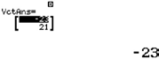Worked Example 3
ClassWiz steps
Solution using ClassWiz steps
Press w5 and select 1 followed by 2 to define vector A as a 2-dimensional vector.

Press T and select 1, 2 followed by 2 to define vector B
as a 2-dimensional vector.

Press T and select 1, 3 followed by 2 to define vector C
as a 2-dimensional vector.

Press W and 3(T3 + T4)pT5

Press = and the calculator will show
Evaluate the column vector
3$\left[\left(\begin{matrix} 1 \\ 4 \end{matrix}\right) + \left(\begin{matrix}-7 \\ 2 \end{matrix}\right) – \left(\begin{matrix} 5 \\ -3 \end{matrix}\right)\right]$.

Solution
3$\left[\left(\begin{matrix} 1 \\ 4 \end{matrix}\right) + \left(\begin{matrix}-7 \\ 2\end{matrix}\right) – \left(\begin{matrix} 5 \\ -3 \end{matrix}\right)\right]$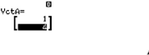
= 3 $\left(\begin{matrix}-6 \\ 6 \end{matrix}\right) – \left(\begin{matrix} 5 \\ -3 \end{matrix}\right)$
= $\left(\begin{matrix}-18 \\ 18 \end{matrix}\right) – \left(\begin{matrix} 5 \\ -3 \end{matrix}\right)$
= $\left(\begin{matrix}-23 \\ 21 \end{matrix}\right)$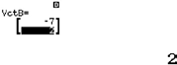

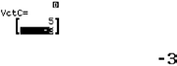

Unit 8 Vectors

Worked Example 4
TEACHER’S GUIDE
Evaluate the magnitude of the following column vectors. You may use your ClassWiz calculator. (a) $\left(\begin{matrix}-3 \\ 8 \end{matrix}\right)$
(b) $\left(\begin{matrix} \\ \begin{matrix}-1 \\ 4 \\ 9\end{matrix} \end{matrix}\right)$
Solution
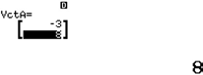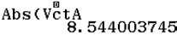
Press W to go back to the main screen and press
q(for the f button.
Press T3 and press =. The calculator will display 8.544003745.
ClassWiz steps
Solution using ClassWiz steps
Press w5 and select 1 followed by 2 to define vector A as a 2-dimensional vector.
(a) $\left|\left(\begin{matrix}-3 \\ 8 \end{matrix}\right)\right|$= $\sqrt{{\left(-3\right)}^{2}{+8}^{2}})$= $\sqrt{73}$

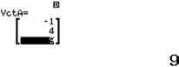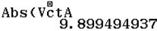(b) $\left|\left(\begin{matrix}-1 \\ 4 \\ 9\end{matrix}\right)\right|$= $\sqrt{{\left(-1\right)}^{2}{+4}^{2}+9^{2})}$ = $\sqrt{835}$
Press W to go back to the main screen and press
q(for the f button.
Press T3 and press =. The calculator will display 9.899494937.
ClassWiz steps
Solution using ClassWiz steps
Press w5 and select 1 followed by 3 to define vector A as a 3-dimensional vector.
Casio ClassWiz Mathematics Workbook

Level 2

Worked Example 5
In the diagram, ABCD is a parallelogram and the diagonals intersect at point E. It is given that DA = 2p + q
and DC = –p + 4q.
B

- Find AB .
- Find DB.
- Find AC .
- Find CE .
2p + q

D
A
E
C
–p + 4q

TEACHER’S GUIDE
Solution
- AB = –p + 4q.
Note that AD = –DA.
- DB = 2p + q – p + 4q = p + 5q
- AC = AD + DC = –2p – q – p + 4q = –3p + 3q (d) CE = –$\frac{ 1 }{ 2 }$ AC = –$\frac{ 1 }{ 2 }$ (–3p + 3q) = + $\frac{ 3 }{ 2 }$ p – $\frac{ 3 }{ 2 }$ q

Worked Example 6
Find the value(s) of the unknown constants p and q in the following vectors.
- 4pa + 5b = (p2 + 3)a + qb
- $\left(\begin{matrix}p \\ -q\end{matrix}\right)+ 2\left(\begin{matrix}p \\ q^{2}\end{matrix}\right) = \left(\begin{matrix} 9 \\ 1 \end{matrix}\right)$
Solution
(a) 4pa + 5b = (p2 + 3)a + qb
By comparison, 4p = p2 + 3
p2 – 4p + 3 = 0
(p – 3)(p – 1) = 0
p = 3 or 1 By comparison, q = 5
(b) $\left(\begin{matrix}p \\ -q\end{matrix}\right)+ 2\left(\begin{matrix}p \\ q^{2}\end{matrix}\right) = \left(\begin{matrix} 9 \\ 1 \end{matrix}\right)$
$\left(\begin{matrix}p+2p \\ -q+2q^{2}\end{matrix}\right) = \left(\begin{matrix} 9 \\ 1 \end{matrix}\right)$
By comparison, 3p = 9
p = 3
By comparison, – q + 2q2 = 1
2q2 – q – 1 = 0 (2q + 1)(q – 1) = 0
q = –$\frac{ 1 }{ 2 }$ or 1

Unit 8 Vectors

Worked Example 7
TEACHER’S GUIDE
Find the value of the angle, in degrees, formed by the vector $\left(\frac{-4}{5}\right)$ against the positive x-axis.

Solution
Gradient of OA = – $\frac{ 4 }{ 5 }$
Since gradient is negative, the angle formed by the vector against the positive x-axis is going to be obtuse.
tan θ = –$\frac{ 4 }{ 5 }$
Basic angle = tan–1 $\left(\frac{ 4 }{ 5 }\right)$ = 38.7°

Angle formed by the vector against the positive x-axis = 180° – 38.7° = 141.3°

Worked Example 8
- In the diagram, 2AB = 3AX. Find the ratio of the area of ∆ABC to the area of ∆XBC.

X
A
C

B

- In the diagram, BC is parallel to DE and AC = 5CE. Find the ratio of the area of ∆ABC to the area of ∆ADE.

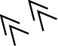D
B

A C E

Solution
- Given 2AB = 3AX, and AX : AB = 2 : 3,
Since triangle CAB and triangle CXB share the same height,
Note that the base in reference to the height is AB and XB.
$\frac{Area of ∆ABC }{Area of ∆XBC}$ = $\frac{Base of ∆ABC }{Base of ∆XBC}$ = $\frac{ 3 }{ 5 }$
- Since ∆ABC is similar to ΔADC,
$\frac{Area of ∆ABC }{Area of ∆ADE}$ = $\left(\frac{AC}{AE}\right)$ = ${\left(\frac{ 5 }{ 6 }\right)}^{2}$= $\frac{ 25 }{ 36 }$

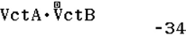Casio ClassWiz Mathematics Workbook
TEACHER’S GUIDE

Level 3

Worked Example 9
Evaluate the dot product of a = $\left(\begin{matrix}-2 \\ 7\end{matrix}\right)$ and b = $\left(\begin{matrix}3 \\ -4\end{matrix}\right)$ using the ClassWiz calculator and hence find the angle

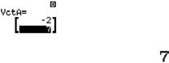that is formed between the two vectors.
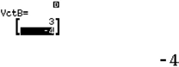
ClassWiz steps
Solution using ClassWiz steps
Press w5 and select 1 followed by 2 to define vector A as a 2-dimensional vector.

Press T and select 1, 2 followed by 2 to define vector B
as a 2-dimensional vector.

Press WT3TR2T4 = .

Unit 8 Vectors

Worked Example 10
TEACHER’S GUIDE
TEACHER’S GUIDE
- By finding the magnitude of the cross product of a = $\left(\begin{matrix}-2 \\ 7\end{matrix}\right)$ and b = $\left(\begin{matrix}3 \\ -4\end{matrix}\right)$with the use of ClassWiz
calculator, find the area of the triangle that is formed by the two vectors.
- By finding the magnitude of the cross product of a = $\left(\begin{matrix} -2 \\ 7 \\ 5\end{matrix}\right)$and b = $\left(\begin{matrix} 3 \\ -4 \\ 2\end{matrix}\right)$with the use of ClassWiz
calculator, find the area of the triangle that is formed by the two vectors.

Solution
- 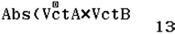The area of the triangular plane is 6.5 square units.
The magnitude of the cross product gives the area of the parallelogram plane.
To find the area of the triangular plane, we need to divide the area by 2.

as a 2-dimensional vector $\left(\begin{matrix} 3 \\ -4\end{matrix}\right)$ .

Press WeT3OT4 = .

Press T and select 1, 2 followed by 2 to define vector B
a 2-dimensional vector $\left(\begin{matrix}-2 \\ 7\end{matrix}\right)$.
.
Press w5 and select 1 followed by 2 to define vector A as

ClassWiz steps
Solution using ClassWiz steps

- 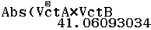The area of the triangular plane is 20.5 square units. (3 s.f.)
The magnitude of
the cross product
gives the area of the
parallelogram plane.
To find the area of the
triangular plane, we
need to divide the area
by 2.

Press w5 and select 1 followed by 3 to define vector A as
ClassWiz steps
Solution using ClassWiz steps
a 3-dimensional vector $\left(\begin{matrix} -2 \\ 7 \\ 5\end{matrix}\right).$
.
Press T and select 1, 2 followed by 3 to define vector B

as a 3-dimensional vector $\left(\begin{matrix} 3 \\ -4 \\ 2\end{matrix}\right)$.
Press WeT3OT4 = .

Casio ClassWiz Mathematics Workbook
CLASSWIZ WORKSHEETS

CLASSWIZ WORKSHEETS

Level 1
- In the grids, vectors a and b are given. Draw the following vectors. (a) 2.5a (b) –3a
- 2b (d) 4b
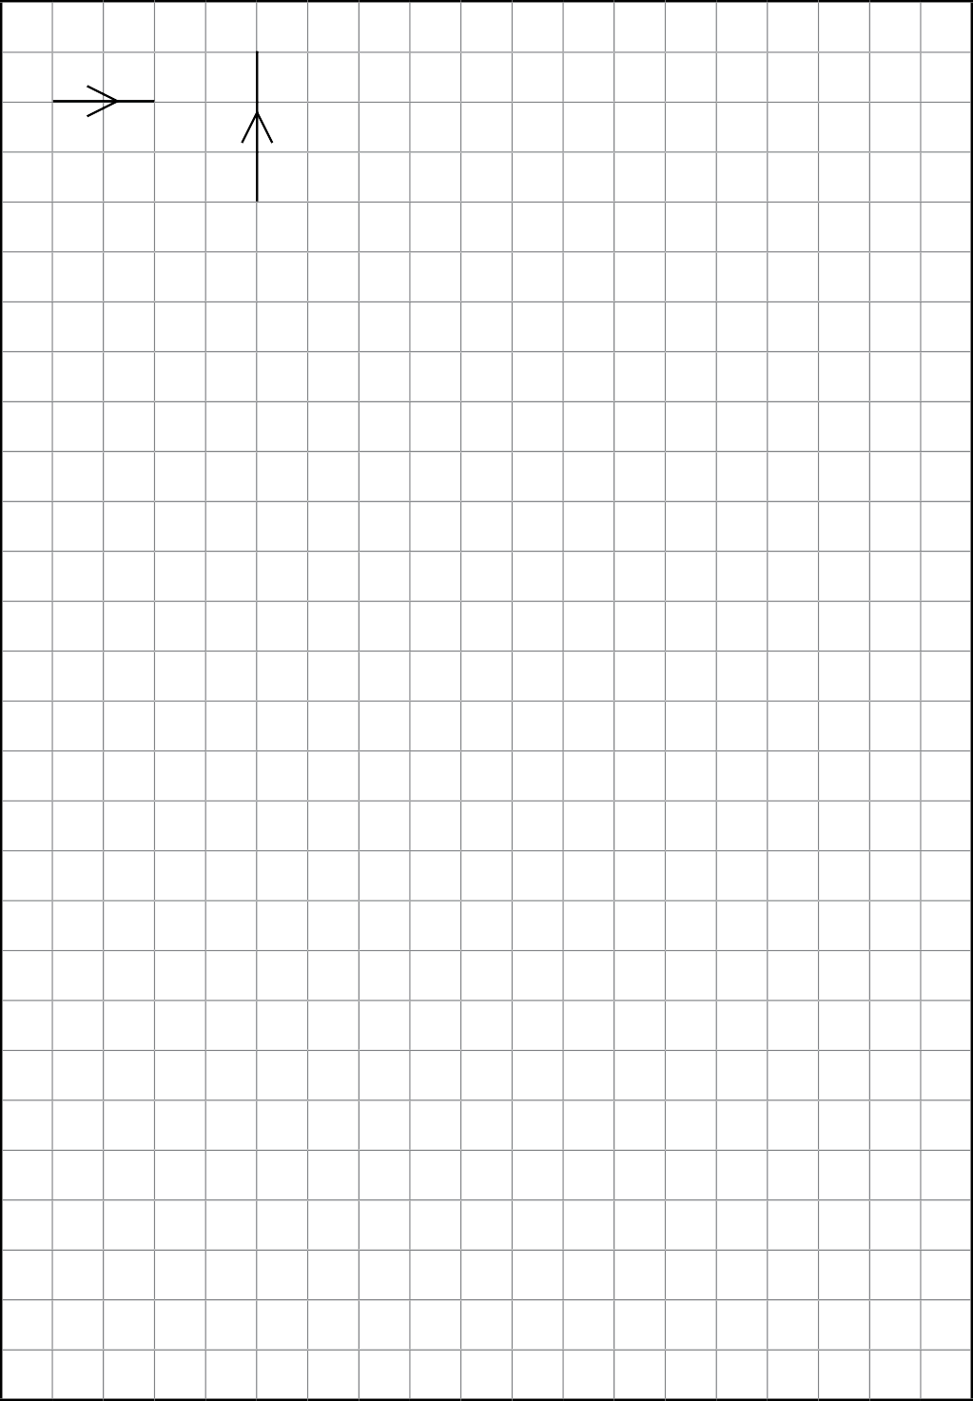
(e) –b

a

b

Unit 8 Vectors

- Simplify the following vectors.
CLASSWIZ WORKSHEETS

(a) –(a + b) | (b) 2a – (b – 2a)
(c) 0b – 3a + 7b | (d) 4b – (0a + 2b)

- Find the resultant vector AB in the following diagrams.

(a) A |  |  | a | O |  |  | (b) 3q  O |  | B
 |  |  |  |  |  |  | –2p
 |  |  | 2b
 |  |  |  |  |  |  |  | A
B
(c) A |  |  |  |  | B |  | (d) O | –5g
2h |  | O | 3k |  |  |  | 2h | B
 |  |  |  |  |  |  | A
(e) A |  |  |  |  |  | B | (f ) A | 5m
 | 1_ i  2 |  |  |  | 3j |  | O
 |  |  | O
 |  |  |  |  |  |  | –2n
 |  |  |  |  |  |  | B
(g) A  C 2a  5_ c  3 – 1_ b  2  O  B |  |  |  |  |  |  | (h) O | –2k
 |  |  |  |  |  |  |  |  |  |  | C
 |  |  |  |  |  |  |  |  |  | 1_ l
 |  |  |  |  |  |  | –3j | B |  | 2
 |  |  |  |  |  |  | A

Casio ClassWiz Mathematics Workbook
CLASSWIZ WORKSHEETS

- In the grids, vectors a and b are given. Draw the following resultant vectors.

(a) 2a + b (b)$\frac{ 2 }{3 }$ a + $\frac{ 3 }{2 }$ b

(c) $\frac{ 1 }{2}$ a + 2b
(d) 2b +$\frac{ 1 }{2 }$a
Teachers to note that vectors are commutative. Hence resultant vectors are the same.

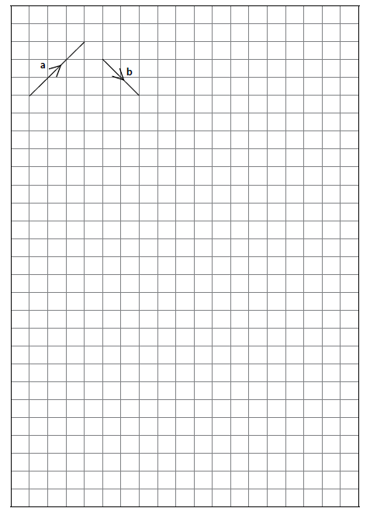

Unit 8 Vectors

- Evaluate the following scalar multiplication.
CLASSWIZ WORKSHEETS

(a) 2(3a) | (b) 3(a – 4b)
(c) 5(2a – b) + 3a | (d) –4(–3a + 7b) + 2(5a – 3b)
- By comparison, find the value of the unknown constants.

(a) 2a + 5b = pa + qb | (b) – 3a + 7b = ha – kb
(c) – 4a – 6b = pa – a + qb | (d) 3(b – ha) = 5a + kb
(e) ka + 2b = 5(a + hb) – 3b | (f ) –5(2a – pb) = 3(a – 4b) + qa – 3b

Casio ClassWiz Mathematics Workbook
CLASSWIZ WORKSHEETS

- Write down the column vector for the following vectors in the Cartesian plane.
i
h
g
f
e
d
b
a
c

  - a = (b) b =

(c) c = (d) d =

(e) e = (f) f =

(g) g = (h) h =

(i) i =

Unit 8 Vectors

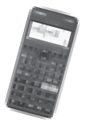 8. Evaluate the following column vectors, given that
ClassWiz set-up
Press w5 and select 1 followed by 2 to
define vector A as a 2-dimensional vector$\left(\begin{matrix} 4 \\ 5 \end{matrix}\right)$.
Press T and select 1, 2 followed by 2 to
define vector B as a 2-dimensional vector$\left(\begin{matrix}-6 \\ 3 \end{matrix}\right)$.
Press T and select 1, 3 followed by 2 to
define vector B as a 2-dimensional vector$\left(\begin{matrix}2 \\ -7 \end{matrix}\right)$.
Press T and select 1, 4 followed by 2 to
define vector B as a 2-dimensional vector$\left(\begin{matrix}-3 \\ -1 \end{matrix}\right)$.

CLASSWIZ WORKSHEETS
OA = $\left(\begin{matrix} 4 \\ 5 \end{matrix}\right)$, OB = $\left(\begin{matrix}-6 \\ 3\end{matrix}\right)$, OC = $\left(\begin{matrix} 2 \\ -7\end{matrix}\right)$ and OD = $\left(\begin{matrix}-3 \\ -1\end{matrix}\right)$.

(a) OA + OB

(b) OA – OB | (c) OA + OB + OC
(d) OC + 2OD | (e) 2OD + OC
Teacher to note: Vectors are commutative.
(f ) 3OA – 5OD | (g) 4(OD – OB)
(h) (OA + OB) + OD | (i) OA + (OB + OD)
Teacher to note: Vectors are associative.

Casio ClassWiz Mathematics Workbook
CLASSWIZ WORKSHEETS

- By comparison, find the value of the unknown constants a and b in the following vectors.

(a) $\left(\begin{matrix} a \\ b \end{matrix}\right)$ = $\left(\begin{matrix} -3 \\ 4\end{matrix}\right)$ | (b) $\left(\begin{matrix} 5 \\ a \end{matrix}\right)$ = $\left(\begin{matrix} 2b \\ 3\end{matrix}\right)$
(c) $\left(\begin{matrix} 1.5a \\ 2b-3\end{matrix}\right)$ = $\left(\begin{matrix} 5-a \\ 3b\end{matrix}\right)$ | (d) -2$\left(\begin{matrix} 2a \\ b+3\end{matrix}\right)$ = $\left(\begin{matrix} 8 \\ b\end{matrix}\right)$
(e) $\left(\begin{matrix} 5 \\ -1\end{matrix}\right)+2\left(\begin{matrix} a \\ 2b\end{matrix}\right)$ = $\left(\begin{matrix} 1 \\ 3b\end{matrix}\right)$ | (f ) 2$\left[\left(\begin{matrix} a \\ 2+b\end{matrix}\right)-\left(\begin{matrix}3 \\ -1 \end{matrix}\right)\right]$= $-\left(\begin{matrix} a \\ 2b\end{matrix}\right)$
- Evaluate the magnitude of the following column vectors.
You may use the ClassWiz calculator by pressing the f function.

(a) $\left(\begin{matrix} 5 \\ 1 \end{matrix}\right)$

(b)$\left(\begin{matrix} 2 \\ 2 \end{matrix}\right)$ | (c) $\left(\begin{matrix} 2m \\ 3n \end{matrix}\right)$
(d)$\left(\begin{matrix} 3 \\ 7 \end{matrix}\right)$ | (e) $\left(\begin{matrix} 6 \\ 14 \end{matrix}\right)$
Teacher to note: Is the magnitude of $\left(\begin{matrix} 6 \\ 14 \end{matrix}\right)$going to be twice of $\left(\begin{matrix}3 \\ 7\end{matrix}\right)$ ? Since 2$\left(\begin{matrix} 3 \\ 7\end{matrix}\right)$= $\left(\begin{matrix} 6 \\ 14 \end{matrix}\right)$ , the scalar

is 2, and the magnitude will be twice of $\left(\begin{matrix}3 \\ 7\end{matrix}\right)$.

(f )$\left(\begin{matrix} 6 \\ -5 \end{matrix}\right)$ | (g) $\left(\begin{matrix}-6 \\ 5 \end{matrix}\right)$
Teacher to note: Will these 2 vectors give the same magnitude? Since $\left(\begin{matrix}- 6 \\ 5 \end{matrix}\right)$ = -$\left(\begin{matrix}- 6 \\ 5 \end{matrix}\right)$, the two
vectors are in the opposite direction. They will have the same magnitude.

Unit 8 Vectors

- Write down the position vectors of the following vectors.
CLASSWIZ WORKSHEETS
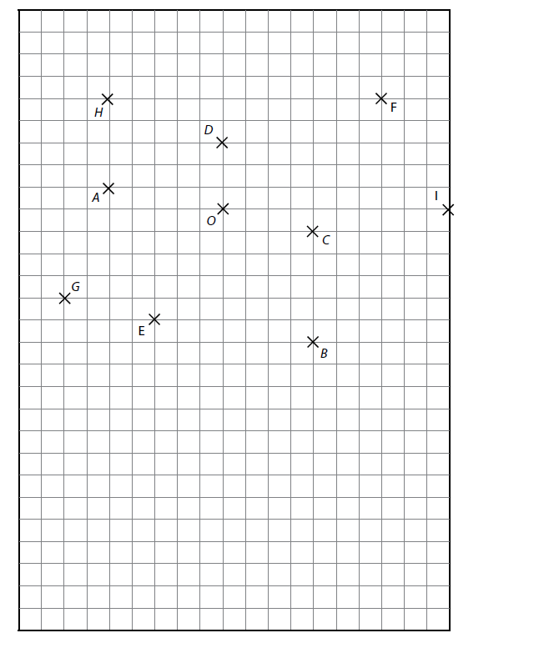

  - OA = (b) OB =

(c) OC = (d) OD =

(e) OE = (f) OF =

(g) OG = (h) OH =

- OI =

Casio ClassWiz Mathematics Workbook
CLASSWIZ WORKSHEETS

Level 2
- In the grids, vectors a and b are given. Draw the following resultant vectors.

(a) 2a + b (b) –2a – 2b

(d) –$\frac{ 3 }{2}$ b – a
(c) a +$\frac{ 3 }{2}$ b

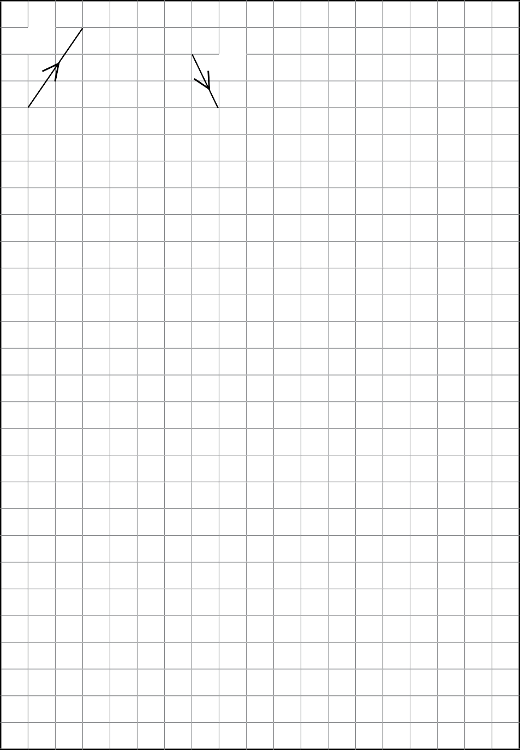
(e) 3a – 2.5b
Teachers to note that two vectors are in opposite direction, and help them understand why.

b
a

Unit 8 Vectors

- On the grid, OX = a and OY = b. There are several points marked on the grid. Write down in terms of a
CLASSWIZ WORKSHEETS
and/or b for the following vectors.
E
D
F
O
C
Y
X
a
b
A
B

  - OA (b) OB

(c) OC (d) OD

(e) OE (f) OF

Casio ClassWiz Mathematics Workbook
CLASSWIZ WORKSHEETS

- On the grid, OM = a and ON = a. There are several points marked on the grid. Write down in terms of a
and/or b for the following vectors.
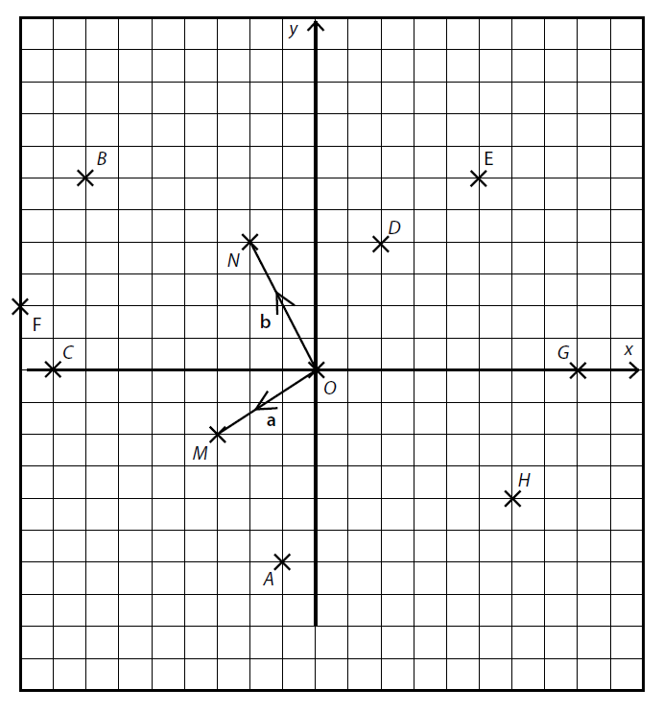

  - OA (b) OB

(c) OC (d) OD

(e) OE (f) OF

(g) OG (h) OH

Unit 8 Vectors

- In the diagram, ABCD is a parallelogram and the diagonals intersect at point E. Find
CLASSWIZ WORKSHEETS
4a B
A
E
C

b

D

  - DC (b) AC

(c) BD (d) CE

- In the diagram, triangle ABC is similar to triangle DEC, where the corresponding lengths are in the ratio of 2 : 1 respectively. AD and BE are straight lines that intersect at C. Given that AC = 4h and EC = k, find the following vectors in terms of h and k.

A B
E
D
k
C
4h

  - CD (b) BC

Teacher to note the parallel property of ED and AB. Can you find the scalar multiple? Since triangle ABC is similar to triangle DEC, angle EDC = angle BAC. By the property of alternate angles, ED is parallel to AB.
(d) BA
(c) ED

Casio ClassWiz Mathematics Workbook
CLASSWIZ WORKSHEETS

- The diagram shows a quadrilateral ABCD where AD = 1.5 BC . Given that AB = 2q and AD = 3p, find
A

D
2q
3p
B
C

  - BC (b) DC

(c) DB (d) AC

- The diagram shows a trapezium ABCDEF where AB is parallel to FC and FE : ED : DC are in the ratio of 1 : 3 : 4. Given that FE = a and AE = b, find

A B

F C
b
a
E
D

  - FD (b) AB

(c) FB (d) CE

(e) BC (f) AC

Unit 8 Vectors

- By comparison, find the value(s) of the unknown constants.
You may use your Classwiz calculator for solving the quadratic equations.
CLASSWIZ WORKSHEETS
(a) 3a – 2b = (p2 – 2p)a + qb

(b) 7pa – 5a – 6b = 2p2 a + qb

(c) 10qa + (p2 – 1)b = 2(2q2 – 3)a + 3b

- By comparison, find the value of the unknown constants a and b in the following vectors.

You may use your Classwiz calculator for solving the | quadratic equations and simultaneous equations.
(a) $\left(\begin{matrix}3a \\ –2b\end{matrix}\right)$ – 2$\left(\begin{matrix}2b \\ 1\end{matrix}\right)$ = $\left(\begin{matrix}10 \\ –a\end{matrix}\right)$ | (b) $\left(\begin{matrix}7a \\ –2b\end{matrix}\right)$ + $\left(\begin{matrix} 1 \\ 1\end{matrix}\right)$ = $\left(\begin{matrix}6b \\ –a\end{matrix}\right)$
(c) 4$\left(\begin{matrix}2a \\ b\end{matrix}\right)$ – 3$\left(\begin{matrix}5 \\ –a\end{matrix}\right)$ = $\left(\begin{matrix}b \\ 10\end{matrix}\right)$ | (d) $\left(\begin{matrix}a^{2} \\ b\end{matrix}\right)$ – 5$\left(\begin{matrix} 3 \\ 1\end{matrix}\right)$ = $\left(\begin{matrix}-2a \\ 1 – b\end{matrix}\right)$
(e) 2$\left(\begin{matrix}a^{2} \\ 20\end{matrix}\right)$ = $\left(\begin{matrix}3a \\ b^{2}\end{matrix}\right)$ + $\left(\begin{matrix}5 \\ b-2\end{matrix}\right)$ | (f ) $\left(\begin{matrix}{3a}^{2} \\ -11b\end{matrix}\right)$ = $\left(\begin{matrix}14a \\ -b^{2}\end{matrix}\right)$ + 5$\left(\begin{matrix} 1 \\ -6\end{matrix}\right)$

Casio ClassWiz Mathematics Workbook

- It is given that p = $\left(\begin{matrix}-5 \\ 8\end{matrix}\right)$ and q = $\left(\begin{matrix}3 \\ -10\end{matrix}\right)$and r =$\left(\begin{matrix} a \\ b\end{matrix}\right)$.

  - Express as a column vector
    - 3p – q.
    - –4p + 2q.

  - Find
(i) |–2p|.
- |3p – q|.
CLASSWIZ WORKSHEETS

  - Given that 2p + q = r, find the value of a and b.

  - Given that –2p – 3q = 2s, express s as a column vector.

- It is given that a = $\left(\begin{matrix}1 \\ -3\end{matrix} \right)$ and b = $\left(\begin{matrix}-9 \\ 7\end{matrix}\right)$ and r = $\left(\begin{matrix} m \\ 3\end{matrix}\right)$.
  - Express as a column vector
    - 4a – 3b.
    - –a + 2b.

  - Find
(i) |4a – 3b|.
(ii) |3a – b|.

  - Given that 2a + b is parallel to r, find the value of m.

Unit 8 Vectors

- It is given that OA = $\left(\begin{matrix} 5 \\ 9\end{matrix}\right)$, OB = $\left(\begin{matrix}-3 \\ 6\end{matrix}\right)$ and OC = $\left(\begin{matrix}-7 \\ 1\end{matrix}\right)$ .
CLASSWIZ WORKSHEETS
  - Express AB as a column vector.
  - Express BC as a column vector.
  - Find | BC |.

13. It is given that AB = $\left(\begin{matrix} 3 \\ 5\end{matrix}\right)$ and BC = $\left(\begin{matrix}-2 \\ -8\end{matrix}\right)$ .
- Express AC as a column vector.

- Find | AC |.

- Given that CD =$\frac{ 1 }{2}$ CB, express CD as a column vector.

- Given that C is the point (4, 6), find coordinates of point D.

14. The coordinates of points A and B are (5, –7) and (8, 11) respectively.
- Express OA and OB as column vectors.

- Find AB.

- Given that AB = 3BC, find the coordinates of C.

Casio ClassWiz Mathematics Workbook
CLASSWIZ WORKSHEETS

- It is given that OD = $\left(\begin{matrix}-1 \\ 8\end{matrix}\right)$ and OE $\left(\begin{matrix} \\ \begin{matrix}6 \\ 11\end{matrix}\end{matrix}\right)$ .
  - Find DE.

  - Given that OP = $\left(\begin{matrix} \\ \begin{matrix}m \\ 6 \end{matrix}\end{matrix}\right)$ and OP is parallel to DE, find the value of m.

- It is given that PQ = $\left(\begin{matrix} \\ \begin{matrix}-5 \\ 5\end{matrix}\end{matrix}\right)$ and QR = $\left(\begin{matrix} \\ \begin{matrix}2 \\ -3\end{matrix}\end{matrix}\right)$.
  - Find OQ given that the coordinates of point R is (8, –5).

  - Find the coordinates of X given that QX = $\frac{ 2 }{ 5 }$PQ.

- It is given that AB = $\left(\begin{matrix} \\ \begin{matrix}4 \\ -1\end{matrix}\end{matrix}\right)$ and AD = $\left(\begin{matrix} \\ \begin{matrix}-2 \\ 5\end{matrix}\end{matrix}\right)$.
  - Express BD as a column vector.

  - Given that ABCD is a parallelogram, find the column vector DC.

  - A point X(6, t) is such that DX =$\begin{matrix} 1 \\ 2 \end{matrix}$ DC. Given that the coordinates of D are (k, k), find the value of k
and of t.

Unit 8 Vectors

- The Cartesian plane shows the points O, P, Q, R.
CLASSWIZ WORKSHEETS
R
O
x
P
Q
y

  - Express, as a column vector,
    - PQ.
    - QR.

  - Using the vector method, find the coordinates of S, given that PQRS is a parallelogram. Mark out the point S in the diagram.

  - Given that XY = – $\frac{ 1 }{2}$ OQ and the coordinates of Y are (–5, –3), find the coordinates of X.

Casio ClassWiz Mathematics Workbook
CLASSWIZ WORKSHEETS

- Given the following column vectors, find the value of the angle in degrees, against the positive x-axis.

(a) $\left(\begin{matrix} 5 \\ 4\end{matrix}\right)$ | (b) $\left(\begin{matrix}-1 \\ 3\end{matrix}\right)$
(c) $\left(\begin{matrix} 8 \\ -9\end{matrix}\right)$ | (d) $\left(\begin{matrix} 2 \\ -2\end{matrix}\right)$
(e) $\left(\begin{matrix}-6 \\ -4\end{matrix}\right)$ | (f) $\left(\begin{matrix} 3 \\ 2\end{matrix}\right)$
multiples and are parallel to each other. Will the angle formed against the positive x-axis be the same?
Teacher to note: ( $\begin{matrix}-6 \\ -4\end{matrix}$ ) = –2($\begin{matrix} 3 \\ 2 \end{matrix}$ ). Hence, they are scalar

Unit 8 Vectors

- Find the ratio of the area of the triangles in the form of area of triangle ABC : area of triangle XBC.
CLASSWIZ WORKSHEETS

(a) A  X  8  B | 8 | C |  | (b)  B | A  3 |  |  | C | X
(c) B  A  4 C | 23 |  | X | (d) B  A  b | X |  |  | 1.5b |  | C
(e) X |  |  |  | (f) |  |  | X
 |  |  |  | 5
A |  |  | 2h | B |  |  |  | C
h |  |  |  | 12
B | C |  |  | A
(g) 2b | X |  |  | (h) 7p  C  B  4p |  |  |  |  |  | A  X
C |  | B |  |  |  |  |  |  |  | A  X
3b |  |  |  |  |  |  |  |  |  | A  X
A |  |  |  |  |  |  |  |  |  | A  X

Casio ClassWiz Mathematics Workbook
CLASSWIZ WORKSHEETS

- For questions (a) to (h), either the magnitude or vector of the sides of the triangle is given.

  - Given that triangle ABE is similar to triangle DBC. Find the ratio of area of triangle ABE : area of triangle DBC .
C

2p 6p
A
B
E

D

  - Given that triangle ABE is similar to triangle ADC. Find the ratio of area of triangle ABE : area of triangle ADC.
C

A E D
B
10
5

Unit 8 Vectors

  - Given that triangle ABC is similar to triangle EDC. Find the ratio of area of triangle ABC : area of triangle EDC.
CLASSWIZ WORKSHEETS
E
A
4
C
6
B
D

  - Given that triangle ADC is similar to triangle ABE and BCDE is a parallelogram. Find the ratio of area of triangle ADC : area of triangle ABE.

B
E
A
Teachers to prompt students to think further: Are triangles ADC and ABE similar or congruent?

D C

Casio ClassWiz Mathematics Workbook
CLASSWIZ WORKSHEETS

  - Given that triangle ABE is similar to triangle ACD. Find the ratio of area of triangle ABE : area of triangle ACD .

A
Teachers to prompt students to think further: Can you find the ratio of area of triangle ABE to the area of quadrilateral BECD?

C D
3
B
E
1

  - Given that triangle ABE is similar to triangle CDE. Find the ratio of area of triangle ABE : area of triangle CDE.
A
Teachers to prompt students to think further: Are lines AB and DC parallel? How can you prove it?

D
3p
E
p

B C

Unit 8 Vectors

  - Given that triangle ACB is similar to triangle BDC. Find the ratio of area of triangle ACB : area of triangle BDC .
CLASSWIZ WORKSHEETS

A
4.5
E
B
3
C
Teachers to prompt students to think further: Can you find the length of DC?

D

  - Given that triangle ABE is similar to triangle ACD. Find the ratio of area of triangle ABE : area of triangle ACD.
C
Teachers to prompt students to think further: Can you describe the property of line BE with line CD?

A D
B
E

Casio ClassWiz Mathematics Workbook

Level 3
- Given that a =$\left(\begin{matrix} 3 \\ 4\end{matrix}\right)$ , b = $\left(\begin{matrix}-2 \\ 7\end{matrix}\right)$ and c = $\left(\begin{matrix}-9 \\ 5\end{matrix}\right)$ find the following dot product. You may use the ClassWiz
calculator.

(a) a∙b |  | (b) b∙a
 | Teacher to note: Dot pro | oduct is commutative.
(c) a∙c |  | (d) b∙c
(e) (a + c)∙b |  | (f ) b∙(a + c)
 | Teacher to note: Dot pro | oduct is commutative.

- Given that a = $\left(\begin{matrix}3 \\ 4 \\ -5\end{matrix}\right)$, b = $\left(\begin{matrix}-2 \\ 7 \\ 4\end{matrix}\right)$ and c = $\left(\begin{matrix}-9 \\ 5 \\ 3\end{matrix}\right)$, find the following dot product. You may use the

ClassWiz calculator.
CLASSWIZ WORKSHEETS

(a) a∙b |  | (b) b∙a
 | Teacher to note: Dot pro | oduct is commutative.
(c) a∙c |  | (d) b∙c
(e) (a + c)∙b |  | (f ) b∙(a + c)
 | Teacher to note: Dot pro | oduct is commutative.

Unit 8 Vectors

CLASSWIZ WORKSHEETS
3. Given that a = $\left(\begin{matrix} 3 \\ 4 \\ -5\end{matrix}\right)$, b = $\left(\begin{matrix}-2 \\ 7 \\ 4\end{matrix}\right)$and c = $\left(\begin{matrix}-9 \\ 5 \\ 3\end{matrix}\right)$, find the following cross product and its magnitude.
You may use the ClassWiz calculator.

(a) a × b |  | (b) b × a
 | Teacher to note: Cross pro | duct is NOT commutative.
(c) a × c |  | (d) b × c

4.Given that a = $\left(\begin{matrix} 3 \\ 4 \end{matrix}\right)$, b = $\left(\begin{matrix}-2 \\ 7\end{matrix}\right)$ and c = $\left(\begin{matrix}-9 \\ 5\end{matrix}\right)$, use the ClassWiz angle
function to find the angle formed between vectors. You may use
ClassWiz set-up
Press TR3 to use the angle function.
Select a vector, input a comma and select another vector. Press T3 q) T4 = to get the angle between Vct A and Vct B.
Press q) for the comma (,) function.
your ClassWiz calculator.
  - a and b

  - a and c

  - b and c

5. Given that a = $\left(\begin{matrix} 3 \\ 4 \\ -5\end{matrix}\right)$, b = $\left(\begin{matrix}-2 \\ 7 \\ 4\end{matrix}\right)$ and c = $\left(\begin{matrix}-9 \\ 5 \\ 3\end{matrix}\right)$, use the dot product to find the angle formed between
the vectors. You may use your ClassWiz calculator.
- a and b

- a and c

- b and c

Casio ClassWiz Mathematics Workbook
CLASSWIZ WORKSHEETS

6. In the diagram, the coordinates of points P, Q and R are given as (2, 7), (9, 9) and (6, 2) respectively. You may use your ClassWiz calculator.
y

x
Q (9, 9)
P (2, 7)
θ1
θ2
θ3

R (6, 2)
O

- Express as column vectors
    - PQ.
    - QR.
    - PR .

(b) Find the magnitude of
- PQ,
- QR,
- PR, leaving your answer in the exact form.

(c) By using the ClassWiz angle function, find the angle, to 2 decimal places,
- θ1 formed between vectors PQ and QR.
- θ2 formed between vectors PQ and PR .
- θ3 formed between vectors PR and QR.

  - Find the area of triangle by evaluating each of the following formulas.
    - $\frac{ 1 }{2}$| PQ| |QR| sin $θ_{1}$
Teacher to note: This method is to find
the area of the triangular plane formed by points A, B and C. By using any 2 vectors, we can obtain the same answer. This is
a longer method as compared to using cross product in question 7.

    - $\frac{ 1 }{2}$| PQ| | PR | sin θ2

    - $\frac{ 1 }{2}$| PR | |QR| sin θ3

Unit 8 Vectors

7. In the diagram, the coordinates of points A, B and C are given as (2, 2), (6, 9) and (10, 4) respectively. You may use your ClassWiz calculator.
area of triangle =$\frac{ 1 }{ 2 }$ $\left|a\right|\left|b\right|$ sin θ.
the triangle. This is much faster
than the formula in question 6:
to multiply $\frac{ 1 }{ 2 }$to get the area of
The magnitude of the cross product of 2 vectors,
|a × b|, gives us the area of the
parallelogram. Hence, we need
CLASSWIZ WORKSHEETS

y
B(6,9)
C(10,4)
A(2,2)
0
x

(a) Express as column vectors
ClassWiz set-up
Press 0.5fT3OT4=)
to find the area of the triangle formed by Vct A and Vct B.
- AB .
- BC .
- AC .

(b) Find half the magnitude of the cross product of
Teacher to note: This method is to find
the area of the triangular plane formed by points A, B and C. By using any 2 vectors, we can obtain the same answer.
- AB and AC .
- AB and BC .
- BC and AC .

Casio ClassWiz Mathematics Workbook

- Given that a = $\left(\begin{matrix} 3 \\ 4\end{matrix}\right)$, b = $\left(\begin{matrix}-2 \\ 7\end{matrix}\right)$ and c = $\left(\begin{matrix}-9 \\ 5\end{matrix}\right)$, use cross product to find the following vectors. You may

use your ClassWiz calculator.
Formula for finding area of triangle = $\frac{ 1 }{2}$ |a × b|
(a) a and b
ClassWiz set-up
Press 0.5fT3OT4=)
to find the area of the triangle formed by Vct A and Vct B.
(b) a and b

(c) b and c

- Given that a = $\left(\begin{matrix} 3 \\ 4 \\ -5\end{matrix}\right)$ , b = $\left(\begin{matrix}-2 \\ 7 \\ 4\end{matrix}\right)$and c = $\left(\begin{matrix}-9 \\ 5 \\ 3\end{matrix}\right)$, use cross product to find the area of the triangle
formed by the following vectors. You may use your ClassWiz calculator.
CLASSWIZ WORKSHEETS
- a and b

- a and c

- b and c

Unit 8 Vectors

- In the diagram, OPQR is a parallelogram. It is given that coordinates of point P and Q are (2, 5) and (7, 8) respectively. You may use your ClassWiz calculator.
CLASSWIZ WORKSHEETS

y

x
Q(7,8)
P(2,5)
R
O

  - Express as column vectors
- OP
- RQ
- PQ
- OR

(b) Given that point D lies on the Cartesian plane such that ODPR is a parallelogram, find the coordinates of D.

(c) Find
- angle POR.
- the area of OPQR by using cross product.
- the area of ODPR by using cross product.

Casio ClassWiz Mathematics Workbook

Level 4
- In the diagram, SP = –2p + q, SR = 9p + 3q and QR = –4p – 3q.
Q

P

–2p + q

–4p – 3q
O

R

CLASSWIZ WORKSHEETS
9p + 3q
S

  - Express PQ in terms of p and q.
  - Show that PQRS is a trapezium.
  - Find the ratio of PQ : SR.
  - Find the numerical value of
- $\frac{ Area of triangle PSR}{Area of triangle QSR}$.
- $\frac{Area of triangle PSR}{Area of trapezium PQRS}$.

Unit 8 Vectors

- In the diagram, OABC is a parallelogram. It is given that OA = 2m – n and OC = –m + 2n.
CLASSWIZ WORKSHEETS
D C

B
–m + 2n
2m – n
O

A

  - Express in the simplest form in terms of m and n,
    - AC .
    - OB.
  - Given that OD = – 2m + 2n,
    - explain why OD is parallel to AC .
    - find the ratio of OD : AC.
  - Given that the area of triangle OCA is 30 units2, find the area of triangle ODA.

Casio ClassWiz Mathematics Workbook
CLASSWIZ WORKSHEETS

- In the diagram, OPQR is a parallelogram. X is the midpoint of QR and Y is the midpoint of OX. S is a point on OR such that OS = 2SR. It is given that OR = r and OP = p.

P Q

p Y X O r S R

  - Express in the simplest form in terms of p and r,
    - OX.
    - PY .
    - OS .
    - YS .
  - Show that PY = k YS and find the value of k.
  - Find the numerical value of $\frac{ Area of triangle OYS }{Area of triangle OPY}$ .

Unit 8 Vectors

- In the diagram, OAB is a triangle and X is the midpoint of AB and Y is the midpoint of OX. Z is a point on OA such that OA = 3 OZ. It is given that OZ = a and BX = b.
CLASSWIZ WORKSHEETS

A

O
Z
X
a
Y
b
B

  - Express in the simplest form in terms of a and b,
    - OA.
    - AB .
    - OB.
    - OX.
    - ZY .
    - YB .
  - Show that YB = k ZY and find the value of k.
  - Find the numerical value of $\frac{Area of triangle OYB }{Area of triangle ZAB}$ .

Casio ClassWiz Mathematics Workbook
CLASSWIZ WORKSHEETS

- In the diagram, OABE is a parallelogram and D is produced from AE. OEC and BCD are straight lines, E is the midpoint of AD and 2OC = 3OE. It is given that OA = a and OE = b.

D
C
E
b

B

O a A

  - Express in the simplest form in terms of a and b,
    - ED .
    - CD.
    - BC .

  - Find the numerical value of
- $\frac{Area of triangle DEC }{Area of triangle CEB}$.
- $\frac{Area of triangle DEB }{Area of triangle BEA}$.
- $\frac{ Area of triangle DEC}{Area of triangle OEA}$.
- $\frac{Area of triangle DEB}{Area of parallelogram OABE}$.

