TEACHER’S GUIDE

Unit
6

EXPONENTIAL AND LOGARITHMIC FUNCTIONS

KEY CONCEPTS

Exponential functions
y = ax, a > 0, a ≠ 1

Graphs of exponential functions
y = ax, 0 < a < 1
y

x x
y
y = ax, a > 1

Graphs of natural exponential functions
y
y = e–x
x
y = e–x

When a = e = 2.71828…,
y = ex
y y = ex

x

Logarithmic functions
y = ax ⇔ x = loga y

Index form Logarithmic form For x = loga y to be defined,
y > 0, a > 0, a ≠ 1.

Common logarithm log 10 x = lg x Natural logarithm loge x = ln x When the logarithms are defined,
loga 1 = 0 loga a = 1

4 laws of logarithms
- Product Law loga xy = loga x + loga y
- Quotient Law loga ($\frac{ x }{y}$)= loga x – loga y
- Power Law loga xn = n loga x
- Change of Base Law loga b = $\frac{\log_{c} b }{\log_{c} a}$

Casio ClassWiz Mathematics Workbook
TEACHER’S GUIDE

To solve logarithmic equations
If loga M = loga N, then M = N.

Graphs of logarithmic functions
y
y = log x, a > 1
a
y

x x

y = logax, 0 < a < 1

WORKED EXAMPLES

Level 1

Worked Example 1

State the asymptote and the y-intercept of y = 4(2–x) – 1.

Solution
We are going to use the table functions of the ClassWiz calculator to deduce the asymptote and
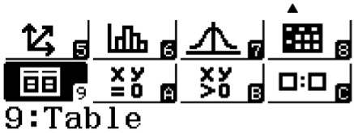
y-intercept.

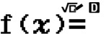
Press w9.

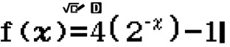
Key in 4(2^zQ)$)p1 for f(x).
Teacher: Please note that you will need to teach the students to cleverly select the values accordingly to question so that the critical values will show up in the table of values.

Press == to skip g(x) since there is only one equation.


Unit 6 Exponential and Logarithmic Functions

Start the range with –1 and end the range at 10. Leave the step as 1.
TEACHER’S GUIDE
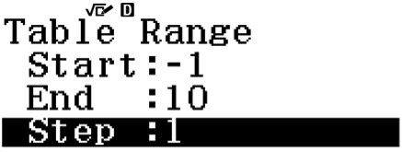

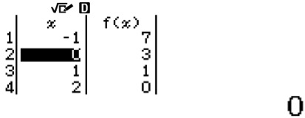
Press = and the table of values will be displayed. Now try to find the asymptote.
Press R to explore the table of values.
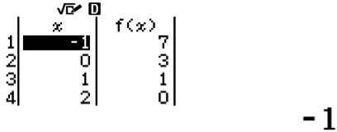
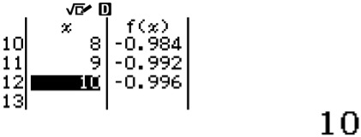
Press = to view more values not stated in the range previously.
Press = continuously until you notice all the f(x) values appear to be the same.
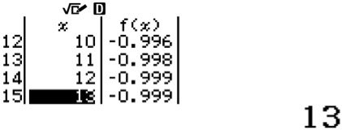
Hence, deduce that the function converges towards y = f(x) = –1. The asymptote is y = –1. For the y-intercept, press either E or R to locate x = 0.
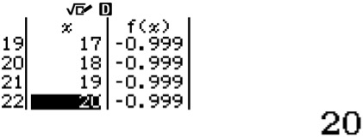
When x = 0, y = f(x) = 3. The y-intercept is y = 3. Alternate solution
Asymptote 2–x > 0 4(2–x) > 0
Exponential functions are always positive. Looking at a general function of ax where a > 0, there is NO real value of x that generates a negative value of ax.
4(2–x) – 1 > –1
y > –1

∴ y = –1 (asymptote)
y-intercept When x = 0,
y = 4(2–0) – 1
y = 4 – 1
y = 3

Casio ClassWiz Mathematics Workbook
TEACHER’S GUIDE

Worked Example 2
Sketch y = –2x + 5.

Solution
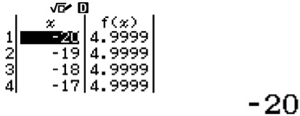
Use the Table function to deduce the asymptote and to find y-intercept.
Hence, deduce that the function converges to y = f(x) = 5.
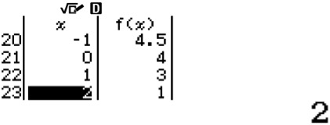
When x = 0, y = 4.

From here, we can use the QR code function to view the general shape of the graph. Press qT to generate a QR code.
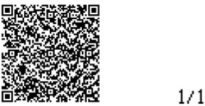

Scan the QR code with CASIO EDU+ mobile application to view graph.
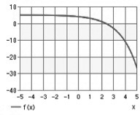

Unit 6 Exponential and Logarithmic Functions

Worked Example 3
TEACHER’S GUIDE

Evaluate log4 9.
Solution
log4 9 = 1.584962501… = 1.58 (to 3 s.f.)
ClassWiz steps
Press i4$9=, and 1.584962501 is displayed.

Worked Example 4
Find the x value of y = 4(7–x) – 589 given that y = –225.

Solution
–225 = 4(7–x) – 589
4(7–x) = 364
(7–x) = 91
Change from index form to logarithmic form to solve for x.
log7 91 = –x

x = –log7 91 = –2.32 (to 3 s.f.)
Check your answer using ClassWiz
Tip: Use the Solve function to check your answers.
Press Qr for ‘=’ sign to input entire equation.
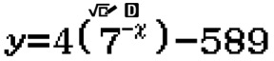
Press !Qn to input ‘y’. Continue to input the rest of the equation on the right hand side. It should look like this:

Press qr to solve the equation.
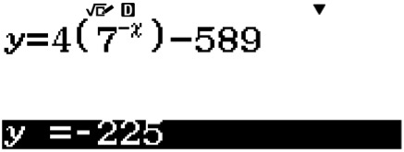
Input y-value given in question and press = to lock in the value.

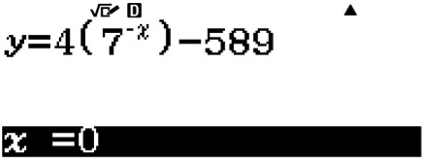
Press 0 to input the value of x as ‘0’ and press = to lock in the value.

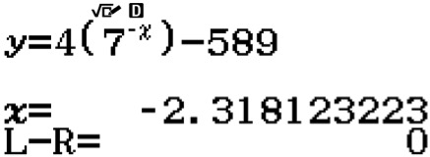
Press = again and the calculator will solve the equation within the parameters set.

Casio ClassWiz Mathematics Workbook

Worked Example 5

State the asymptote and the y-intercept of y = 3 log2 (3x + 2) + 5.
Solution
Asymptote For logarithm to be defined, 3x + 2 > 0.
∴ 3x > –2
x > – $\frac{ 2 }{3}$
∴ x = – $\frac{ 2 }{3}$ (asymptote)

When y = 0, 0 = 3 log2 (3x + 2) + 5
log2 (3x + 2) = – $\frac{ 5 }{3}$
$2^{- \frac{ 5 }{3}}$= 3x + 2
3x = $2^{- \frac{ 5 }{3}}$– 2
x = $\frac{{ 2}^{- \frac{ 5 }{3}}-2 }{3}$ = –0.562 (to 3 s.f.)
TEACHER’S GUIDE
Worked Example 6
Sketch y = 2 log3 (x – 2) – 5.
Solution
Asymptote: x = 2 When y = 0,
y
x
2
17.6
0 = 2 log3 (x – 2) – 5
log3 (x – 2) = $\frac{ 5 }{2}$
$3^{\frac{ 5 }{2}}$ = x – 2

x = $3^{\frac{ 5 }{2}}$ + 2 = 17.6 (to 3 s.f.)

Unit 6 Exponential and Logarithmic Functions

Level 2
TEACHER’S GUIDE

Worked Example 7

Solve 5 logx 7 = 3.
Solution

logx 7 = $\frac{ 3 }{5}$
If $a^{\frac{ c }{d}}$ = b, then a = $b^{\frac{ d }{c}}$ . This is achieved
by taking power of $\frac{ d }{c}$ on both sides.
$x^{\frac{ 3 }{5}}$ = 7

x = $7^{\frac{ 5 }{3}}$ = 25.6 (to 3 s.f.)

Check your answer using ClassWiz
Tip: Use the Solve function to check your answers.
Press Qr for ‘=’ sign to input entire equation of 3 = 5 logx 7.
Press qr to solve the equation.
Press 0 to input the value of x as ‘0’ and press = to lock in the value.
Press = again and the calculator will solve the equation within the parameters set. The calculator should display x = 25.61513997 after a short while.

Worked Example 8

Simplify 3 log3 27 + $\frac{ 5 }{6}$ log3 243 without the use of a calculator.
Solution
3 log 3 27 + $\frac{ 5 }{6}$ log3 243 = 3(3) + $\frac{ 5 }{6}$ (5)
= $\frac{ 79 }{6}$

Let log3 27 = x
These following steps are not necessary
but they can help you understand how
to approach such questions better.

3x = 27
3x = 33
∴ x = 3

Let log3 243 = y
3y = 243
3y = 35
If a question requires you to work without a calculator, the answer will usually be an integer value.
∴ y = 5

Worked Example 9

Given that log4 3 = a and log4 5 = b, express log4 180 in terms of a and b.
Solution
Alternative method
log422 = 2 log4 2
= 2($\frac{ 1 }{2}$)
= 1

log4 180 = log4 (22 × 32 × 5)
= log4 22 + log4 32 + log4 5
= log4 4 + 2 log4 3 + log4 5
= 1 + 2a + b

Casio ClassWiz Mathematics Workbook
TEACHER’S GUIDE

Worked Example 10
Solve log5 (x + 4) = log5 (3x – 8).
There is NO cancellation of any logarithmic function here. Since both log functions have the same base, we only have to compare the expressions in the log function.

Solution
Use the Table function to solve this equation. Take log5(x + 4) to be f(x).
Take log5(3x – 8) to be g(x).
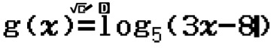
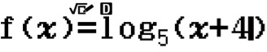

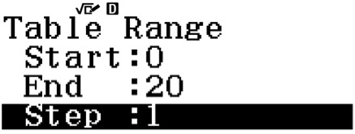
Set the Table Range as

Press = and you will see
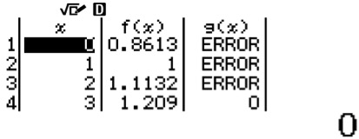

Press either E or R to locate an x value such that f(x) and g(x) have the same value.
Teacher: Please note that you can teach the students the concept of solving two equations by deriving the same coordinates.
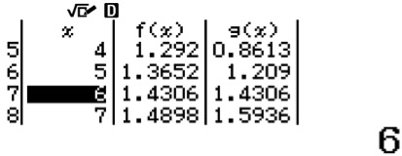

Hence, the solution is x = 6.

Alternate solution
log5 (x + 4) = log5 (3x – 8)
x + 4 = 3x – 8
2x = 12
x = 6

Unit 6 Exponential and Logarithmic Functions

Level 3
TEACHER’S GUIDE

Worked Example 11
Solve 4x + 3 + 12 = 2x + 4 by using substitution.

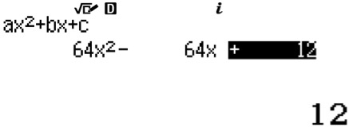
Solution
ClassWiz steps
Press wQz and select 2 for polynomials and 2 for second degree of polynomial.
Input the coefficients as shown:
4x + 3 + 12 = 2x + 6
22x + 6 + 12 = 2x + 6
26 (22x) – 26 (2x) + 12 = 0
Let 2x be u.
64u2 – 64u + 12 = 0
16u2 – 16u + 3 = 0 (4u – 3)(4u – 1) = 0
u = $\frac{ 3 }{4}$ or $\frac{ 1 }{4}$
2x = $\frac{ 3 }{4}$ or $\frac{ 1 }{4}$
Press = to obtain the first solution of $\frac{ 3 }{4}$ and
x = log2 $\frac{ 3 }{4}$ or log2 $\frac{ 1 }{4}$
= again to obtain the second solution of $\frac{ 1 }{4}$ .
x = –0.415 or –2

Casio ClassWiz Mathematics Workbook
CLASSWIZ WORKSHEETS

CLASSWIZ WORKSHEETS
Level 1 

Evaluate each of the following expressions, giving non-exact answers to 3 significant figures.

(a) 3e2 | (b) $4^{\frac{ 3 }{2}}$ | (c) 5(e3) | Teachers may these 2 questions to teach the students that (ab)n = anbn.
(d) 6e | (e) ${11}^{\frac{ 5 }{3}}$ + 2 | (f) 6(2π)  Teachers can use these 2 questions to teach the algebraic identities  (a + b) = a2 + 2ab + b2 ≠ a2 + b2.
(g) (π + e)2 | (h) π2 + e2
(i) (7e)π | (j) 7π × eπ
(k) ${28}^{\sqrt{10}}$ | (l) 8(9e + 3)2
You may use the Table function to solve 2(a) to (e).
- State the asymptote and the y-intercept of the following graphs.

(a) y = ex | 1 |  | y | y = ex | x | (b) y = –5x | –1 | y | y = –5x | x
(c) y = 3x + 1 |  |  | y | y = 3x + 1 |  | (d) y = 4x + 1 |  | y
 |  |  |  |  |  |  | 1
 |  | 1
 |  |  |  |  | x |  |  |  |  | x
 |  |  |  |  |  |  |  |  | y = –4x + 1
(e) y = 5ex – 3 |  |  |  |  |  | (f) y = –4($\frac{ 1 }{5}$)^{x} – 3
(g) y = 2(3–x) + 5 |  |  |  |  |  | (h) y = –2(e–x) + 3

Unit 6 Exponential and Logarithmic Functions

Sketch the following exponential graphs.
ClassWiz steps
You may use the Table function to find the asymptote and the y-intercept. Use the QR code function by pressing qT.
CLASSWIZ WORKSHEETS

(a) y = 7x | (b) y = e–x
(c) y = ex – 1 | (d) y = 3x – 2
(e) y = –3x – 5 | (f) y = –2(5x)
(g) y = –2ex + 1 | (h) y = –3(6–x) + 2

Casio ClassWiz Mathematics Workbook
CLASSWIZ WORKSHEETS

Find the y value of the following equations for each given x value, giving non-exact answers to 3 significant figures.

(a) | y = 2x – 3, x = –20 | (b) | y = e–x + 2, x = 4
(c) | y = 5ex – 7, x = 10 | (d) | y = –3e2x + 9, x = –3
(e) | y = 4(5–x) – 6, x = 19 | (f) | y = –7(11–2x) + 23, x = –13

- Evaluate the following logarithmic expressions, giving your answers to 3 significant figures.

(a) lg 6 | (b) ln 3
(c) log10 15 | (d) loge 29
(e) 7 log7 8 | (f) 6 log3 20 + 5
(g) 8 ln 228 – 31 | (h) –5 lg 77 + 3
(i) 23 log5 1 – 18 log4 19 | (j) 5 log2 3
(k) 8 log4 60 + 3 | (l) –7 log7 50 – 14

Unit 6 Exponential and Logarithmic Functions

Find the x value of the following equations for each given y-value, , giving your answers to 3 significant figures.
CLASSWIZ WORKSHEETS

(a) | y = 2x – 3, y = 8 | (b) | y = e–x + 2, y = 41
(c) | y = 5ex – 7, y = 60 | (d) | y = 3e2x + 9, y = 78
(e) | y = 4(5–x) – 6, y = 90 | (f) | y = 7(11–2x) + 23, y = 700

Casio ClassWiz Mathematics Workbook

State the asymptote and the x-intercept of each of the following graphs.
CLASSWIZ WORKSHEETS

(a) y | = log2 | x | y | y | = log2 x  x | (b) | y = –5 log4 x |  | y  y = –5 log4 x | x
(c) y = log3 x + 1 |  |  | y |  | y = log3 x + 1  x | (d) y = log2 (x + 1) |  | y | y = log2 ( x + 1 )  x
(e) y = 5 lg x – 2 |  |  |  |  |  | (f) y = $\frac{ 3 }{2}$ ln x + 1
(g) y = 3 log2 (x – 1) |  |  |  |  |  | (h) y = –4 log3 (x – 2) – 4

Unit 6 Exponential and Logarithmic Functions

Sketch each of the following logarithmic graphs, stating clearly the x-intercepts.
CLASSWIZ WORKSHEETS

(a) y = 3 log3 x | (b) y = –5 ln x
(c) y = lg x – 1 | (d) y = lg (x + 1)
(e) y = –7 log3 (2x – 1) | (f) y = 5 log4 2x + 1
(g) y = –ln (x + 1) – 2 | (h) y = 8 log7 (3x + 2) – 6

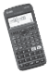
Casio ClassWiz Mathematics Workbook
CLASSWIZ WORKSHEETS

Level 2

For Questions 1 to 7, t represents the number of years. You may use Table functions to solve the questions.

- The value, V, of the car is given by V = 54 000e–5t. Find the initial value of the car.

- The price, P, of an apartment is given by P = 253 000e0.01t. Find the price of the apartment after 5 years.

The population, N, of Town X is modelled by N = 287 000$e^{- \frac{t}{46}}$ . Find the size of the population after 8 years.

The selling price, P, of an antique vase is given by P = 86 900$e^{1+ \frac{t}{489}}$. Find the selling price after 20 years.

- The price, p, of a handphone is given by p = 1100e–0.2t. Find the price of the handphone after 2 years.

- The cost, A, of the motorcycle is modelled by A = 5000e–kt. Given that the motorcycle is valued at
$3500 after 2 years, find the value of k to 3 significant figures.

Unit 6 Exponential and Logarithmic Functions

7. The price, V, of an exquisite diamond is modelled by V = 105 900ekt. Given that the price of the item increased by $23 450 after 20 years, find the value of k to 3 significant figures.
CLASSWIZ WORKSHEETS

8. Solve each of the following logarithmic equations by converting the logarithmic form to index form, giving any non-exact answer in 3 significant figures.

(a) lg x = 5 | (b) ln x = 0.7
(c) log3 x = 4 | (d) log2 x = 7
(e) 3 log5 x = 9 | (f) 2 log2 2x = 20
(g) log5 3x – 7 = –5 | (h) 3 log10 ($\frac{ x }{2}$) = 12
(i) 7 log8 (68x – 3) – 3 = 18 | (j) logx 5 = 1
(k) logx 27 = 3 | (l) logx 72 = 4
(m) 3 logx 89 + 1 = 16 | (n) 2 logx 63 – 5 = 7

Casio ClassWiz Mathematics Workbook
CLASSWIZ WORKSHEETS

Simplify each of the following expressions without the use of a calculator.

(a) log2 1 | (b) log4 64
(c) 7 log8 8 | (d) 2 log5 125
(e) 5 log2 16 | (f ) 2 log4 64 – 3
(g) $\frac{ 3 }{2}$ log7 343 × log2 32 | (h) 5 log8 64 ÷ 3 log9 729

- Evaluate each of the following by converting it to common or natural logarithms using the Change of Base Law, leaving any non-exact answer to 3 significant figures.

(a) log6 8 | (b) log4 17
(a) log5 ($\frac{7}{ 11 }$) | (d) $\log_{\frac{ 1 }{3}}$ 9
(e) 2 log7 19 | (f) log3 18
(g) log2.5 23 | (h) logπ e5

Unit 6 Exponential and Logarithmic Functions

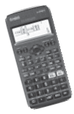
Given that log4 3 = a and log4 5 = b, express each of the following in terms of a and b.
CLASSWIZ WORKSHEETS

(a) log4 15 | (b) log4 45
(c) log4 375 | (d) log4 675
(e) log4 20 | (f) log4 240

Casio ClassWiz Mathematics Workbook
CLASSWIZ WORKSHEETS

Given that lg x = p and lg y = q, express the following in terms of p and q.

(a) lg xy | (b) lg 100x2y
(c) lg ($\frac{ 10y }{x}$) | (d) lg $\sqrt{x^{3}y}$
(e) lg $\frac{{ 10x}^{\frac{ 1 }{3} }}{\sqrt{y}}$ | (f) xy

Unit 6 Exponential and Logarithmic Functions

Simplify and express each of the following as a single logarithm.
CLASSWIZ WORKSHEETS

(a) logx 8 – 2 logx 4 | (b) lg $\frac{7}{ 18 }$ – 2 lg $\frac{ 5 }{ 7 }$ + 4 lg $\frac{ 2 }{3}$
(c) 5 loga 2 – 3 loga 4 + loga 5 | (d) 3 – 2 lg 9
(e) 4 + log4 7 | (f) 5 logx 2 – 8 + logx x3

Casio ClassWiz Mathematics Workbook
CLASSWIZ WORKSHEETS

Find y in terms of x for each of the following equations.

(a) lg y = 2 – $\frac{ 1 }{2}$ lg x | (b) lg (y + 1) = 1 + 3 lg x
(c) 2 log3 y – 4 = log3 (x – y2) | (d) 3 log2 (x + 2) = 3 + log2 (x + y)
(e) log4 y = log2 x + log2 10 – log2 3 | (f) log9 y + log3 y = 4 log3 x + 3 log3 4

Unit 6 Exponential and Logarithmic Functions

Solve each of the following equations.
CLASSWIZ WORKSHEETS

(a) log2 (2x + 1) = log2 (4x – 9) | (b) log3 (x + 3) + log3 (x – 5) = log3 (2x + 6)
(c) lg 18 + lg ($\frac{ 2 }{3}x$) – lg (3x + 1) = 0 | (d) 2 lg 5 – lg (x + 3) = 1 – lg (2x – 2)
(e) log4 x + log4 (2x – 3) = 1 | (f) log2 (x + 3) + log2 (8x – 5) – log2 (2x – 1) = 3
(g) log3 (x – 1)2 = 4 + log3 (2x – 1) | (h) 3 logx 2 + logx 9 = 4

Casio ClassWiz Mathematics Workbook
CLASSWIZ WORKSHEETS

Solve the following equations.
ClassWiz steps
Use the Solver function by pressing qr or you may use the Table functions to find the same coordinate.

(a) log4 (6 – x) – log2 8 = log3 9 | (b) log5 (9 – 10x) – log5 (3x + 2) = log7 49
(c) log5 x – log25 (2x – 5) = $\frac{ 1 }{2}$ | (d) log9 (3x + 2) = log3 x + log3 2
(e) log2 x – log4 (x + 3) = 4.5 | (f) 3 log2 x – log4 x = $\frac{ 5 }{2}$

Unit 6 Exponential and Logarithmic Functions

17. Find x in terms of a for each of the following.
CLASSWIZ WORKSHEETS
  - loga x = 1 + loga (7x – 10a)

2 loga x = 2 + $\frac{ 1 }{2}$ loga x3

  - loga (5x – 2) = loga (2 + x) + 3

Casio ClassWiz Mathematics Workbook
CLASSWIZ WORKSHEETS

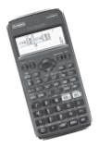
18. Solve each of the exponential equations.

(a) 5x = 10 |  | (b) | 2(5x) = 3 | (c) | 5 – 62x = 3
(d) | (2.3)x = 23 | (e) e2x = 7 |  | (f) | 5e3x = 21
(g) | e3x – 20 = 0 | (h) | 4e5x – 250 = 0 | (i) | 3x + 1 = 17

ClassWiz steps
You may use table functions to solve Questions 1 to 4.
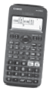
Level 3
Unit 6 Exponential and Logarithmic Functions

A bowl of soup cools from its initial temperature, T °C, in x minutes. Given that T = 95(0.95)x, find
CLASSWIZ WORKSHEETS
  - its initial temperature.
  - the temperature at 15 minutes.
  - the time taken, to the nearest minute, for the soup to reach a room temperature of 25°C.

- Alex put $50 000 into an investment plan that pays 4% interest compounded annually, and the amount $A, at the end of t years is given by A = 50 000(1.04)t.
  - Calculate the amount at the end of 5 years.
  - Calculate the minimum number of years needed to achieve a total of $75 000 for the investment plan.

- At the beginning of year 2000, the population, P, of an insect species after n years is modelled by
P = 53 400e–0.05n. Find the population of the insects
  - at the beginning of year 2000.
  - at the beginning of year 2017, giving your answer to 3 significant figures.

Casio ClassWiz Mathematics Workbook
CLASSWIZ WORKSHEETS

A town wanted more people to settle and live there, so they launched a campaign that would attract people to their town. The given algorithm for the population, P, after t years, is given by
P = 7500 ln (t + e).

Find the initial population in the town.
  - The minimum number of years for the population to double.

- Using suitable substitutions, solve each of the following equations.

(a) 2(49x) + 3 = 5(7x) | (b) 9x + 20(3x) = 3x + 3 – 12
(c) 52x + 7 = 25x + 1 | (d) 9x + 10 = 4(3x + 1)

Unit 6 Exponential and Logarithmic Functions

Solve the following simultaneous logarithmic equations. log4 (x + 2) = 1 + log2 y
CLASSWIZ WORKSHEETS
log2 y + log2 4 = 2 + log4 x

Solve the following simultaneous logarithmic equations. log2 xy = 7
3 log8 x – 4 log8 y = 0

Casio ClassWiz Mathematics Workbook

Solve each of the following equations.
CLASSWIZ WORKSHEETS

  - log2 x + $\frac{2}{\log_{2 }x }$ = 3

  - log3 y + logy 9 = log2 ($\frac{ 1 }{8}$)

  - log4 x + logx 32 = $\frac{ 19 }{6}$

Unit 6 Exponential and Logarithmic Functions
CLASSWIZ WORKSHEETS

Level 4

Given that loga

3 = x and loga

5 = y, express loga

($\frac{ 125a }{81}$)x – 1 in terms of x and y.

Given that loga ${xy}^{2}$ = p and loga ($x^{2}y$) = q, find loga $\frac{ y }{x}$ in terms of p and q.

Given that m = 4x and n = 8 y , express log2 ($\frac{m^{3}}{{ 32n}^{2} }$) in terms of x and y.

Casio ClassWiz Mathematics Workbook
CLASSWIZ WORKSHEETS

4. Solve log3 (1 – x) + log3 (x + 5) = 2 log9 (3x + 11).

- Solve the following simultaneous equations. 3y – 0.5 = $\frac{81}{{ \sqrt{3}}^{x} }$
log6 (5x – y) = 1 + log6 2

